小学英语六年级上第三单元 （第九课时）
小试牛刀
1. 选出不同类的单词。
A. plane | B. car | C. vehicle | D. taxi
正确答案：C
2. 选出不同类的单词。
A. happy | B. angry | C. upset | D. worry
正确答案：D
3. 选出不同类的单词。
A. comfortable | B. safe | C. invention | D. dangerous
正确答案：C
4. 看图片，选出正确选项。
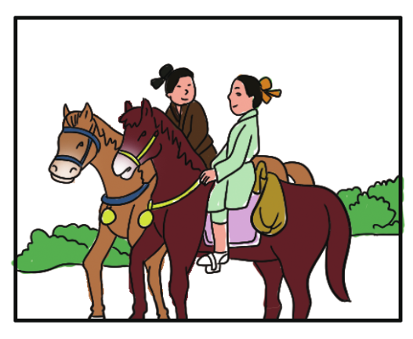 | A. rode bikes | B. rode horses
正确答案：B
5. 看图片，选出正确选项。
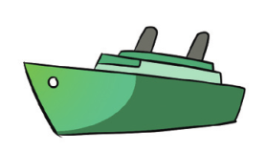 | A. by air | B. by ship
正确答案：B
6. ---Who_________ those vehicles?
--- Some smart people did.
A. invention B. invent C. invented
正确答案：C
7. Their inventions make our life ___________ and ____________.
--- Some smart people did.
A. difficult / slow B. easy / comfortable C. fast / dangerous
正确答案：B
8. 读句子选择正确的图片。
Some smart people invented those vehicles.
A. 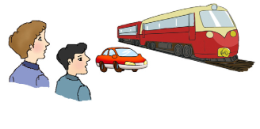 | B.
正确答案：A
9. 读句子选择正确的图片。
Mr. Bell invented the telephone.
A. 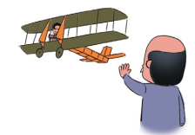 | B. 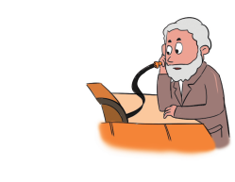
正确答案：B
10. 读句子选择正确的图片。
Traveling in the old days was very slow.
A. 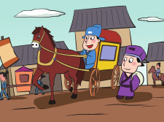 | B.
正确答案：A

