**小学英语六年级上第三单元 （第八课时）**

**小试牛刀**

1. 听第10课课文录音，选择正确答案。

What did Mike and his parents do in Hangzhou?

a. They visited their old friends.

b. They enjoyed the beautiful landscape (景色).

c. They visited the West Lake.

d. They went around the lake by bike.

e. They ate lots of yummy food.

f. They did some shopping.

A. b,c,d,f B. a,b,e,f C. b,c,e,f

正确答案：A

2. 选出不同类的单词。

|  |  |  |  |
| --- | --- | --- | --- |
| A. air | B. bus | C. train | D. subway |

正确答案：A

3. 选出不同类的单词。

|  |  |  |  |
| --- | --- | --- | --- |
| A. flew | B. took | C. bought | D. fly |

正确答案：D

4. 看图片，选出正确选项。

|  |  |  |
| --- | --- | --- |
|  | A. the book fair | B. the Spring Festival Fair |

正确答案：B

5. 看图片，选出正确选项。

|  |  |  |
| --- | --- | --- |
|  | A. did some housework | B. did some shopping |

正确答案：B

6. 看图片，选出正确选项。

|  |  |  |
| --- | --- | --- |
| https://tse1-mm.cn.bing.net/th/id/OIP.hHLvjJ-i2krvlAAIWK9iuQHaHa?w=205&h=205&c=7&o=5&pid=1.7 | A. a silk dress | B. a silk scarf |

正确答案：B

7. 看图片，选出正确选项。

|  |  |  |
| --- | --- | --- |
|  | A. the train station | B. the bus station |

正确答案：A

8. 根据图片回答问题。

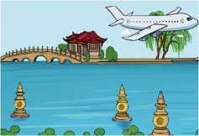How did you go to Hangzhou?

A. I flew to Hangzhou.

B. I took a train to Hangzhou.

C. I drove to Hangzhou.

正确答案：A

9. 根据图片回答问题。

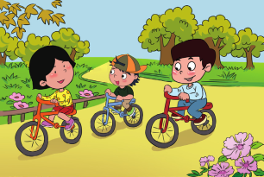Hi, Yangyang! What did you do last weekend?

A. I visited the museum with my parents.

B. I went around the park by bike with my parents.

C. I played football with my friends in the park.

正确答案：B

10. 根据图片回答问题。

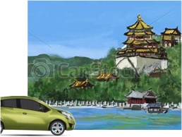Did you go to the Summer Palace by bus?

A. No. We went there by bike.

B. No. We took a subway to get there.

C. No. We drove there.

正确答案：C