**小学英语六年级上第三单元 （第七课时）**

**小试牛刀**

1. 听第9课课文录音，选择正确答案。

Where did Mike and his parents go last weekend?

A. They went to Shanghai.

B. They went to Hangzhou.

C. They went to Tianjin.

正确答案：B

2. 听第9课课文录音，选择正确答案。

Was Mike in school on Monday?

A. Yes, he was.

B. No, he wasn’t.

正确答案：B

3. 看图片，选出正确选项。

|  |  |  |
| --- | --- | --- |
| 图片1.png | A. took a train to Hangzhou | B. flew to Hangzhou |

正确答案：B

4. 看图片，选出正确选项。

|  |  |  |
| --- | --- | --- |
|  | A. drove to Xiangshan | B. rode to Xiangshan |

正确答案：A

5. 看图片，选出正确选项。

|  |  |  |
| --- | --- | --- |
|  | A. took the train to Tianjin | B. took the car to Tianjin |

正确答案：A

6. 读句子选择正确的图片。

|  |  |
| --- | --- |
| We flew to Hangzhou last weekend. | |
| A. | B. |

正确答案：A

7. 读句子选择正确的图片。

|  |  |
| --- | --- |
| Your parents must be upset. | |
| A. https://buildahead.com/wp-content/uploads/2017/02/happy-emoji-smaller.png | B. http://cliparts.co/cliparts/kiK/BG7/kiKBG78qT.png |

正确答案：B

8. 读句子选择正确的图片。

|  |  |
| --- | --- |
| I drove to the Summer Palace with my parents. | |
| A. | B. https://tse1-mm.cn.bing.net/th/id/OIP.P5WRjI-WUPts05ka_9U6xAHaE2?w=281&h=178&c=7&o=5&pid=1.7 |

正确答案：A

9. 根据图片回答问题How did you go to Shanghai last weekend?

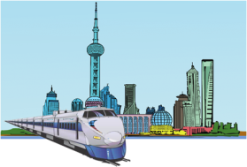 A. I flew to Shanghai.

B. I drove to Shanghai.

C. I took a train to Shanghai.

正确答案：C

10. 根据图片回答问题Did you walk to the museum last month?

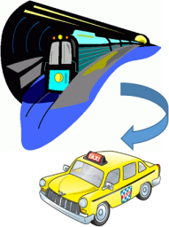A. No. I took a subway first and then changed to the taxi there.

B. No. I took a taxi first and then changed to the subway there.

C. No. I took a bus first and then changed to the taxi there.

正确答案：A