**小学英语五年级上第三单元（第九课时）**

**小试牛刀**

1. I enjoy dressing up as a superhero.的正确理解是

A. 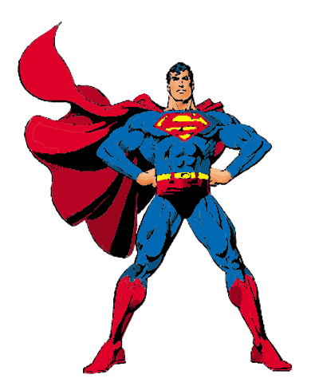 B. E:\design cliparts\H to I\Clip Art\Holidays\Halloween (A - D)\Costume - Pirate 10.wmf C. E:\design cliparts\H to I\Clip Art\Holidays\Halloween (Sl - Z)\Witch Flying 31.wmf

正确答案：A

2. He enjoys dressing up as an alien.的正确理解是

A. E:\design cliparts\H to I\Clip Art\Holidays\Halloween (E - G)\Ghost 30.wmf B.  C. E:\design cliparts\H to I\Clip Art\Holidays\Halloween (A - D)\Dracula 5.wmf

正确答案：B

3. Which one is the symbol of Halloween?

B. 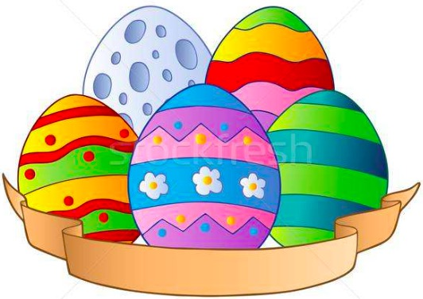

正确答案：A

4. People have Christmas trees and get Christmas gifts on this day.

正确答案：C

5. What do people eat on Thanksgiving?

B. 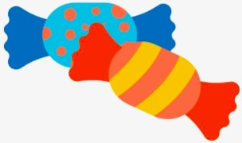 C. 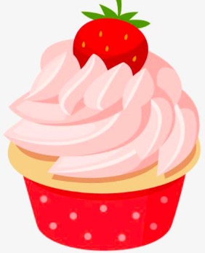

正确答案：A

6. When is Thanksgiving?

A. It’s on the first Thursday in November.

B. It’s on the fourth Thursday in November.

C. It’s on the fourth Tuesday in November.

正确答案：B

7. What do children say on Halloween?

A. Merry Christmas!

B. Trick or treat!

C. Happy Thanksgiving!

正确答案：B

8. Which one is NOT the activitiy on Halloween?

A. Children dress up at night.

B. Children knock on doors.

C. Families get together.

正确答案：C

9. What do children do on Easter?

A. Children dress up at night and knock on doors for candies.

B. Children get together and eat turkey.

C. Children have an Easter egg hunt.

正确答案：C

10. Which holiday is in October?

A. Halloween. B. Thanksgiving. C. Christmas.

正确答案：A