**小学英语五年级上第三单元（第七课时）**

**小试牛刀**

1. Chinese calendar的正确理解是

A. 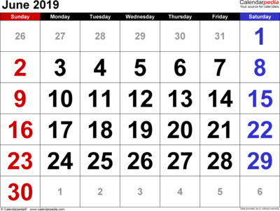 B. 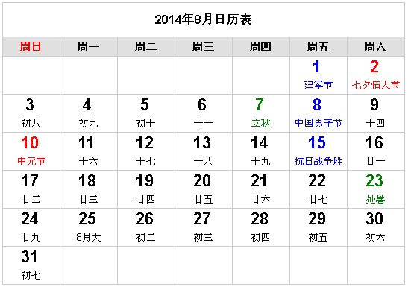

正确答案：B

2. moon cake的正确理解是

A.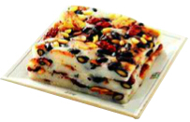 B.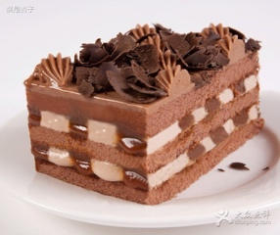 C.

正确答案：C

3. enjoy the bright full moon的正确理解是

C. 

正确答案：B

4. It’s a traditional festival in China. People eat *jiaozi* on that day.

A.  B.  C. 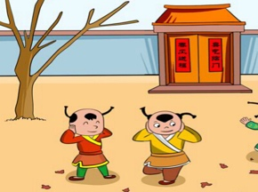

正确答案：C

5. It is on the fifteenth day of the first month in the Chinese calendar.

正确答案：B

6. What do people eat on the Lantern Festival?

C.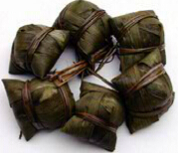

正确答案：B

7. When is the Mid-Autumn Festival?

A. It’s on the fifteenth day of the eighth month in the Chinese calendar.

B. It’s on the fifth day of the fifth month.

C. It’s on Aug.15th.

正确答案：A

8. When is the Spring Festival?

A. It’s on Jan.1st.

B. It’s on the first day of the first month in the Chinese calendar.

C. It’s on the fifteenth day of the first month in the Chinese calendar.

正确答案：B

9. What do people do on the Spring Festival?

A. People have a big dinner.

B. People enjoy the bright full moon.

C. People have dragon boat races.

正确答案：A

10. What do people do on the Lantern Festival?

A. People climb mountains.

B. People watch dragon boat races.

C. People see lantern shows at night.

正确答案：C