**小学英语四年级上第六单元（第9课时）**

**小试牛刀**

1. 下列两个单词划线的部分

nice kite

|  |  |
| --- | --- |
| A 发音相同 | B 发音不相同 |

正确答案：A

1. 下列两个单词划线的部分

cat take

A 发音相同 B 发音不相同

正确答案：B

3. 下列选项与图片内容相符的是

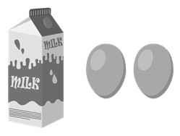

A I’d like some eggs and milk.

B I’d like some eggs and juice.

正确答案： A

4. 下列选项与图片内容相符的是

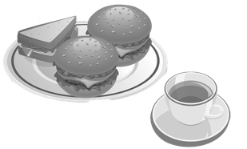

A I'd like two sandwiches and some bread. Tea is my favorite drink.

B I'd like two hamburgers and a sandwich. Tea is my favorite drink.

正确答案： B

5. 选择正确的答语是

-- What would you like to eat?

--________________________

A May I take your order now?

B I’ll have some vegetables.

正确答案：B

6. 判断句子与图片内容是否相符

--I’d like some sandwiches and salad.

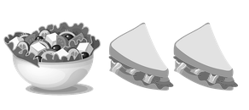

A 不相符 B 相符

正确答案：B

7. 阅读对话回答问题：

Waiter: May I take your order now?

Ms. Li: Yes. I'd like some chips and orange juice. Do you have fried chicken wings and pizza?

Waiter: Yes, we do.

Ms. Li: What do you have for dessert?

Waiter: We have all kinds of ice cream, biscuits, cookies and a lot of pies.

Ms. Li: OK. A banana pie for me.

Waiter: Is that all for you today?

Ms. Li: Yes. How much are they?

Waiter: They're eighty-six yuan.

Ms. Li loves the banana pie.

A. Yes. B. No.

正确答案：A

8. 对话中：Ms. Li wants to eat a pizza.

A. Yes. B. No.

正确答案：A

9. 对话中，This is a Chinese food restaurant.

A. Yes. B. No.

正确答案：B

10.对话中：You can buy jiaozi in the restaurant.

A. Yes. B. No.

正确答案：B