**小学英语四年级上第五单元 （第8课时）**

**小试牛刀**

1. What is the second step of shopping?
2. Make a choice. B. What to buy. C. Pay

正确答案：A

1. What is the third step of shopping?
2. Make a choice. B. What to buy. C. Pay

正确答案：C

1. 听第16课课文录音，选择正确答案。

What does Guoguo want to buy?

A. She wants to buy pants.

B. She wants to buy a pair of shoes.

C. She wants to buy a jacket.

正确答案：B

4. 听第16课课文录音，选择正确答案。

---How much are the shoes?

---They are dollars.

1. thirteen B. thirty C. three

正确答案：B

1. 听第17课课文录音，选择正确答案。

What will mom buy for Sara?

1. A jacket. B. A dress. C. A coat.

正确答案：A

1. 听第17课课文录音，选择正确答案。

The jacket will go with Sara’s trousers.

A. green B. blue C. red

正确答案：C

7. 读答语，选择正确的问句。

--- .

---They are fifty dollars.

1. How much are they? B. How much is it?

正确答案：A

8. 读答语，选择正确的问句。

--- .

---It is eleven yuan.

1. How much are they? B. How much is it?

正确答案：B

1. 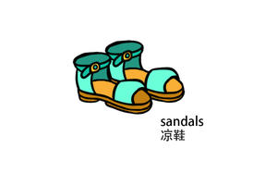看图片，选择正确的单词。

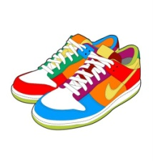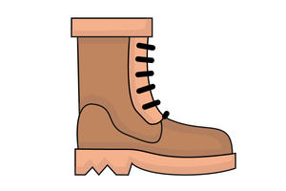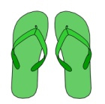

( ) ( ) ( ) ( )

1. sandals B. slippers C. sneakers D. boot

正确答案：A B D C

10. 读问句, 选择正确的答语。

|  |  |
| --- | --- |
| --- May I try them on? | |
| --- .  A. Sure. Here you are.  B. This one looks nice.  C. Can I help you? |  |

正确答案：A