**小学英语三年级上第五单元（第8课时）**

**小试牛刀**

1. It’s sunny and hot. I can put on my _______.

|  |  |
| --- | --- |
| A. | B. |
| C:\Users\air\AppData\Local\Temp\1581735696(1).png  sweater | C:\Users\air\AppData\Local\Temp\1581735830(1).png  shorts |

正确答案：B

2. It’s windy and cold .I can put on my _______.

|  |  |
| --- | --- |
| A.  C:\Users\air\AppData\Local\Temp\1581735999(1).png | B.  C:\Users\air\AppData\Local\Temp\1581736183(1).png |
| gloves | skirt |

正确答案：A

3. It’s rainy and cool. What can you do?

|  |  |
| --- | --- |
| A. | B. |
| C:\Users\air\AppData\Local\Temp\1581736824(1).png | C:\Users\air\AppData\Local\Temp\1581736694(1).png |
| jump in the puddles | go swimming |

正确答案：A

4. It’s sunny and warm. What can you do?

|  |  |
| --- | --- |
| A. | B. |
| C:\Users\air\AppData\Local\Temp\1581737359(1).png | C:\Users\air\AppData\Local\Temp\1581737471(1).png |
| go skiing | have a picnic |

正确答案：B

5. Great! I can put on my raincoat. Do you have a lot of ________in summer?

|  |  |
| --- | --- |
| A. snow | B. rain |
| 1580717175(1) | C:\Users\air\AppData\Local\Temp\1581737878(1).png |

正确答案：B

6. I can put on my gloves. Do you have a lot of ________in winter?

|  |  |
| --- | --- |
| A. snow | B. rain |
| 1580717175(1) | C:\Users\air\AppData\Local\Temp\1581737878(1).png |

正确答案：A

7. When the _______is cold and snowy, we wear thick clothes to keep us warm.

A. weather B. clothes

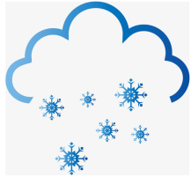

正确答案：A

8. We wear____, pants, coats, scarves and mittens in cold winter.

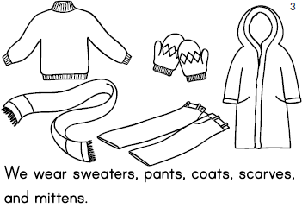

1. sweaters B. T-shirt

正确答案：A

9. When the weather is ____. We wear raincoat to keep us dry.

A．rainy B. sunny

正确答案：A

10. It is a sunny day. Can we go to the park?

A. Yes, we do. B. Ok, let’s go.

正确答案：B