1. 请你为下面的句子选择正确的图片。

My number is fifteen.

|  |  |  |
| --- | --- | --- |
|  |  |  |
| A | B | C |

正确答案：C

2. 请你读对话，选择正确的图片。

–What’s your number?

–My number is twenty.

|  |  |  |
| --- | --- | --- |
|  |  |  |
| A | B | C |

正确答案：C



3. 请选择正确的单词，将句子补充完整。

–What’s his number?

–His number is __________.

A. six B. sixteen C. sixty

正确答案：B

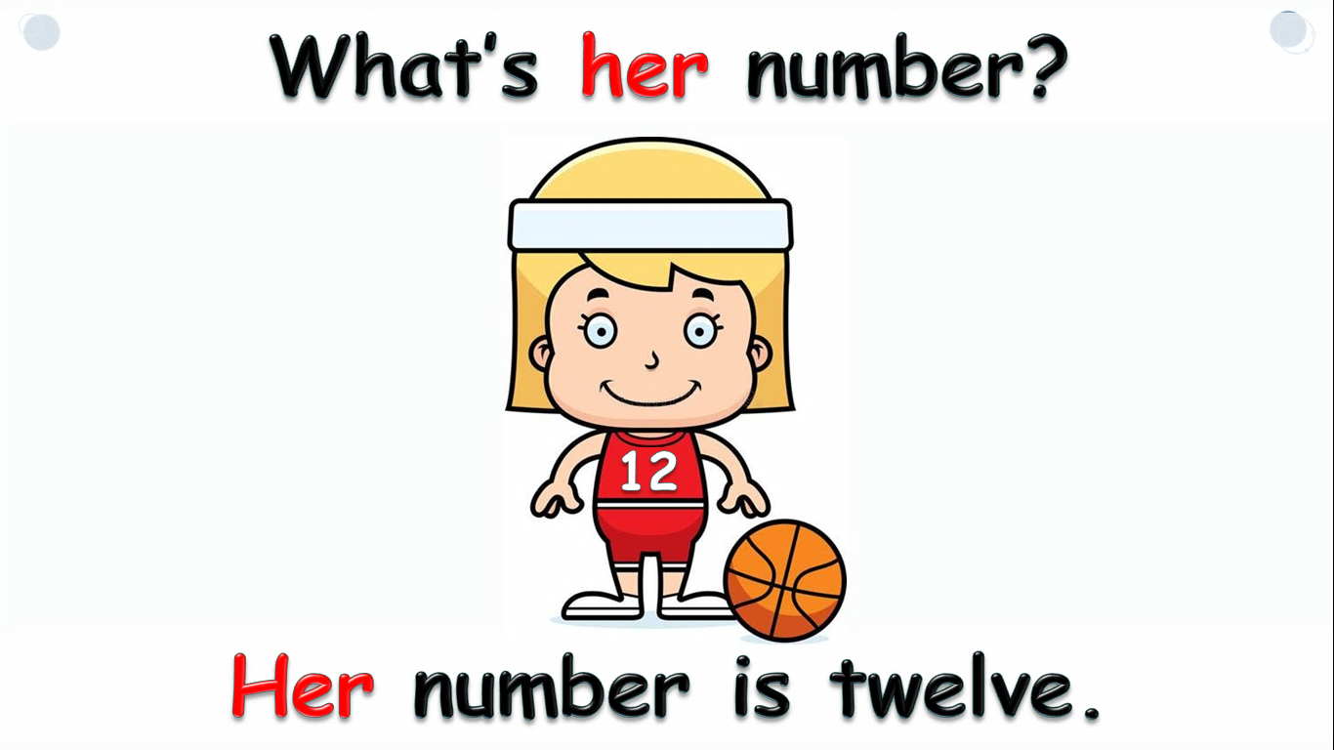4. 根据图片，选择正确的答语。

What’s her number?

A. Her number is two.

B. Her number is twelve.

C. Her number is twenty.

正确答案：B

1. 根据英文描述，请找到合适的算式。

Five plus five plus ten is twenty.

A. 5+5+10=20 B. 5+5-10=0 C. 5+5+10+20=40

正确答案：A

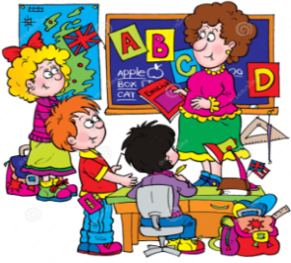6. 读句子，选择正确的答语。

How many English classes do you have in a week?

1. We have three classes.
2. Yes, I do.
3. My number is three.

正确答案：A

7. 根据图片，给句子选择正确的选项。

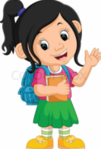How many do you have in your class?

A. boys B. teachers C. girls

正确答案：C

8. 请你选择正确的路线编号，将句子补充完整，帮助饥饿的小猪找到食物。

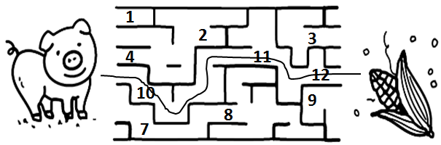The pig goes from ten to _____________,

to twelve，it gets a corn（玉米）.

A. eleven B. two C. eight

正确答案：A

9. 根据图片，选择正确的答语。

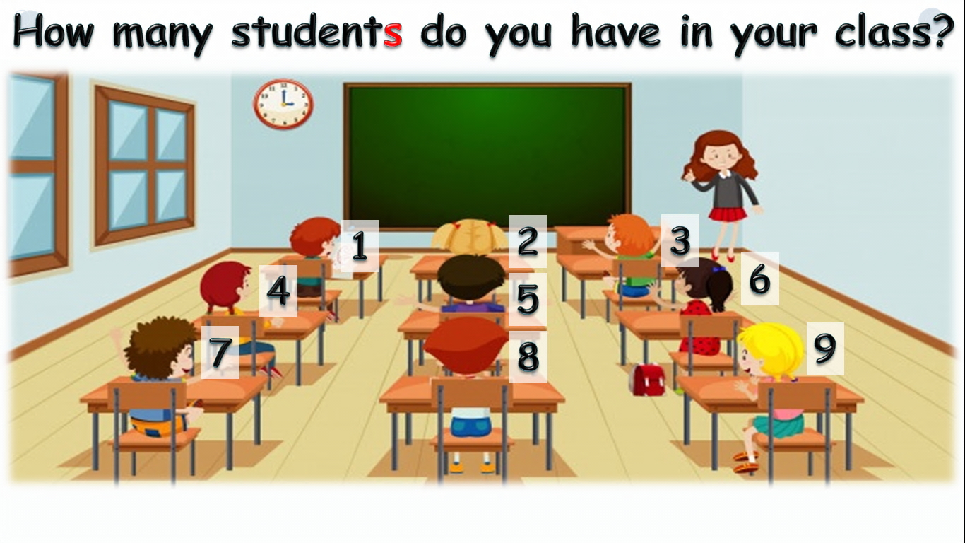How many students （学生）do you have in your class?

A. We have six students.

B. We have nine students.

C. We have nineteen students.

正确答案：B

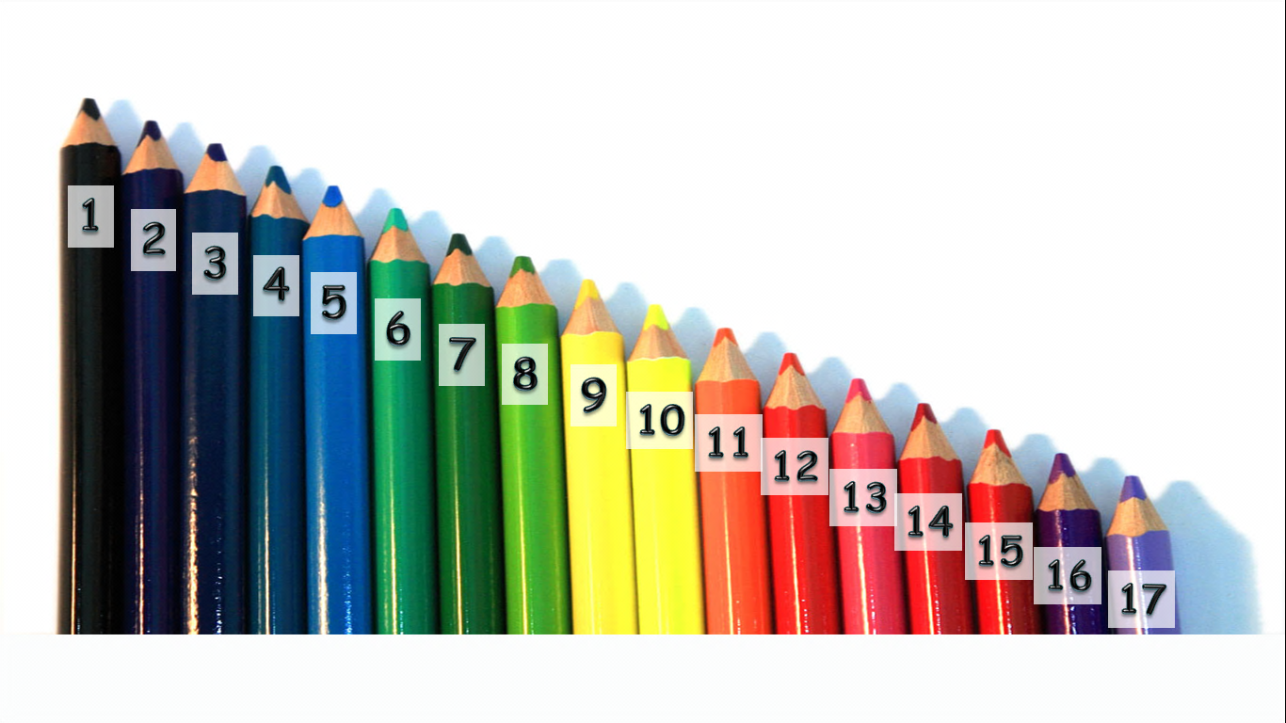10. 根据图片，选择正确的答语。

How many pencils do you have?

A. I have seven pencils.

B. I have eleven pencils.

C. I have seventeen pencils.

正确答案：C