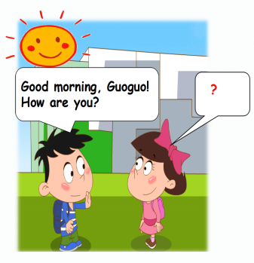1.早上，毛毛在上学的路上遇见了果果，毛毛主动和果果打招呼，果果该如何回答呢？

A. Hi, Maomao!

B. I’m fine. Thanks.

C. I’m Guoguo.

正确答案：B

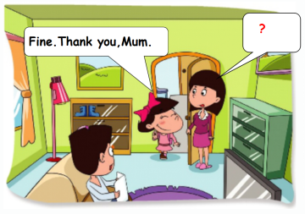2.晚上，果果放学回到家，妈妈想知道果果今天一天过得怎么样，妈妈该怎么问果果呢？

A. Good evening, Guoguo! How are you today?

B. Good morning, Guoguo! How are you?

C. Good afternoon, Guoguo! How are you today?

正确答案：A

3.下午，果果在路上遇见了洋洋，洋洋主动问候果果，果果该怎么回答呢？

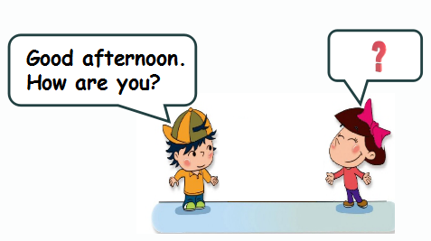A. How are you, Guoguo?

B. I’m fine, too.

C. I’m fine. Thank you.

正确答案：C

4.下午放学了，同学们该怎么和王老师道别呢？

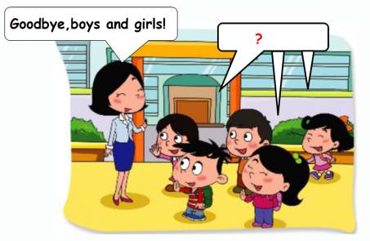A. Good afternoon, Miss Wang !

B. Bye-bye, Miss Wang!

C. How are you, Miss Wang?

正确答案：B

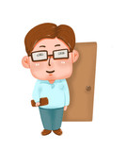5.根据问话，选择合适的答语：

？

How are you today, Dad?

A. How are you?

B. Good evening!

C. Fine. Thank you.

正确答案：C

6.选择合适的单词填空：

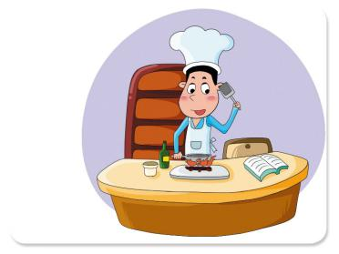 A cook, a cook,

A cook has a .

A. cook

B. book

C. good

正确答案：B

7.看图片，选择与图片相符的单词：

A. a cook

B. good

C. a book

正确答案：B

8.看图片，选择与图片相符的单词：

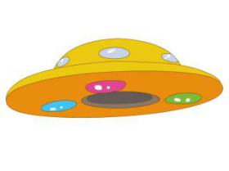A. a uniform

B. a UFO

C. a cup

正确答案：B

9.玲玲见到王老师，想想她是怎么与王老师问候的？

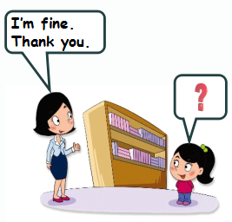A. Good morning, Miss Wang!

B. Goodbye, Miss Wang!

C. How are you, Miss Wang?

正确答案：C

10.图片中**没有**的是：

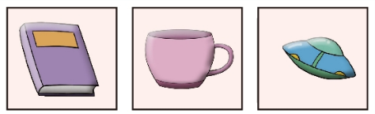A. a book

B. a cup

C. a nut

正确答案：C