**书面表达—情景作文学习指南**

**【学习目标】**

1. 能够以书面形式描述、概括经历，表达情感；

2. 根据表达需要，设计合理的语篇结构；

3. 有意识地选择和运用语言，有效地传递信息，表达意义；

4. 运用语篇衔接手段，提高表达的连贯性。

**【学法指导】**

认真审题（审体裁、审人称、审时态、审内容），确定主题，结构严谨，衔接自然，勾勒完美画卷。

**【学习任务】**

假设你是红星中学高三学生李华。上周你们班组织了一次班会，邀请去年毕业的同学回校交流。请根据以下四幅图的先后顺序，写一篇英文周记，记述整个过程。

注意：词数不少于60。

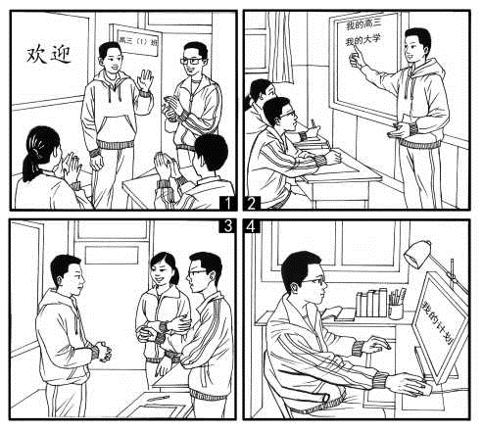

**审题：**

|  |  |  |  |  |
| --- | --- | --- | --- | --- |
|  | **衔接** | **要点** | **细节** | **心情感受** |
| **开篇** |  |  | | |
| **图1** |  |  |  |  |
| **图2** |  |  |  |  |
| **图3** |  |  |  |  |
| **图4** |  |  |  |  |
| **结尾** |  | | | |

____________________________________________________________________________________________________________________________________________________________________________________________________________________________________________________________________________________________________________________________________________________________________________________________________________________________________________________________5

___________________________________________________________________________________________________________________________________________________________________________________________________________________________________________________________________________________________________________________________________________________________________________________________________________________________________________________________10___________________________________________________________________________________________________________________________________________________________________________________________________________________________________________________________________________________________________________________________________________________________________________________________________________________________________________________________15___________________________________________________________________________________________________________________________________________________________________________________________________________________________________________________________________________________________________________________________________________________________________________________________________________________________________________________________20