**语法复习 定语从句-关系代词**

**[学习目标]** 本节课重点复习定语从句中的关系代词部分，关注其用法，并在新语境中熟练运用。

**[学法指导]** 学生阅读句子，观察特点，概括定语从句中关系代词涉及到的用法，并完成填空练习。

**Task 1 观察下列句子并分析**

## She is the girl who lives next door.

## The work that has just been finished is very important.

## That is the book which I want to read.

## This is the scientist whose achievements are well known.

## Do you know the student whom the teacher is talking with?

# **Task 2. 了解基本定义**

## 什么是定语从句？

## 在复合句中修饰某一名词或代词的从句叫定语从句， 也称为形容词性从句。

## 什么是先行词？

## 被定语从句修饰的名词或代词叫先行词。

## 什么是关系代词？

## 引导定语从句的关系词，有两种关系代词和关系副词

## 怎么确定使用关系代词？

## 我们根据关系词在从句中的成分来确定用关系代词还是关系副词。

**Task 3. 回顾上述例句，学会规范表述**

**Task4. 概括总结**

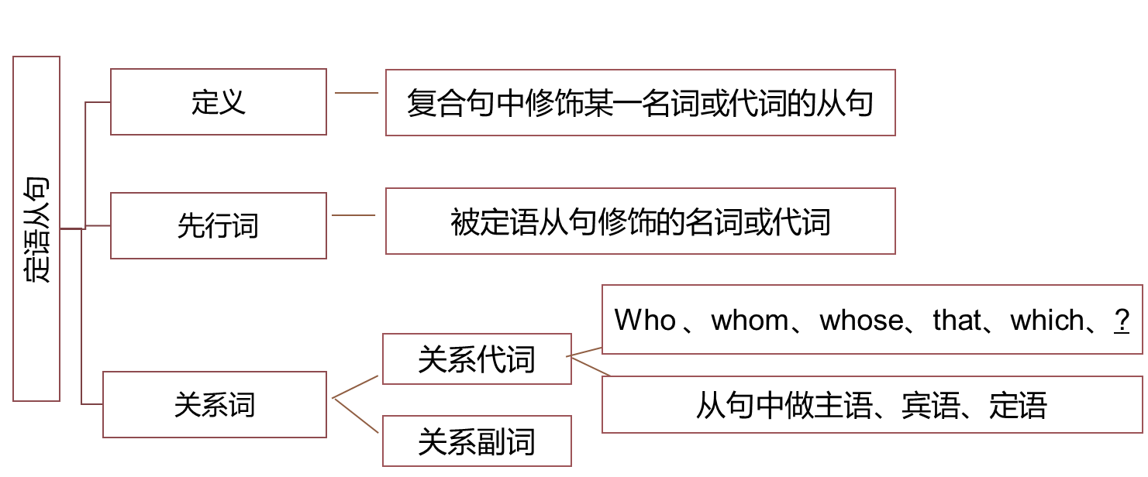

**Task 5. 课后练习**

1. The young man _____ was trapped in the lift for 3 hours is Tim.
2. I saw some trees _____ leaves were black because of the polluted air.
3. The place _______ you want to visit is far away from Xi’an
4. He saw a house _____ windows were all broken.
5. I will never forget the days _______ we spent together.
6. The earthquake ______ hit the city in 1906 was the biggest in American history.
7. Please pass me the book _____ cover is black.
8. Do you know the man _______ we saw at the hotel?
9. I’m not interested in the book ______ has just been published.
10. Mobike is a popular service _______ brings convenience to us.