小学英语六年级上第二单元 （第六课时）
小试牛刀
1. 听第7课课文录音，选择正确答案。
What happened to the little piggy?
A. He had a toothache.
B. He had a headache.
C. He had a stomachache.
正确答案：C
2. 听第7课课文录音，选择正确答案。
What did the little piggy have for lunch today?
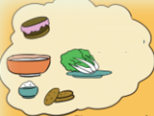 | 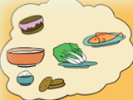 | 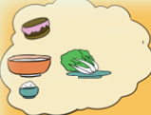
A. | B. | C.
正确答案：B
3. 看图片，选出正确选项。
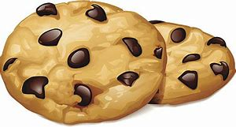 | A. sweet cakes | B. honey cookies
正确答案：B
4. 看图片，选出正确选项。
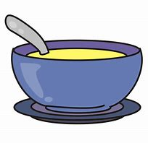 | A. a bowl of soup | B. a bowl of rice
正确答案：A
5. 读句子选择正确的图片。
You should stop eating too much candy.
A.  | B. 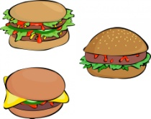
正确答案：A

6. ---What happened _______ you?
--- I hurt myself.
A. to B. of C. off
正确答案：B
7. ---What did the doctor say to you?
--- He said I should stop _________ too much Coke.
A. drink B. drinking C. eating
正确答案：B
8. If your friend had a terrible toothache, what will you advise him/her to do?
A. You should go to bed early tonight.
B. You must be more careful next time.
C. You should stop eating too much chocolate.
正确答案：C
9. If your friend hurt his / her neck, what will you advise him / her to do?
A. You should take a long walk.
B. You should go to the hospital and take an X-ray.
C. You should take some pills and have a rest.
正确答案：B
10. If your friend ate nine hamburgers, what will you advise him / her to do?
A. You should stop eating too much and exercise more.
B. You should go to the hospital and take an X-ray.
C. You should take some pills and have a rest.
正确答案：A

