**拓展提升任务——写作的审题迁移**

**任务一、阅读下面题目要求，完成分析图表，并完成写作任务。**

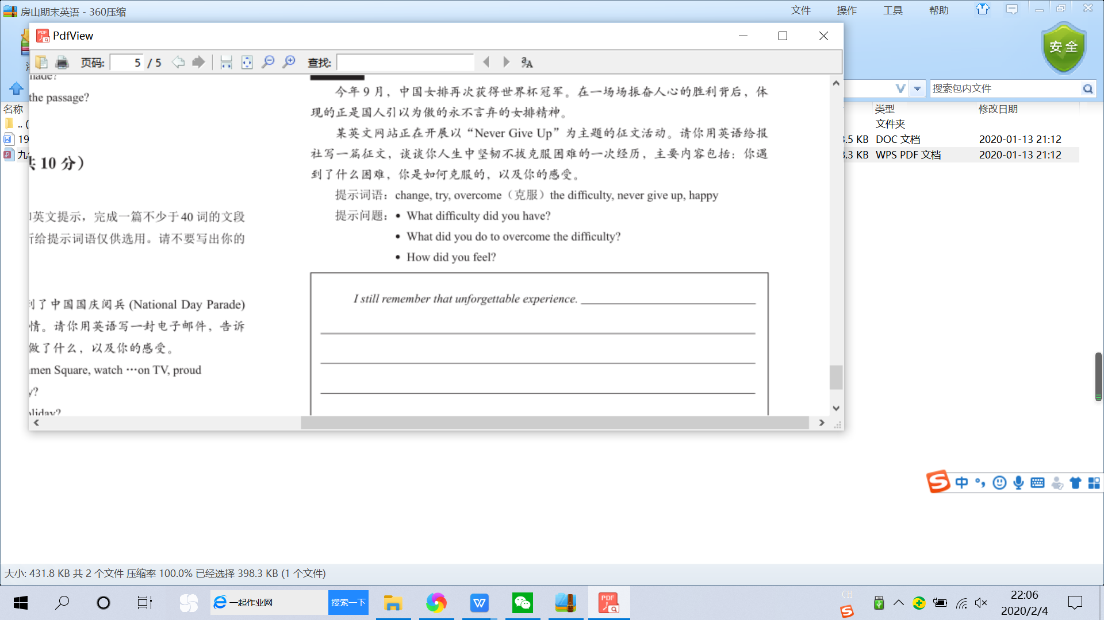

Never Give Up

话题：

表达方式

短语、句型

信息点

**正文：**

I still remember that unforgettable experience. _____________________________________

_________________________________________________________________________________________________________________________________________________________________________________________________________________________________________________________________________________________________________________________________________________________________________________________________________________________________________________________________________________________________________________________________________________________________________

**任务二、完成下面的表格，并用迁移的方法完成下面的书面表达。**

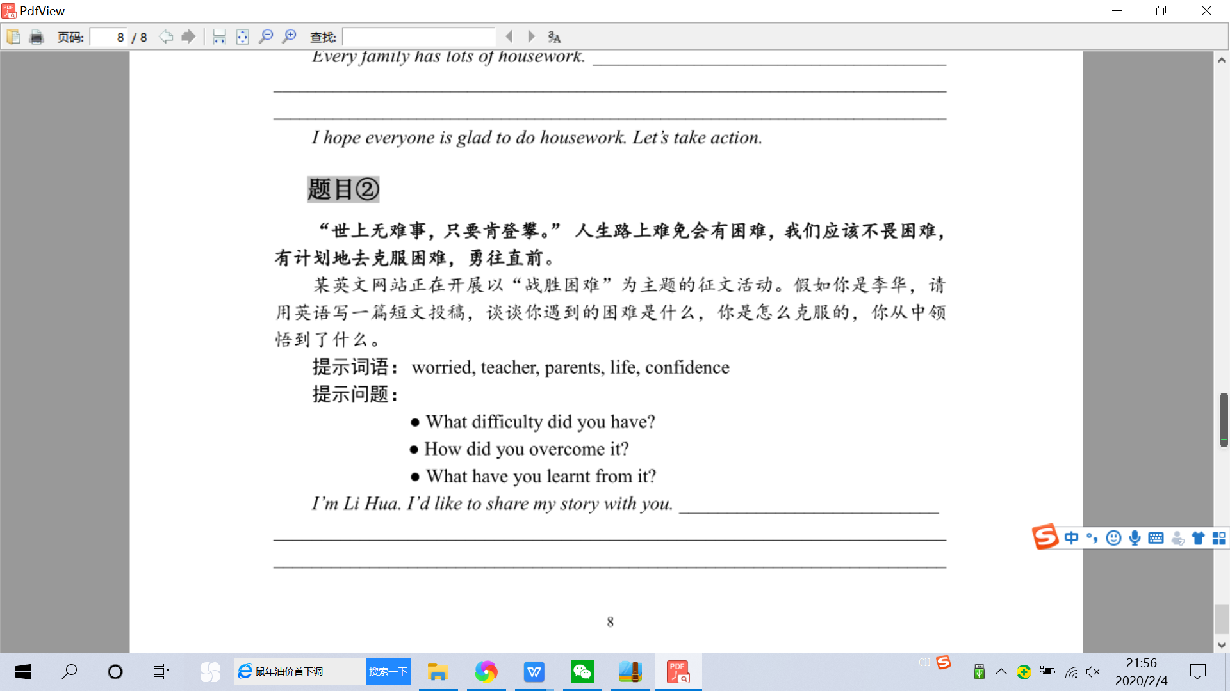

|  |  |  |  |  |
| --- | --- | --- | --- | --- |
| 书面表达 | 话题 | 信息点 | 表达方式 | 迁移点 |
| Never Give Up |  |  |  |  |
| 战胜困难 |  |  |  |

**正文：**

I’m Li Hua. I’d like to share my story with you._________________________________________

________________________________________________________________________________________________________________________________________________________________________________________________________________________________________________________________________________________________________________________________________________________________________________________________________________________________________________________________________________________________________________________________________________________________________________________________________________________________________________________