**课时作业**

**分析下面的题目要求，完成思维导图，完成两篇篇书面表达。**

**书面表达一**

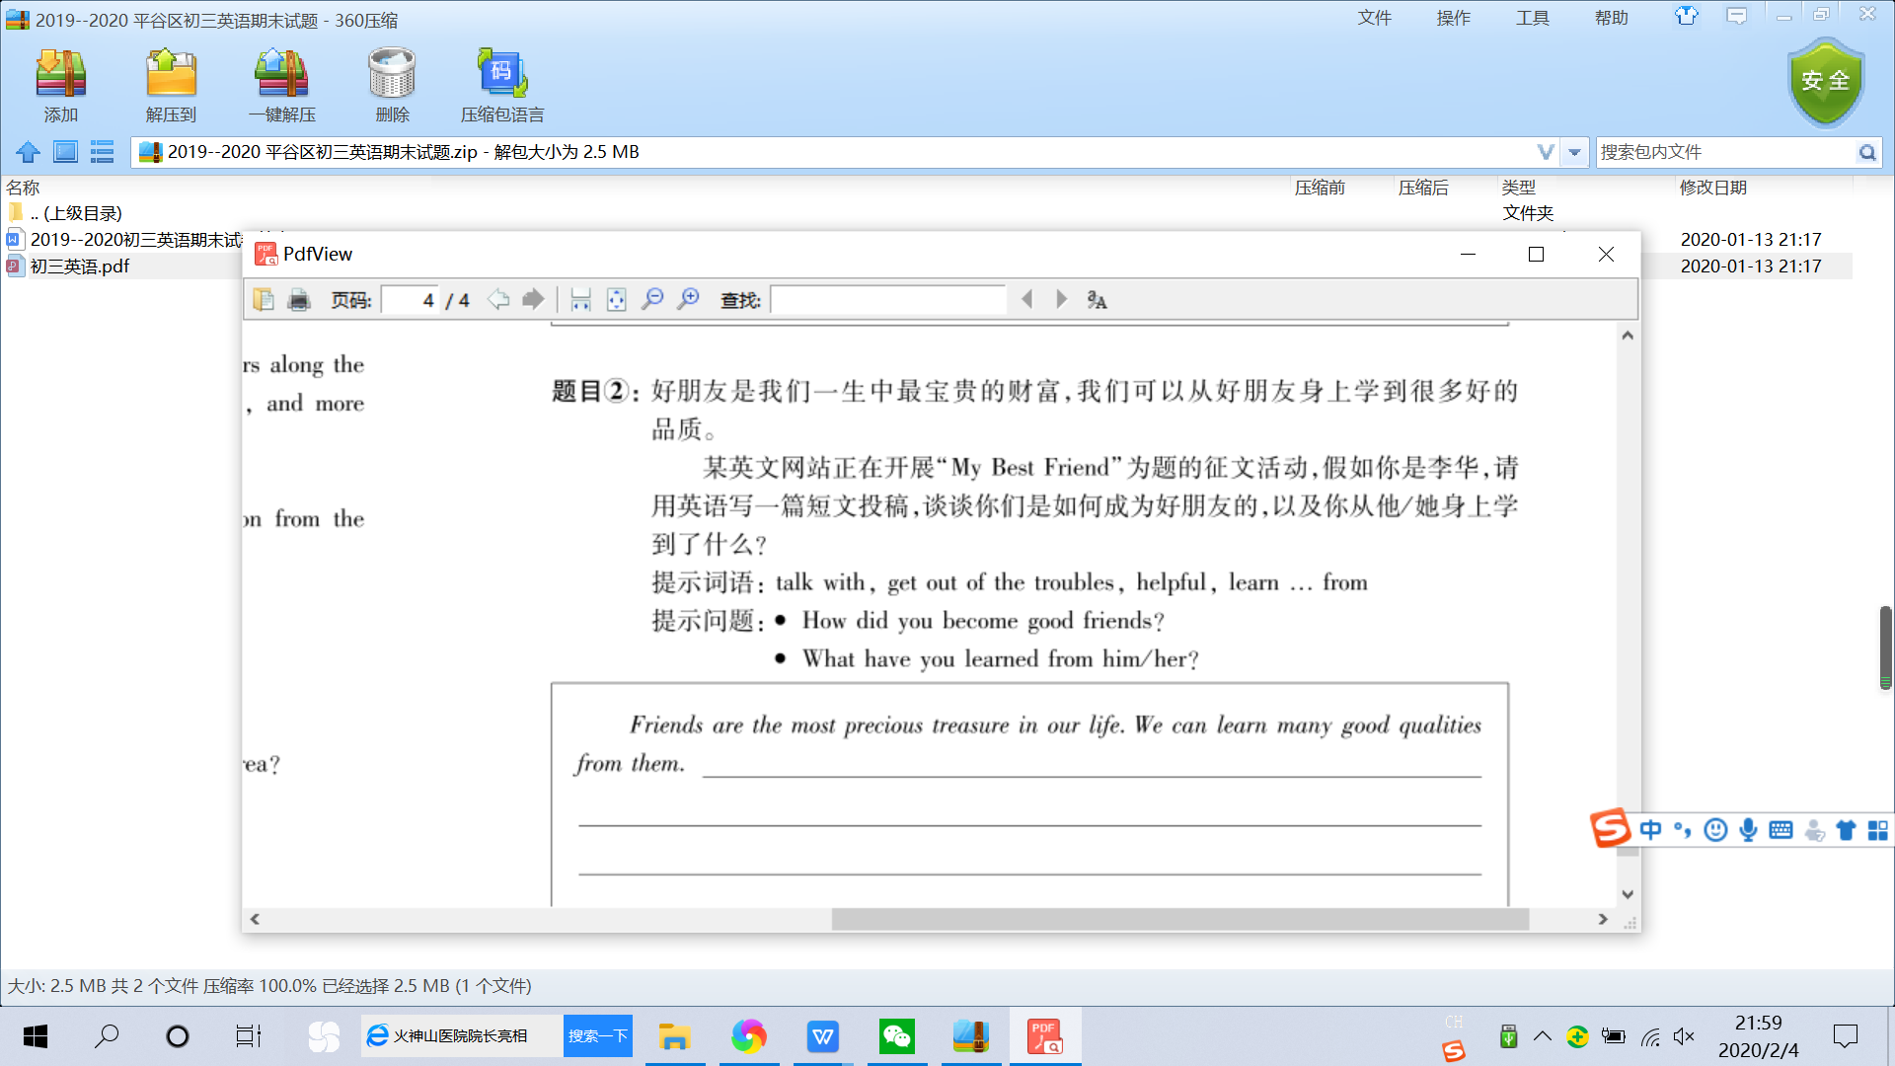

My Best friend

话题：

表达方式

短语、句型

结构安排

*Friends are the most precious treasure in our life . We can learn many good qualities from them . _____________________________________________________________________*

*___________________________________________________________________________________________________________________________________________________________________________________________________________________________________________________________________________________________________________________________________________________________________________________________________________________________________________________________________________________________________________________________________________________________________________________________________________________________________________________________________________*

**书面表达二**

“静以修身，俭以养德”，勤俭节约是中华民族的传统美德，无论生活富足与否，我们都应该提倡节俭，拒绝浪费。

某英文网站在开展以“节约是美德”为主题的征文活动，假如你是李华，请用英语写一篇短文投稿．谈谈生活中你是怎么做的，以这样做的意义。

提示词语：thrifty(节约的).save.turn off.money.virtue（美德）

提示问题：What do you do in your daily life？

Why do you do so？

It’s one of our traditional virtues to be thrifty.

结构安排

节约是美德

话题：

表达方式

短语、句型