书面表达一：

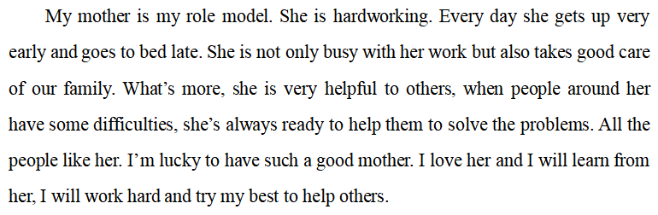

书面表达二：

*A role model in my family sets a good example for me.* My grandpa is my role model. He is a good teacher. He always works very hard at his work. He gets up early and comes home late every day. At home, he is very kind to our family members. When my neighbors have some trouble, he always gives hands to them warmly. He is very strict with me. He always helps me with my subjects patiently in his free time. In my memory, I always remember the day I got the first full mark. When I showed it to grandpa, he smiled and encouraged me to make more progress. With his help, I have overcome a lot of difficulties and learned a lot. So I have thought of my grandpa as my role model in my life.