小学英语六年级上第二单元 （第五课时）
小试牛刀
1. 听第6课课文录音，选择正确答案。
1. What happened to Yangyang?
A. He hurt his right arm.
B. He hurt his left leg.
C. He hurt his right leg.
正确答案：C
2. 听第6课课文录音，选择正确答案。
---Why did Yangyang hurt himself?
---- Because _______________.
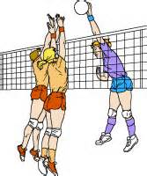 |  | 
A. | B. | C.
正确答案：B
3. 选出划线部分发音不相同的单词。
A. baby | B. sky | C. study | D. sunny
正确答案：B
4. 选出划线部分发音不相同的单词。
A. way | B. stay | C. fly | D. may
正确答案：C
5. 读句子选择正确的图片。
My cat scratched me.
A. 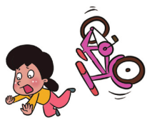 | B. 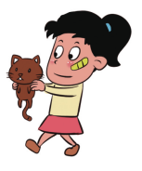
正确答案：B
6. 读句子选择正确的图片。
We had a football match yesterday morning.
A.  | B. 
正确答案：A
7. 选出不同类的单词。
A. neck | B. headache | C. leg | D. ear
正确答案：B
8. 选出不同类的单词。
A. caught | B. broke | C. go | D. hurt
正确答案：C
9. If you want to know what your friend did last night, what will you say？
A. What do you do every evening?
B. What will you do tomorrow?
C. What did you do last night?
正确答案：C
10. If there is something wrong with your friend’s arm, what will you say to him/her?
A. What happened to your arm?
B. How did that happen?
C. Are you OK?
正确答案：A

