**定语从句复习**

**[学习目标]**本节课重点复习定语从句的用法，包括关系代词和关系副词的用法。

**[学法指导]**学生通过观察、发现的学习方式复习定语从句的用法，并在语境中恰当地使用语法。

**Task 1. Read and Find:** Find the attributes in the following sentences.

1. She is a beautiful girl.

2. It is a coffee cup.

3. People in the world play basketball.

4. He has a big family to support.

5. We met a group of students returning from school.

6. He is a famous writer who comes from a small town.

**Task 2. Read and tell：  
Relative pronoun / Relative adverb?**

1. The man **who/that** is standing beside the woman is a waiter.
2. The children **whom** Mr. Black is teaching are all from Si Chuan.
3. I like the suitcase **whose** color is blue.
4. The hat **which** she bought last year is worn out.
5. I still remember the days **when** we travelled together.
6. This is the factory **where** my father works.
7. I don’t know the reason **why** you quarreled with him.

**Task 3. Practice   
Exercise 1: Fill in the blanks using the proper relative pronouns.**

1.A plane is a machine _________can fly .

2.The car __________my uncle bought last week was stolen.

3.I have a roommate _______ never cleans the kitchen.

4. I’d prefer someone ________ I have fun with.

5. It was a meeting _____ importance I did not realize at the time.

6. Our team lost the championship, ______ depressed me and my friends.

**Exercise 2: Fill in the blanks using the proper relative adverbs.**

1. The reason ____he was late was that he got up late.

2. I still remember the day _____I first came to Beijing.

3. This is the farm _________ we worked when we were young.

4. Hong Kong was under the British rule until 1997 ____ it was returned to China.

5. He got into a situation ______it is hard to decide what is right and wrong.

**Exercise 3: Finish the introduction of cities using proper relative pronouns/adverbs.**

* Beijing has many popular tourist attractions, ____ include the Great Wall, the Summer Palace, and the Forbidden City. Tourists ____ come here for the first time are amazed by the crowds, the busy streets, and the constantly changing skyline.
* Seoul is well known for its spicy food and its shopping areas, ____ you can find everything from antique pottery to custom-made clothing. The Myeong-dong area has dozens of shops ____ sell the latest fashions.
* Barcelona is famous for museums, nightlife, and seafood- and for the architect Antoni Gaudi, ____designed several of the city’s most distinctive buildings. The restaurants here stay open until midnight, ____ many locals are enjoying dinner.
* The place ____ most tourists go first in Sydney is the famous Opera House, but this Australian city also has great restaurants and museums. The spring and fall are the seasons ____ most people come to visit.

**Exercise 4: Describe the pictures using attributive clauses.**

* **Do you know these celebrities?**

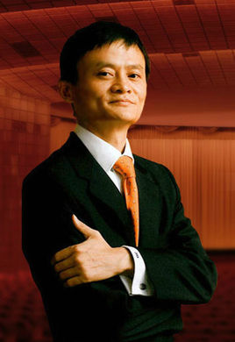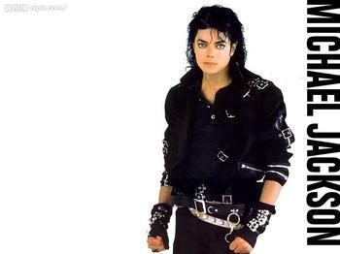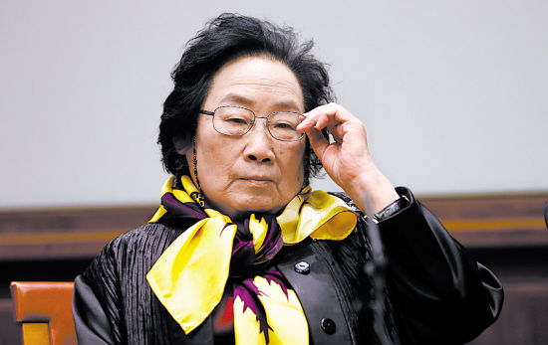

* **How do you explain it?（ that/which ）**

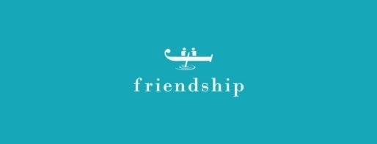

* **What can we do in these places?**

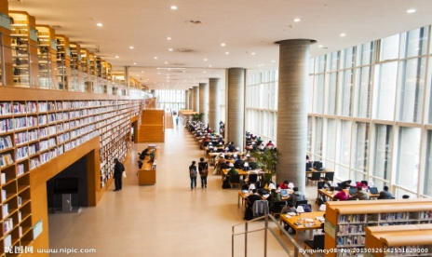

* **What is special about these days?**

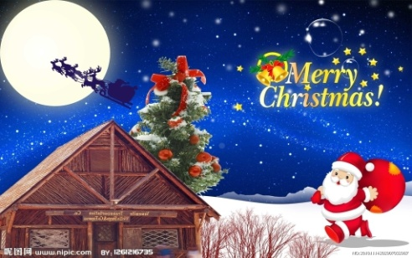

**Exercise 5: Translate the following sentences into English using proper attributive clause.**

* 1. 我喜欢有幽默感的男士。
* 2. 我昨天买了一本书，该书的作者是一位盲人。
* 3. 你昨天借给我的那本书非常有趣.
* 4. 那位老师教我英文，他来自加拿大。
* 5. 我永远不会忘记我们见面的那一天。
* 6. 告诉我今天早晨你迟到的原因。
* 7.你住的那家酒店叫什么名字？
* 8. 他是我见过的最好的老师。

**Answers:**

* 1. 我喜欢有幽默感的男士。
* I like guys who have a good sense of humor.
* 2. 我昨天买了一本书，该书的作者是一位盲人。
* Yesterday I bought a book whose author was blind.
* 3. 你昨天借给我的那本书非常有趣。
* The book that/which you lent me yesterday is very interesting.
* 4. 那位老师教我英文，他来自加拿大。
* The teacher teaches me English, who comes from Canada.
* 5. 我永远不会忘记我们见面的那一天。
* I’ll never forget the day when I met you.
* 6. 告诉我今天早晨你迟到的原因。
* Please tell me the reason why you were late this morning.
* 7.你住的那家酒店叫什么名字？
* What is the name of the hotel where you live?
* 8. 他是我见过的最好的老师。
* He is the best teacher that I have ever seen.