**小学英语六年级上第二单元 （第四课时）**

**小试牛刀**

1. 听第5课课文录音，选择正确答案。

What happened to Mike’s neck?

A. He fell off his bed and hurt his neck.

B. He stood on his head and hurt his neck.

C. He stood on his head and broke his neck.

正确答案：B

2. 听第5课课文录音，选择正确答案。

What does Mike have to do first?

|  |  |  |
| --- | --- | --- |
| th (3) | x-ray_52795 | th (2) |
| A. | B. | C. |

正确答案：B

3. 看图片，选出正确选项。

|  |  |  |
| --- | --- | --- |
|  | A. broke his arm | B. hurt his arm |

正确答案：A

4. 看图片，选出正确选项。

|  |  |  |
| --- | --- | --- |
|  | A. took an X-ray | B. had a blood test |

正确答案：B

5. 看图片，选出正确选项。

|  |  |  |
| --- | --- | --- |
|  | A. stand on his head | B. hurt his leg |

正确答案：A

6. 读句子选择正确的图片。

|  |  |
| --- | --- |
| I hurt my leg when I played basketball yesterday. | |
| A. | B. |

正确答案：B

7. 读句子选择正确的图片。

|  |  |
| --- | --- |
| I wanted to practice *kungfu*. | |
| A. https://tse2-mm.cn.bing.net/th/id/OIP.ekgcLpppnol6umcAstcu1wHaJt?w=152&h=200&c=7&o=5&pid=1.7 | B. https://tse2-mm.cn.bing.net/th/id/OIP.d-fesK3jkuMP31-s02GNDwHaFf?w=267&h=192&c=7&o=5&pid=1.7 |

正确答案：A

8. 读句子选择正确的图片。

|  |  |
| --- | --- |
| My neck aches terribly. | |
| A. https://www.infinitebodyawareness.com/wp-content/uploads/2016/11/43_hes-a-pain-in-my-neck-01.png | B. http://thumbs.gograph.com/gg60719301.jpg |

正确答案：A

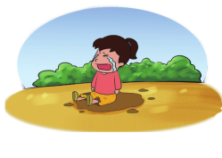9. Why did Lucy cry?

A. Because she cut her finger.

B. Because she fell over.

C. Because she fell off her bike.

正确答案：B

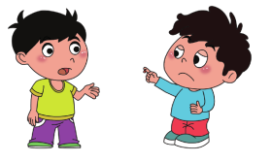10. Why did you go to hospital?

A. Because I hurt my leg.

B. Because I wanted to practice *kungfu*.

C. Because I cut my finger.

正确答案：C