**小学英语五年级上第二单元（第六课时）**

**小试牛刀**

1. wash the clothes的正确理解是

A. 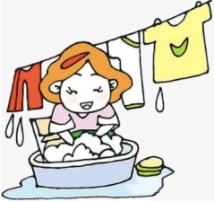 B. 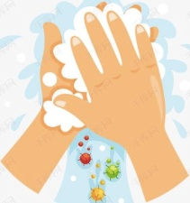 C. 

正确答案：A

2. Which room is clean and bright?

正确答案：C

3. We should always __________.

A. keep our room dirty B. keep our room tidy C. keep our room messy

正确答案：B

4. - ____________________ Shall we fix it this afternoon?

- Yes, let’s.

A. The chair is broken.

B. The bike is broken.

C. The car is broken.

正确答案：B

5. - ____________________ Shall we water them this evening?

- Yes, let’s.

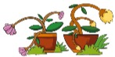A. The plants are wet.

B. The plants are dry.

C. The plants are beautiful.

正确答案：B

6. - The room is messy. ____________________

- Yes, let’s.

A. Shall we tidy our room now?

B. Please don’t tidy our room.

C. We should keep it dirty.

正确答案：A

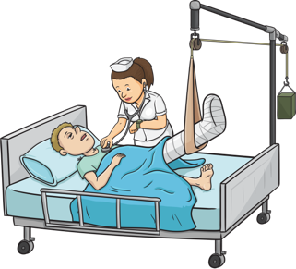7. - Uncle Tom hurt his leg. ____________________

- Yes, let’s.

A. He should have a good rest.

B. Please don’t go to see him.

C. Shall we go to see him this Sunday?

正确答案：C

8. - The windows are dirty. Would you please clean the window with me?

- ____________________

A. No problem.

B. Yes, I do.

C. Sorry, you can’t.

正确答案：A

9. - Can I go out and play?

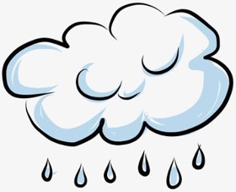 - ____________________

A. Certainly.

B. No, you can’t.

C. Sorry. It’s raining outside.

正确答案：C

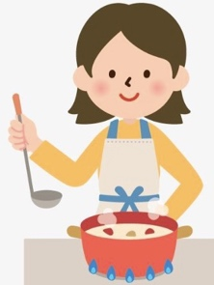10. - Shall we cook dinner now?

- ____________________

A. Yes, I do.

B. No, you can’t.

C. Yes, let’s.

正确答案：C