**小学英语五年级上第二单元（第五课时）**

**小试牛刀**

1. finish my homework的正确理解是

A.  B. 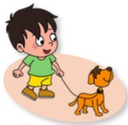 C. 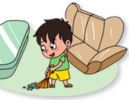

正确答案：A

2. use my computer的正确理解是

C. 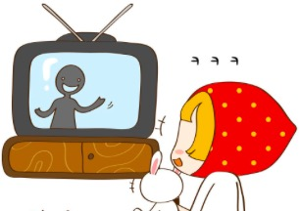

正确答案：B

3. - ____________________

- Sorry, I can’t. I must stay at home and wait for my brother.

A. Do you like to play football?

B. Can I play football?

C. Would you like to play football with me?

正确答案：C

4. - ____________________

- Sorry, you can’t. Dad is watching the news.

A. Do you like to watch the cartoons?

B. Can I watch the cartoons?

C. Would you like to watch the cartoons?

正确答案：B

5. We should be __________ when we ask for help.

A. worried B. happy C. polite

正确答案：C

6. - Would you please pass me the crayons?

- ____________________

A. Yes, let’s.

B. No, you can’t.

C. Here you are.

正确答案：C

7. - Would you like to fly a kite with me?

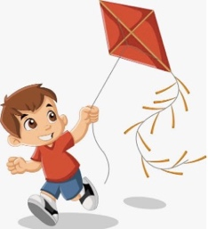 - ____________________

A. Yes, I’d love to.

B. No, I don’t like to fly a kite.

C. Sorry, you can’t.

正确答案：A

8. - May I use your ruler?

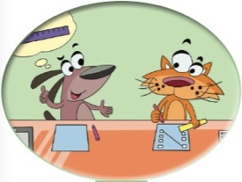 - ____________________

A. No problem.

B. Yes, I do.

C. Thank you.

正确答案：A

9. - Can I open the gift box?

- ____________________

A. No, you can’t.

B. Sorry. It’s not for you.

C. No! It’s not yours.

正确答案：B

10. - Can I copy your homework?

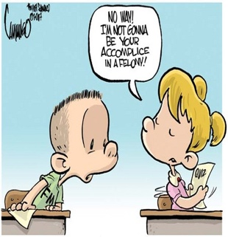 - ____________________

A. Yes, please.

B. No, you can’t.

C. Sorry, you can’t. You should do it on your own.

正确答案：C