**小学英语五年级上第二单元（第四课时）**

**小试牛刀**

1. tidy the room的正确理解是

A.  B.  C. 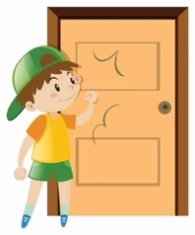

正确答案：B

2. walk the dog的正确理解是

A.  B.  C. 

正确答案：A

3. Would you like to come to my party?对应的图片是

A. 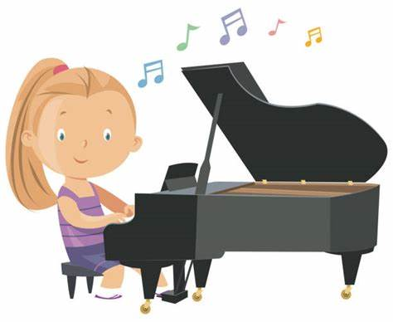 B. 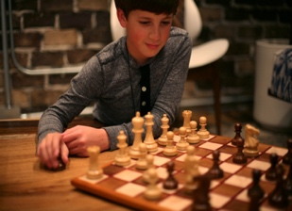 C. 

正确答案：C

4. - __________ to play basketball with me?

- Yes, I’d love to.

A. Would you like B. Do you like C. Can I

正确答案：A

5. - __________ to read books?

-Yes, I do.

A. Would you like B. Do you like C. Can I

正确答案：B

6. - Would you like to draw pictures with me?

- ____________________.

A. No, I don’t. B. Yes, I do. C. Yes, I’d love to.

正确答案：C

7. - Do you like playing the piano?

- ____________________.

A. Yes, I do. B. Yes, I’d love to. C. Sorry, you can’t.

正确答案：A

8. 你想邀请别人来你家做客，你会说：

A. Would you like to come to my house?

B. Can I go to your house?

C. Do you like to come to my house?

正确答案：A

9. 你想请别人帮你拿着书，你会说：

A. Hold the books for me.

B. Would you please hold the books for me?

C. Do you like to hold the books?

正确答案：B

10. 你想借用一下别人的电脑，你会说：

A. My computer doesn’t work.

B. Would you like to use my computer?

C. May I use your computer?

正确答案：C