四年级第三单元（第五课时）
小试牛刀
一、选择恰当单词。
1. Would you mind _____ on the radio?
A. turn B. turning
正确答案：B

2. Could you please _____ the door for me?
A. open B. opening
正确答案：A

3. Would you mind _____ this bag, please?
A. holding B. hold
正确答案：A

4. Would you mind _____ me the water?
A. pass B. passing
正确答案：B

5. Would you please _____ me how to make it?
- Show B. showing
正确答案：A

二、读对话，根据对话内容选择合适的语句。
A. Of course not.
B. Thank you, you are so kind.
C. Yes, of course.
D. Would you please hold these books for me?
E. Would you mind turning on the light for me?
6. 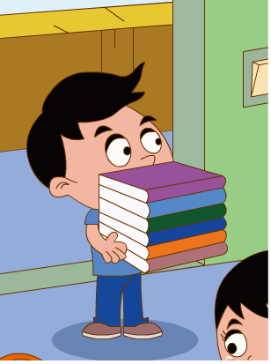 | A: ____________________  B: Sure, no problem.  正确答案：D
7. 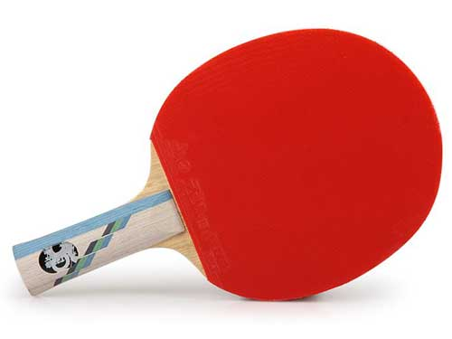 | A: Can I borrow you ping-pong bat?  B: ___________________.Here you are.  正确答案：C
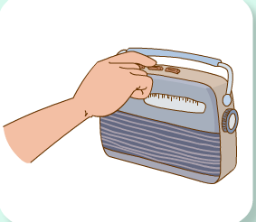  8. | A: Would you mind turning off the radio?  B: _______________________.  正确答案：A
9． 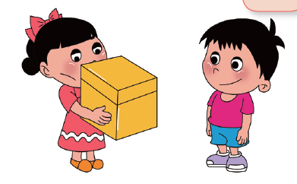 | A: Do you want me to carry this box for you?  B: _________________.  正确答案：B
10．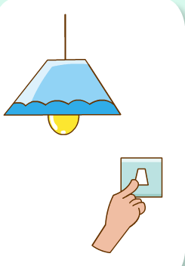 | A: ____________________.  B: Sure, no problem.  正确答案：E

