**四年级第二单元（第四课时）**

**小试牛刀**

1. 帮助单词找到自己的家。
2. A. pet B. cake C. be



正确答案：A

1. A. father B. rabbit C. again

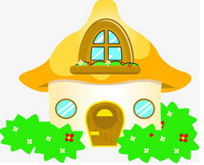

正确答案：B

1. 选出恰当的短语。

3. 看一看( )

A. have a look B. a new robot C. do housework

正确答案：A

4. 稍等( )

A. a new robot B. do housework C. hold on

正确答案：C

5. 一个新的机器人( )

A．a new robot B. do housework C. hold on

正确答案：A

6. 做家务( )

A. have a look B. a new robot C. do housework

正确答案：C

三、读句子，选择。

7. - Hello. May I speak to Tom? This is Linda.

- ____________

1. Speaking. B. Hello. My name is Tom.

正确答案：A

8. - Will you bring your new books to school?

- ___________

1. Yes, I will. B. No, I’m not.

正确答案：A

9. - I have a bad cold. I can’t go to school tomorrow.

-____________

1. I’m happy to hear that. B. I’m sorry to hear that.

正确答案：B

10. - Hi. This is Miss Wang. Who is calling?

- ____________

1. I’m Tina. B. This is Tina speaking.

正确答案：B