**阅读理解—议论文拓展提升任务**

**A （西城统练）**

The rising costs of health care have become a problem for many countries in the world. To deal with this problem, it is recommended that a big part of the government's health budget be used for health education and disease prevention instead of treatment. Actually, many kinds of diseases are preventable in many ways and preventing a disease is usually much cheaper than treating it. For example, people could avoid catching a cold if they dressed warmly when the weather starts getting cold. But many people get sick because they fail to do so, and have to spend money seeing a doctor

Daily habits like eating more healthy food would have kept millions of families from becoming bankrupt if the patients had taken measures for early prevention. For instance, keeping a balanced diet, such as not consuming too much animal fat and insuring a steady intake of vegetables and fruits, seems to be quite important.

One very effective and costless way of prevention is regular exercise, which is necessary for a healthy mind and body. Regular exercise, such as running, walking, and playing sports is a good way to make people feel better or reduce stress

In addition, health education plays a key role in improving people's health. By giving people more information about health, countries could help people understand the importance of disease prevention and ways to achieve it. For example, knowing one's family medical history is an effective way to help keep healthy. Information about health problems among close relatives will make them aware of what they should do to prevent certain diseases through lifestyle changes, which will work before it is too late

However, stressing disease prevention does not mean medical treatment is unimportant. After all, prevention and treatment are just two different means toward the same effect. In conclusion, we could save money on health care and treat patients more successfully if our country spends more money on health prevention and education

1. What’s the best title of the passage?

A．Prevention or Education? B．Prevention or Treatment?

C．Health or Illness? D．Exercise or Illness?

2. Which of the following can replace the underlined word “bankrupt”?

A．Unable to be cured B．Unable to pay one’s debts

C．Stronger than ever before D．More successful than ever before

3. We learn from the passage that ____.

A．dressing warmly can prevent diseases

B．a balanced diet is cheaper than regular exercise

C．the more health education, the better

D．the government’s health budget should be increased

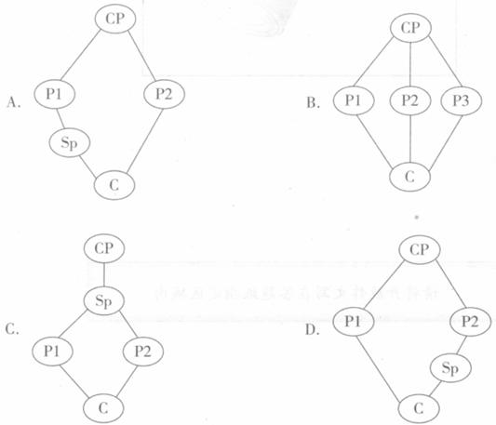4. Which of the following shows the structure of the passage?

CP (Central Point) P (Point) Sp (Sub-point次要点) C (Conclusion 结论)

**B （13年东城一模）**

The Commonwealth games have meant that the eyes of the world have been focused on our fair city—Melbourne. And it would look pretty good, wouldn’t it? And what better way to regain our title as world’s most liveable city? I’m told that we recently lost the right to say this to foreign friends proudly when the international list was re-examined and we slipped to the fourth place.

It’s hard to see how Melbourne could have lost its crown (桂冠) when you look at what it has to offer. 24 hours Coles, free transport for drunks on New Year’s Eve, a new freeway, it’s all here.

The first focus for the international press will obviously be the endless stadiums dotted around the city. But as well as being full every other weekend, these great places often play host to slightly older kids. At Rod Laver, even the olds get a look-in as the Christian evangelical (教会的) road show rolls into town once a year for a night of stadium worship (崇拜).

Another pleasure Melbourne enjoys is that it’s very easy to get around. There’s a bit of a squeeze during rush hour for sure, but nothing like Bangkok, where the journey home can take longer than growing a beard and parking is barely distinguishable from the drive itself. Driving here is a piece of cake. It must be because the wise people who hand out the taxis seem to actively encourage a career behind the wheel within 24 hours of landing in the country as an educational tool for getting to know the city. No slowing down for learning bends, just go, go, go!

As for the social life, with over 40 million bars in Melbourne’s CBD alone, we have plenty of places for spectators to celebrate national victory, making this town as good as any and it happens 24 hours a day, 7 days a week.

Unfortunately, the athletes themselves don’t get to smell the roses to the same degree. But the rest of the world will know that this is the place to be. The most liveable city in the world. By far the easiest place on earth to cheat death, which is essentially what we’re talking about.

5. In Paragraph 1 and 2 the author is wondering _____.

A. how Melbourne has fallen behind

B. when the international list was re-examined

C. what they should do to regain the world’s focus

D. whether Melbourne can offer greater convenience

6. What does the author mainly want to show in the passage?

A. The casual life styles of Melbourne.

B. The various social activities in Melbourne.

C. The competitive advantages of Melbourne.

D. The convenient transportation in Melbourne.

7. From the underlined sentence, we can infer the athletes _____.

A. have minimum social activities

B. take no interest in the beauty of the city

C. are forbidden to live in the busy city centre

D. are unwilling to celebrate the victory publicly

8. Which of the following shows the structure of the passage?

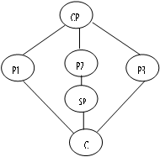 A. B.

CP

P3

P1

P4

P2

C

C. D.

CP

P3

P1

P2

C

CP

P2

SP1

P1

SP2

P3

C

CP: Central Point P: Point Sp: Sub-point (次要点) C: Conclusion

**C（15年北京卷）**

**How Room Designs Affect Our Work and Feelings**

Architects have long had the feeling that the places we live in can affect our thoughts, feelings and behaviors. But now scientists are giving this feeling an empirical(经验的，实证的) basis. They are discovering how to design spaces that promote creativity, keep people focused and lead to relaxation.

Researches show that aspects of the physical environment can influence creativity. In 2007, Joan Meyers-Levy at the University of Minnesota, reported that the height of a room's ceiling affects how people think. Her research indicates that higher ceilings encourage people to think more freely, which may lead them to make more abstract connections. Low ceilings, on the other hand, may inspire a more detailed outlook.

In additions to ceiling height, the view afforded by a building may influence an occupant's ability to concentrate. Nancy Wells and her colleagues at Cornell University found in their study that kids who experienced the greatest increase in greenness as a result of a family move made the most gains on a standard test of attention.

Using nature to improve focus of attention ought to pay off academically, and it seems to, according to a study led by C. Kenneth Tanner, head of the School Design & Planning Laboratory at the University of Georgia. Tanner and his team found that students in classrooms with unblocked views of at least 50 feet outside the window had higher scores on tests of vocabulary, language arts and maths than did students whose classrooms primarily overlooked roads and parking lots.

Recent study on room lighting design suggests than dim(暗淡的) light helps people to loosen up. If that is true generally, keeping the light low during dinner or at parties could increase relaxation. Researchers of Harvard Medical School also discovered that furniture with rounded edges could help visitors relax.

So far scientists have focused mainly on public buildings. "We have a very limited number of studies, so we're almost looking at the problem through a straw(吸管)," architect David Allison says. "How do you take answers to very specific questions and make broad, generalized use of them? That's what we're all struggling with."

1. What does Joan Meyers-Levy focus on in her research?

A. Light. B. Ceilings. C. Windows. D. Furniture.

1. The passage tells us that ______.

A. the shape of furniture may affect people's feelings

B. lower ceilings may help improve students' creativity

C. children in a dim classroom may improve their grades

D. students in rooms with unblocked views may feel relaxed

1. The underlined sentence in the last paragraph probably means that ______.

A. the problem is not approached step by step

B. the researches so far have faults in themselves

C. the problem is too difficult for researchers to detect

D. research in this area is not enough to make generalized patterns

12. Which of the following shows the organization of the passage?

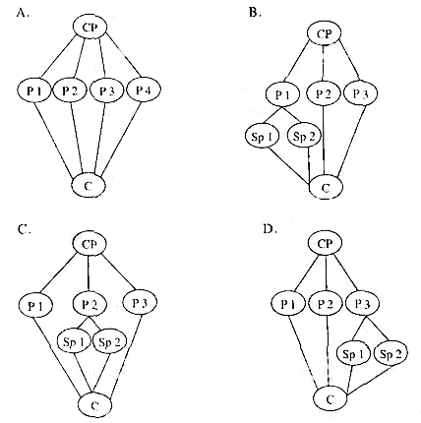

CP: Central Point P: Point SP: Sub-point(次要点) C: Conclusion

**Integrity（2017海淀一模）**

Integrity is the quality of being honest and strong about what you believe to be right. The concept of integrity has played a key role in moral philosophy throughout history and is promoted in all societies because of its importance to social relations. Individual integrity is vital to society, one that enables people to make use of their capacity for critical reflection, does not force people to take up particular roles and does not encourage individuals to betray each other. Besides, societies can be favorable to the development of individual integrity.

Individual integrity can lift up the spirits of the entire society. It can shape the lives of people living in a particular society, the lives of all fellow people and, in its broadest sense, even the destiny(命运) of a nation. By contrast, if those living in the society are corrupt, it could have bad effects, jeopardizing the healthy morality of the society.

On the other hand, a society can be favorable to the development of individual integrity. Society expects and requires integrity. A society consisting of people of integrity, and people who never compromise on their principles, could have a positive mark on the personal development of its members. Being a part of such a morally lively community could serve as a basis for absorbing traits of good character. This could be of a distinct advantage to any individuals in the society.

However, some social structures are of the wrong sort for some individuals to pursue(追求) integrity. If that is the case, we have to ask questions about the moral nature of society first before raising questions about individual integrity. Questions about integrity may turn out to be about what kind of society it is, rather than about the relationship between individual interests and characteristics of a society. The pursuit of adequate individual integrity often depends, not so much on understanding who one is and what one believes and is committed to, but rather understanding what one’s society is and imagining what it could be.

Under no circumstances can we underestimate the importance of human integrity in a society. People, who are honest, trustworthy, compassionate and caring, are the factors decisive in the growth of individuals as well as the development of a society.

13. Individual integrity has been valued in society because ______.

A. it helps develop philosophy

B. it is the basis of critical thinking

C. it is important to social relations

D. it ensures people’s particular roles

14. The underlined word “jeopardizing” in Paragraph 4 probably means ______.

A. destroying B. strengthening C. assessing D. influencing

15. The writer believes that ______.

A. social structures guide the formation of individual integrity

B. the nature of society is decided by economic development

C. the pursuit of individual integrity changes with time

D. individual integrity depends on what one believes

16. Which of the following shows the development of ideas in this passage?

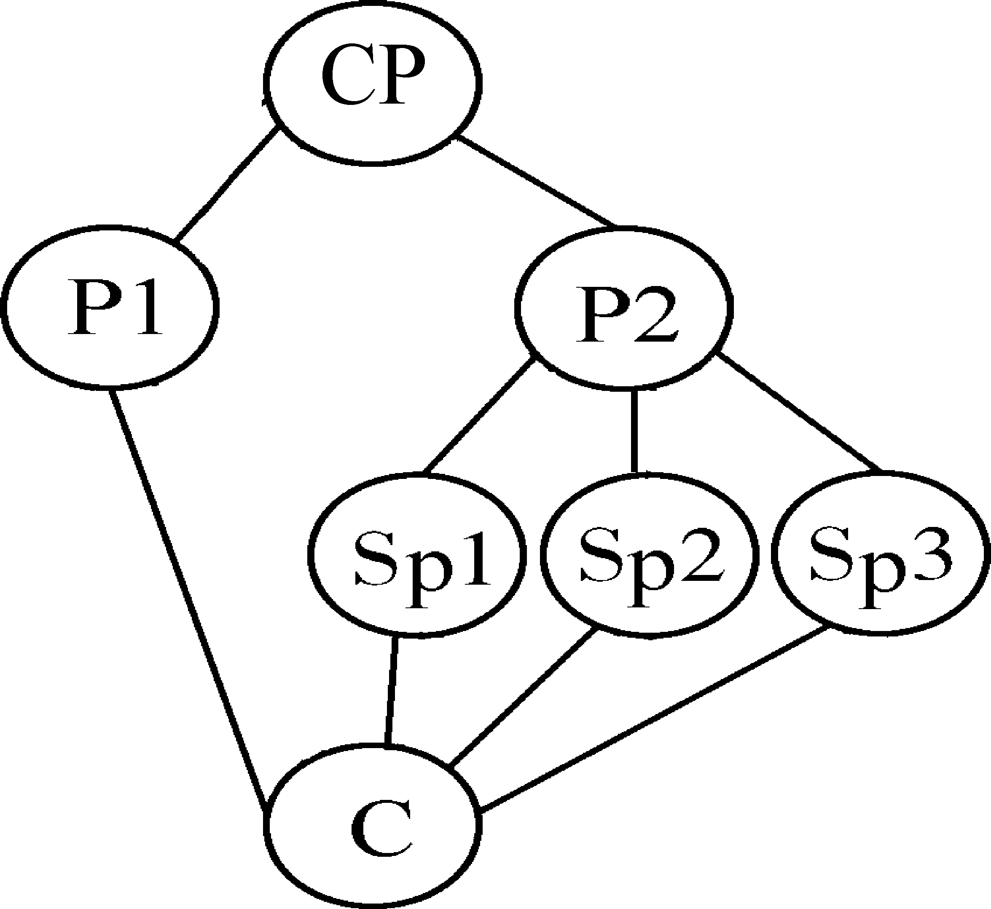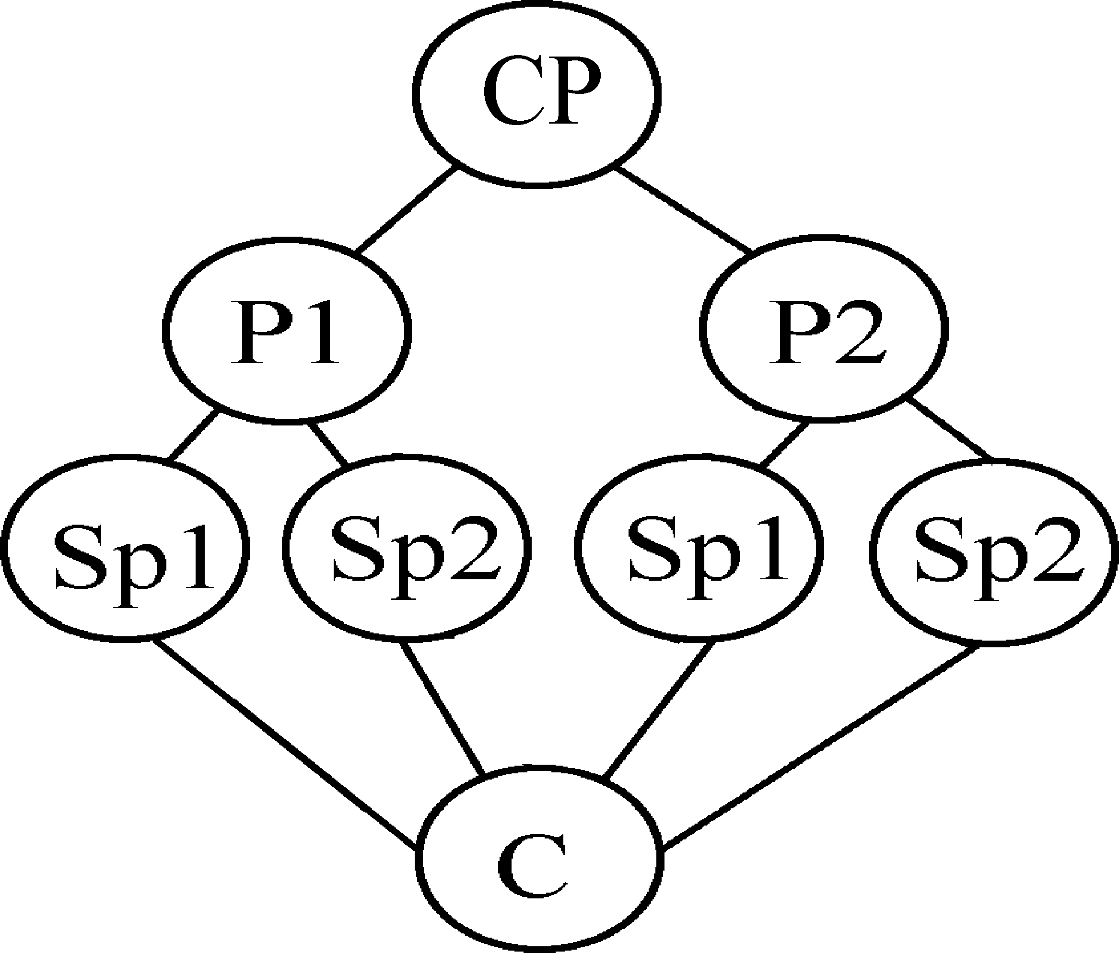

A. B.

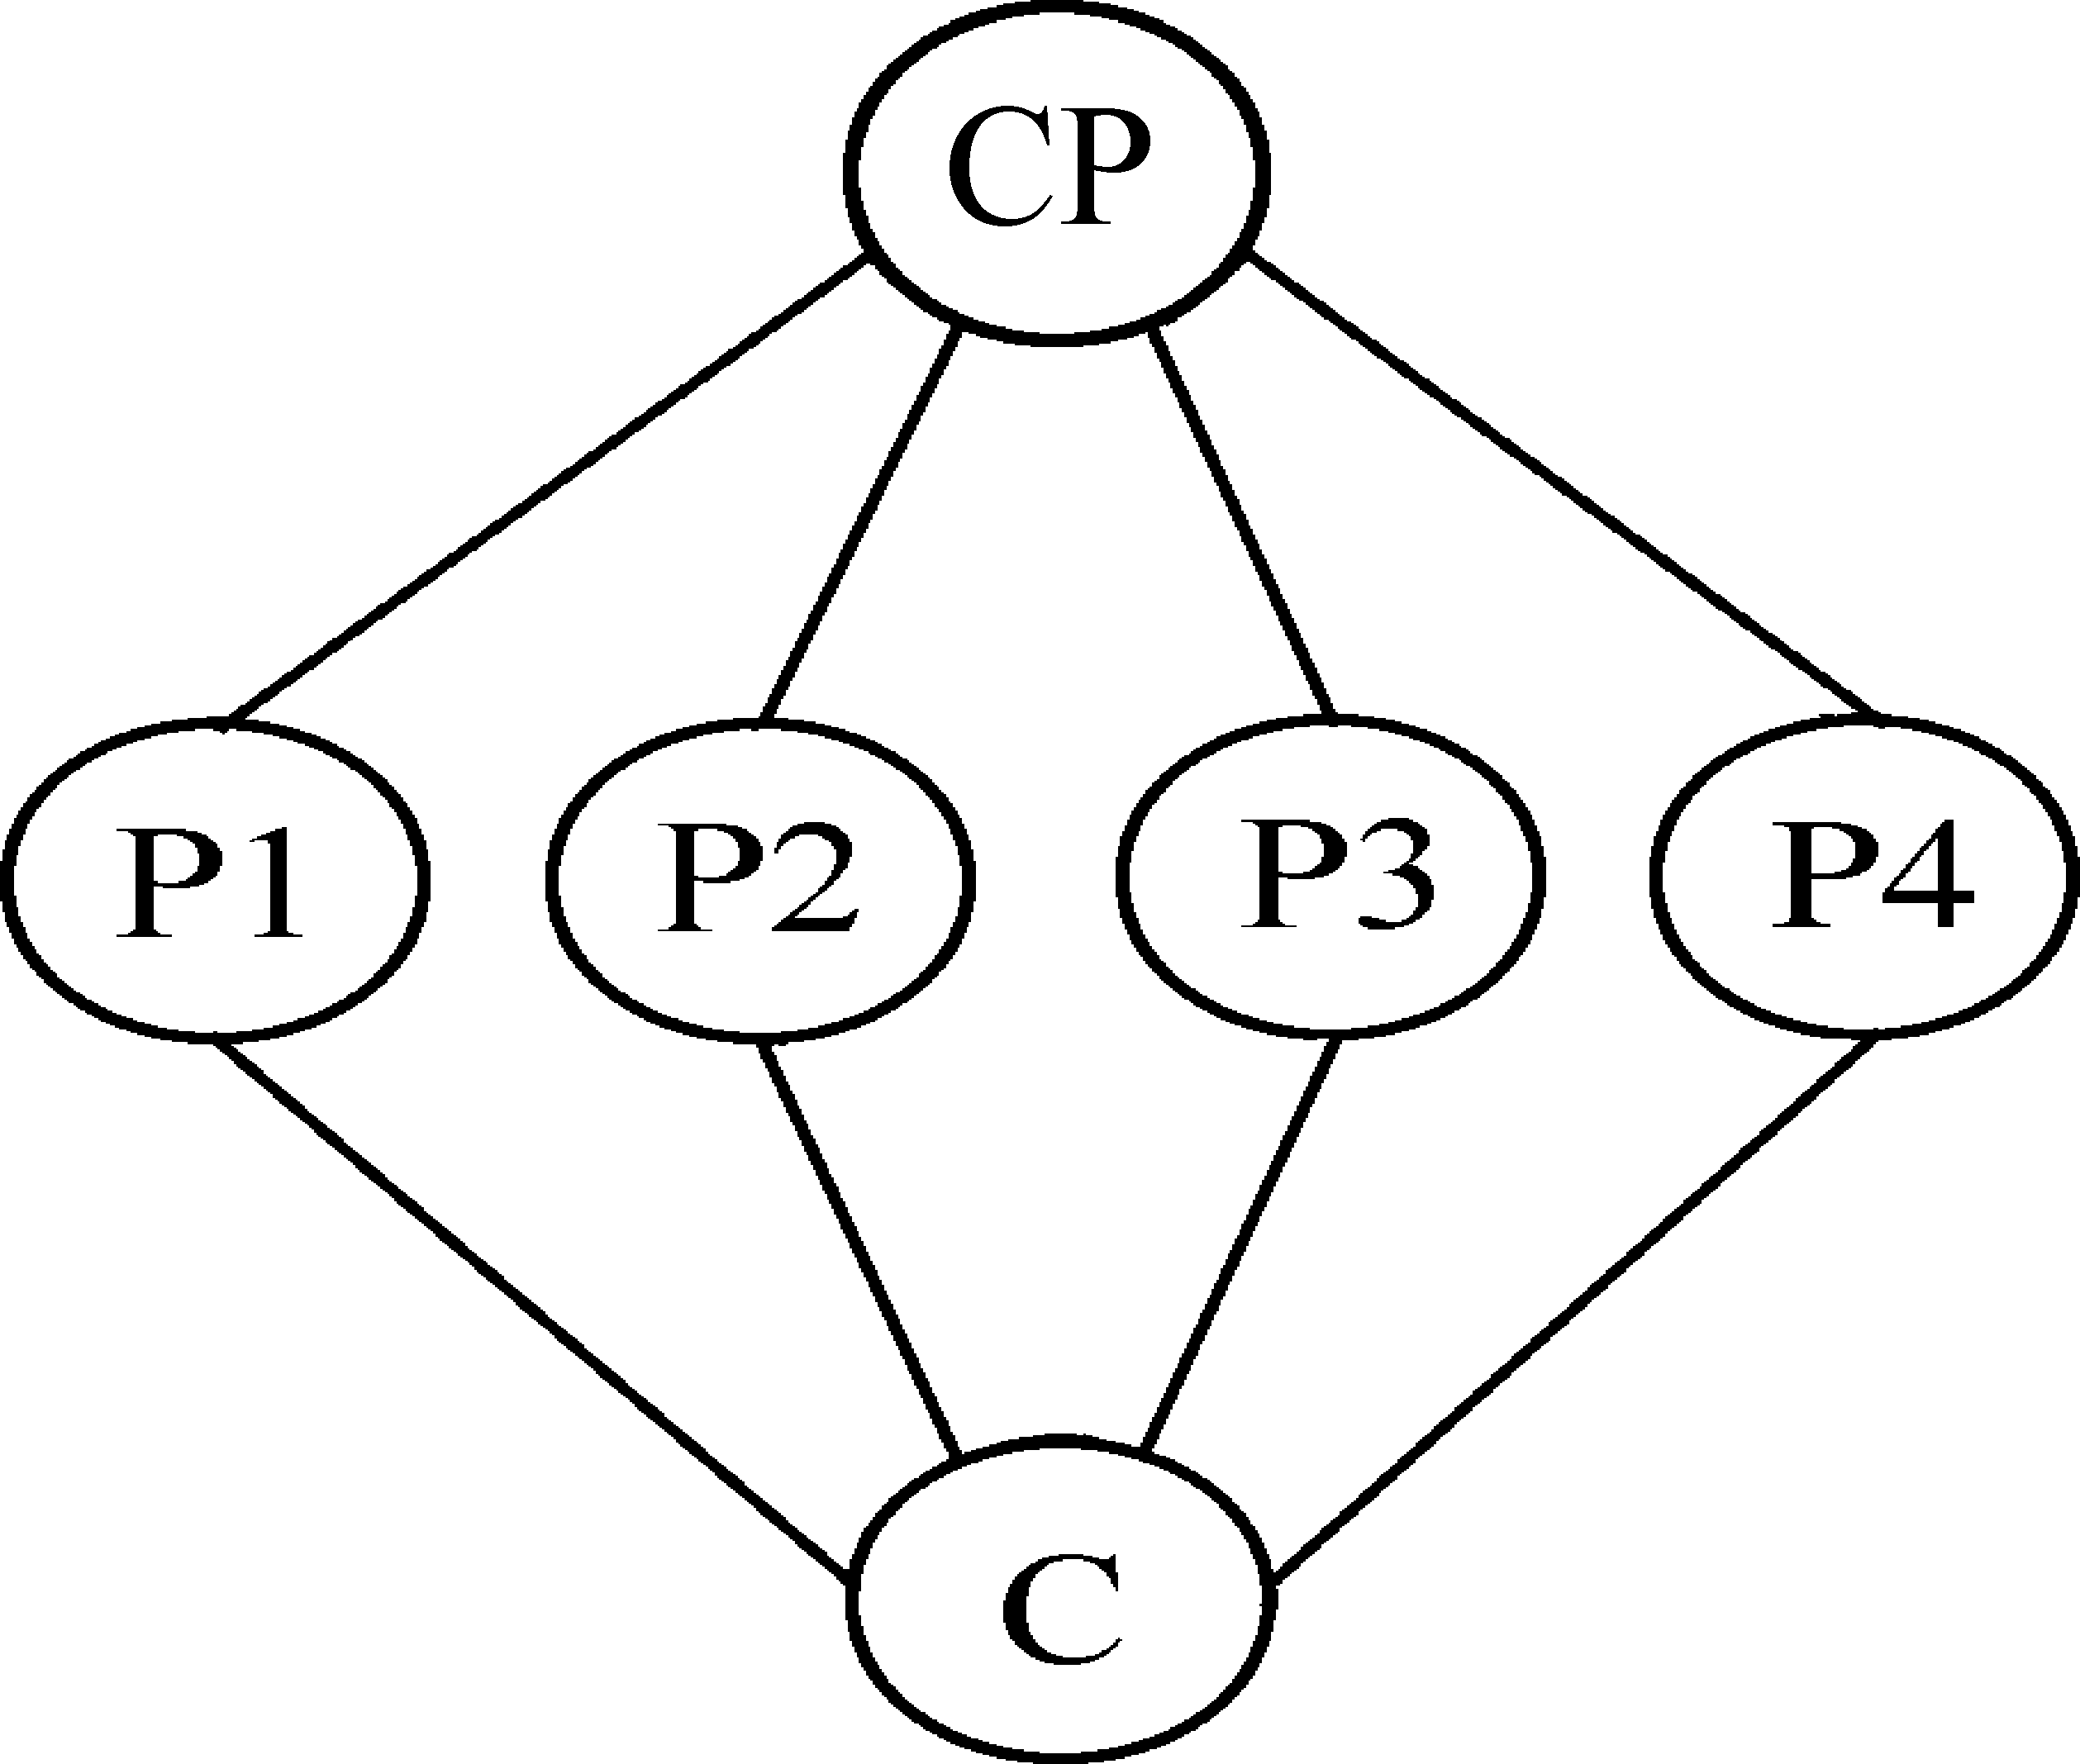

C.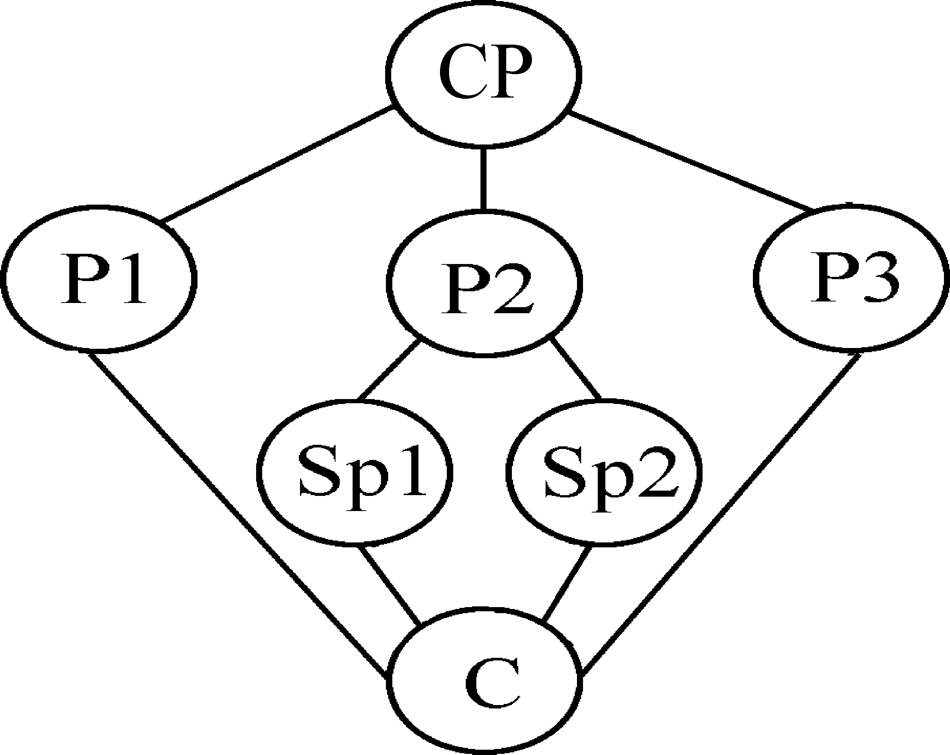 D.

CP: Central Point P: Point Sp: Sub-point(次要点) C：Conclusion