语法《不定式》
【学习目标】
- 了解不定式的基本结构，分析在句子中承担的成分；
- 了解不定式在不同的时态和语态中的变化形式；
- 完成与不定式相关的习题和造句。

【学法指导】
动词不定式infinitive，为非谓语动词。在英语语法中，动词不定式是指动词中的一种不带词形变化从而不指示人称、数量、时态的一种形式。它之所以被称做不定式，是因为动词不被限定，或者说不被词形变化所局限。不定式属于非谓语动词形式。
动词不定式在句中可以作句子除谓语之外的任何句子成分，但它毕竟是动词，所以有动词的属性。动词不定式及其短语还可以有自己的宾语、状语，虽然动词不定式在语法上没有表面上的直接主语，但它表达的意义是动作，这一动作一定由使动者(动词的使用者)发出。这一使动者(动词的使用者)我们称之为逻辑主语。
在学习的时候，同学们可以和非谓语动词的其他形式，如doing和done进行比较学习，也可以通过推敲和背诵经典例句，一通百通，形成语感。

一、不定式结构：to + verb
- 句子成份：
subject （主语）
predicative （表语）
attributive （定语）
object （宾语）
object complement（宾语补足语）
adverbial （状语）
- 否定式: not to do

二、不定式的句子成分
1. It is a huge job to control Yellow River erosion. =To control Yellow River erosion is a huge job.
2. The best way to learn a foreign language is to make friends with a foreigner.
3. This helps to develop local economies.
I found it necessary to talk to him again.
4. This has destroyed almost all the land, and has forced many local farmers to move to other areas.
5. On land with rich soil, local farmers can grow crops to make a living.
Visitors from all over the world now come to admire this great achievement.
6. He didn’t know what to say.
How to solve the problem is very important.
My question is when to start.

三、不定式的时态 & 语态
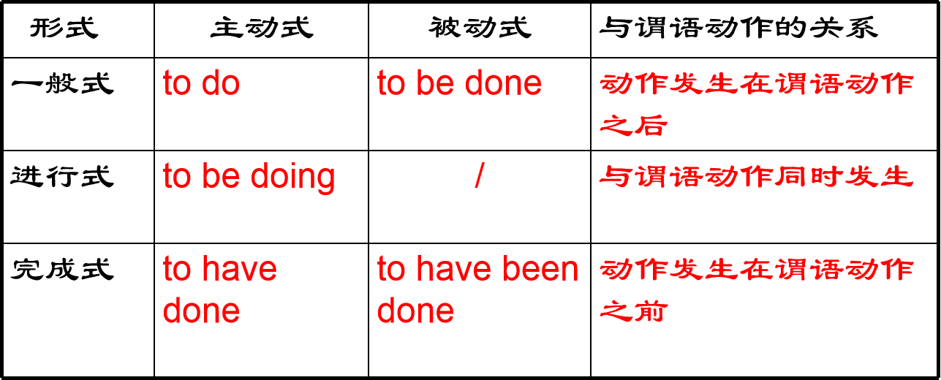

- 不定式的时态
㈠. 一般式( to do ).
1. I opened the door to enter the room.
2. Mr. Smith is going to attend the meeting to be held tomorrow.
㈡.进行式 (to be doing)
1. I am very glad to be working with you.
2. He is said to be studying abroad.
㈢.完成式（to have done)
1. I am sorry to have kept you waiting so long.
2. You seemed to have read the novel written by Mr. Smith.

- 不定式的语态
㈠.主动式( to do / to be doing /to have done)
- We want to learn English well.
- He is the first student to have got the prize.
- We didn’t expect you to be waiting for us here.
- She wished to have been reading as much as the others.

㈡.被动式( to be done / to have been done)
- He didn’t like to be laughed at.
- The chairman announced the meeting to be started.
- The news reporters hurried to the airports, only to be told the film star had left.
- Do let your mother know all the truth. She appears to have been told everything.

四、链接高考
- But some students didn't want _______ (wear) the uniform.(2019浙江卷)
- Picking up her“Lifetime Achievement”award，proud Irene declared she had no plans ________（retire） from her 36-year-old business.(2019全国卷II)
- On our way to the house，it was raining so hard that we couldn't help wondering how long it would take ________（get）there.(2019全国卷III)

