**8年级英语第10课时**

**《复合句大家族 —“宾”客到，齐喝彩》拓展资源**

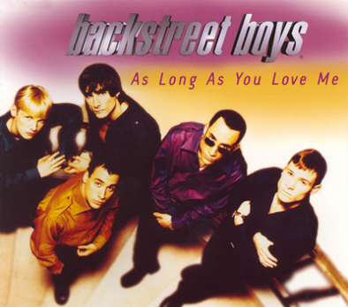**填歌词并学唱歌曲**

（备注：听歌曲请按Ctrl键同时点击此**[链接](http://www.kugou.com/song-36/b0rl1c.html?from_360" \l "hash=4F46579AC8F5B835634C3D1812BD2A15&album_id=0)）**

**As long as you love me**.

歌手：Backstreet Boys

Although loneliness had always been a friend of mine,

I'm leaving my life in your hands,People say I'm crazy that I'm blind,Risking it all in a glance.How you got me blind is still a mystery,I can't get you out of my head.Don't care what is written in your history,As long as you're here with me.I don't care \_\_\_\_\_ \_\_\_\_\_ \_\_\_\_\_,\_\_\_\_\_ \_\_\_\_\_ \_\_\_\_\_ \_\_\_\_\_,\_\_\_\_\_ \_\_\_\_\_ \_\_\_\_\_.As long as you love me.\_\_\_\_\_ \_\_\_\_\_ \_\_\_\_\_,\_\_\_\_\_ \_\_\_\_\_ \_\_\_\_\_ \_\_\_\_\_,Don't care \_\_\_\_\_ \_\_\_\_\_ \_\_\_\_\_,As long as you love me.Every little thing that you've said and done.

Feels like it's deep within me.  
Doesn't really matter if you're on the run.  
It seems like we're meant to be.

I don't care \_\_\_\_\_ \_\_\_\_\_ \_\_\_\_\_,\_\_\_\_\_ \_\_\_\_\_ \_\_\_\_\_ \_\_\_\_\_,\_\_\_\_\_ \_\_\_\_\_ \_\_\_\_\_.As long as you love me.\_\_\_\_\_ \_\_\_\_\_ \_\_\_\_\_,\_\_\_\_\_ \_\_\_\_\_ \_\_\_\_\_ \_\_\_\_\_,Don't care \_\_\_\_\_ \_\_\_\_\_ \_\_\_\_\_,As long as you love me.

As long as you love me.  
As long as you love me.  
[I've](https://www.baidu.com/s?wd=I've&tn=SE_PcZhidaonwhc_ngpagmjz&rsv_dl=gh_pc_zhidao" \t "https://zhidao.baidu.com/question/_blank) tried to hide it so that no one knows.  
But I guess it shows.  
When you look into my eyes.  
What you did and where you're coming from.  
I don't care

As long as you love me, baby!

I don't care \_\_\_\_\_ \_\_\_\_\_ \_\_\_\_\_,\_\_\_\_\_ \_\_\_\_\_ \_\_\_\_\_ \_\_\_\_\_,\_\_\_\_\_ \_\_\_\_\_ \_\_\_\_\_.As long as you love me.\_\_\_\_\_ \_\_\_\_\_ \_\_\_\_\_,\_\_\_\_\_ \_\_\_\_\_ \_\_\_\_\_ \_\_\_\_\_,

Don't care \_\_\_\_\_ \_\_\_\_\_ \_\_\_\_\_,

Who you are.  
Where you're from.  
What you did.  
As long as you love me.  
Who you are.  
Where you're from.  
As long as you love me.  
Who you are.  
As long as you love me.  
What you did.  
I don't care.  
As long as you love me.