**8年级英语第10课时**

**《复合句大家族 —“宾”客到，齐喝彩》学习指南**

【**学习目标**】

1. **能说出宾语从句的定义和三要素，能总结出三要素的相关要点。**
2. **能在实际应用中正确运用宾语从句。**

【**学习任务单**】

**任务一: 找一找,请划线标出龟兔赛跑故事中含有宾语从句的句子。**

**The Tortoise and the Hare**

Long long ago in a forest, a small get-together of animals

was taking place. The hare said that he could beat anyone in

the forest. The elephants thought that the hare would win.

Suddenly a tortoise appeared from the crowd, he disagreed

with the hare and wanted to have a race with him.The race

began. At first, the other animals didn't know if the tortoise

could win. They just watched. The hare ran quickly , but he

had a rest under a tree and fell asleep. The tortoise ran

slowly but he kept walking. At last, the tortoise won. Do you

know why the tortoise could win?

**任务二: 请完成宾语从句小结。**

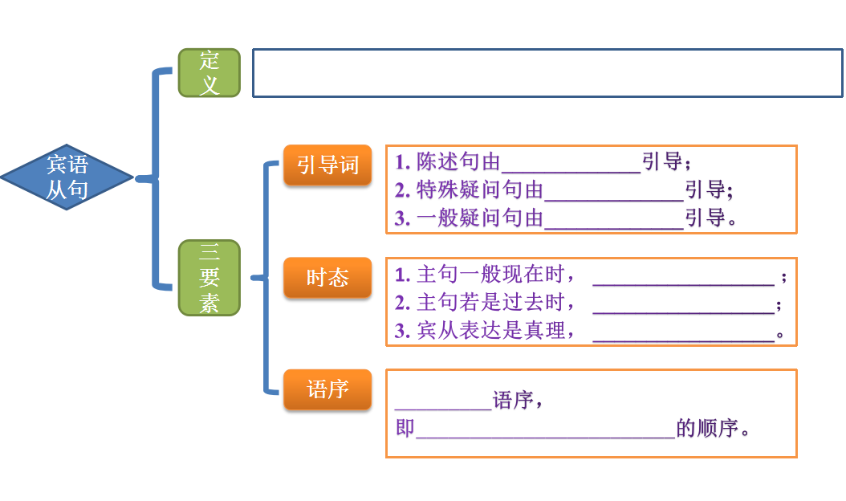

**任务三: 请选择方框中合适的词完成以下日记。**

**how old, if, that, where, when**

I had a very strange dream last night. I dreamt I met an alien! I

asked him 1. ______ he was from . He told me 2. ______ he was

from Mars and he won a competition to visit the earth. I asked him

3.______ he was and he told me he was 500 years old. Then I

asked him 4. ______ he was going back to Mars. He said he did not

know. He asked me 5.______ I would like to visit Mars one day.

Then I heard my mum calling me, “ Wake up, William. Time for

school!” What a strange dream!

**任务四：观察图片（视频中）及提示词，用宾语从句完成下面的故事。**

**The Little Horse and the River**

One day, the mother horse asked __________________________________

(if , mill flour磨面粉). The mill(磨坊）was on the other side of a river. The little

horse wanted to help his mother, but he was not sure _______________________

(if, go through). The old cow said that ___________________(river, not deep).The squirrel told the little horse that ___________________(river, dangerous).The

mother horse suggested the little horse should think about ________________

(the others, say).Do you know ____________________ (how, the little horse)? I

think _____________________(meaningful).