**小学英语三年级上第三单元（第五课时）**

**小试牛刀**

1. 读句子，选择。
2. - When _________ you born?

-I _________ born on August 12th.

A was /were B were/was

正确答案： B

1. Which month is it?

A March B May

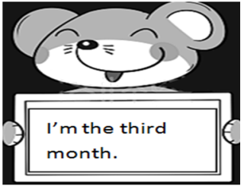

正确答案：A

1. Which month is it?

A March B May

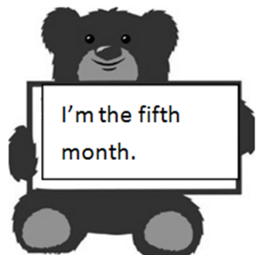

正确答案： B

4. Which month is it?

A. August B January

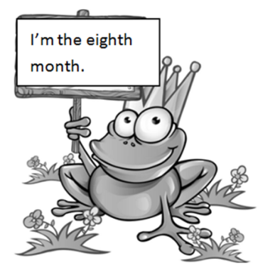

正确答案：A

二、读对话，选择正确答案。

Mary: How old are you, Fangfang?

Fangfang: I’m five. How old are you Jim?

Jim: I’m nine. How old are you, Tom?

Tom: I’m eight. How old are you, Mary?

Mary: I’m three.

5．为Tom选择生日蛋糕和蜡烛 （ ）

|  |  |  |  |
| --- | --- | --- | --- |
| A | B | C | D |
| 1580696792(1) | 1580696869(1) | 1580696934(1) | 1580697066(1) |

正确答案：C

6．为Jim选择生日蛋糕和蜡烛 （ ）

|  |  |  |  |
| --- | --- | --- | --- |
| A | B | C | D |
| 1580696792(1) | 1580696869(1) | 1580696934(1) | 1580697066(1) |

正确答案：B

7．How old is Fangfang? （ ）

A She is five.

B She is six.

正确答案： A

8. Who is three years old? （ ）

A Tom B Mary

正确答案：B

9.听课文录音Lesson 9-Lesson 11，有感情地朗读课文、词汇和短句，注意发音和语调。

10.尝试用英语说一说自己的生日日期，介绍一下爸爸妈妈的生日日期。