小学英语三年级上第二单元（第四课时）
小试牛刀
- 判断两个单词划线的部分发音是否相同。
- chair hair
A 发音相同 | B发音不相同
正确答案：A
- care are
A 发音相同 | B发音不相同
正确答案：B
3. pear bear
A 发音相同 | B发音不相同
正确答案：A
4. where were
A 发音相同 | B发音不相同
正确答案：B

二、读句子，选图片。
5. It is the last day of December.
A | B  | C
正确答案：A

6. What is the date today? It’s April the fifteenth.
A | B | C
正确答案：B
7. Today is June 20th . It’s our football day.
A | B | C
正确答案：C

三、阅读短文，回答问题。
Mike and Amy are good friends. They like sports. They are going to have their sports day on October 10th. Mike can run fast, so he is going to run a race. Amy jumps high so she is going to do the high jump. John can jump far and he is going to do the long jump. Lucy likes skipping rope and she is going to jump the rope. Their friend Sam is going to jump the rope, too.
8. When will they have Sports Day?
A December 10th B October 10th
正确答案： B
9. What is Mike going to do on sports day?
A | B | C | D
 |  | 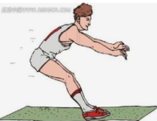 | 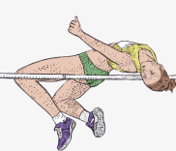
正确答案： B
10. What is Amy going to do on sports day?
A | B | C | D
正确答案：D

