1. 看一看小火车被挡住了哪一节车厢，请你选出来。

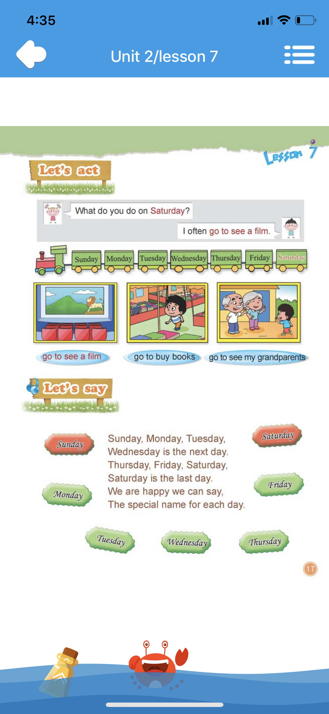

**Saturday**

A. Wednesday B. Winter

正确答案：A

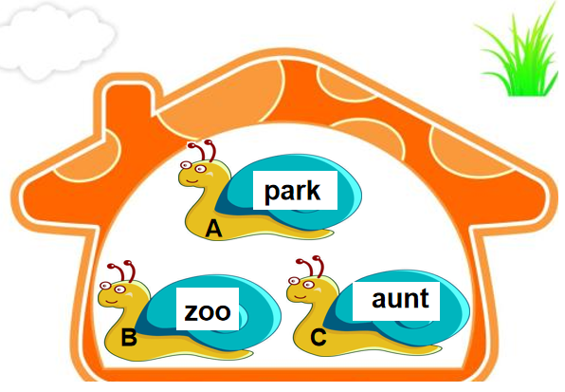

1. 哪只蜗牛找错家了？请你告诉它。

A. park

B. zoo

C. aunt

正确答案：C

1. 请你猜一猜。

She is your mother’s mother. Who is she?



A. B. C.

正确答案：B

1. 以下地点，我们去哪里可以买到很多书呢？

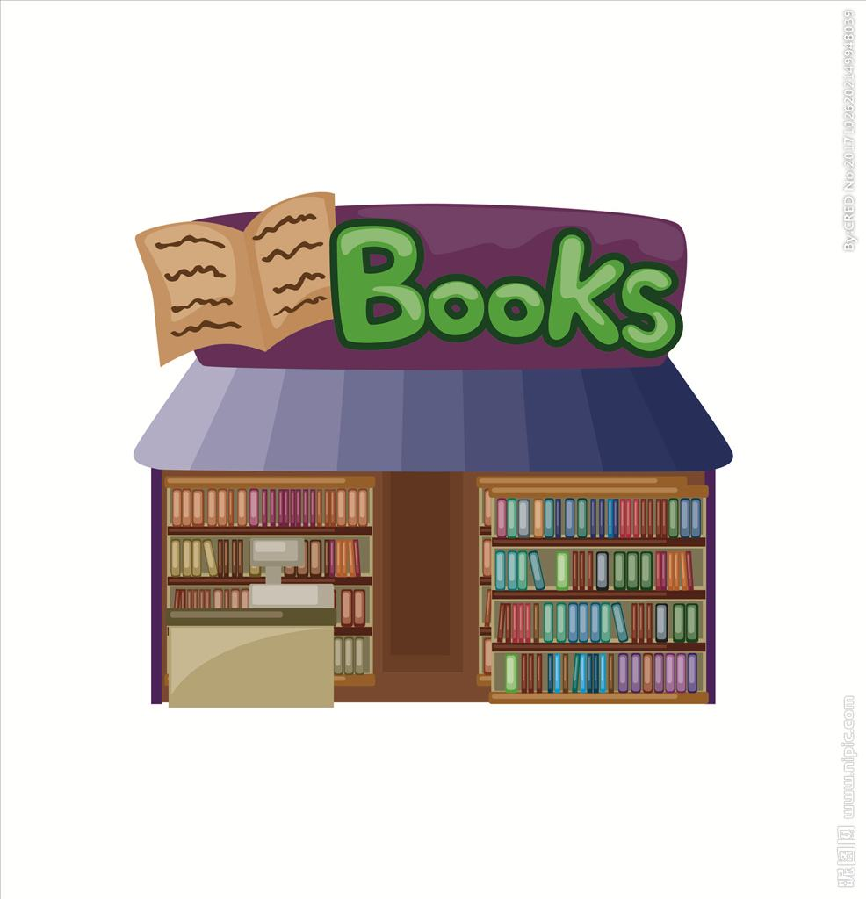

A. B. B. C.

正确答案：B

1. 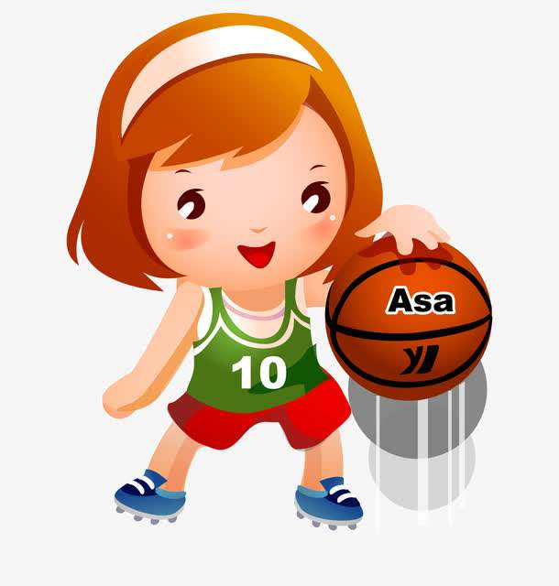看图片，给问句选择一个合适的答语。

Does Jane read books on Friday?

A. Yes, she does.

B. No, she doesn’t.

正确答案：B

1. 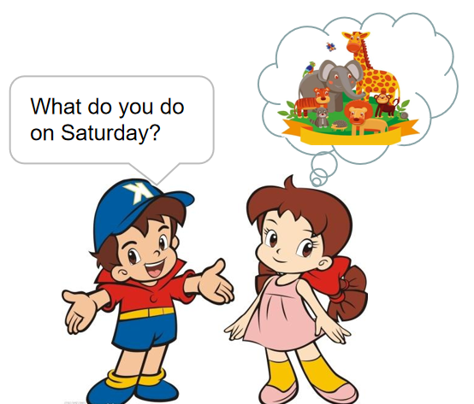请你根据图片，选择正确的句子。

A. I go to the farm on Saturday.

B. I go to the park on Saturday.

C. I go to the zoo on Saturday.

正确答案：C

1. 请你读一读，看哪位同学说的对？

A. There are six days in a week.

B. Saturday is the last day of the week.

正确答案：B

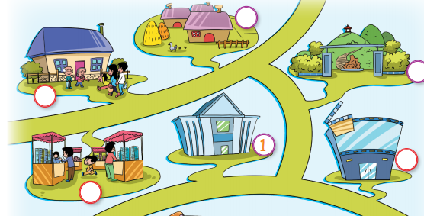

1. 根据图片判断句子对错。

There is a cinema in the picture.

A.√         B.×

正确答案：A

1. 读句子，选择正确的图片。

Mike likes reading very much. He often goes to buy books on Sunday.

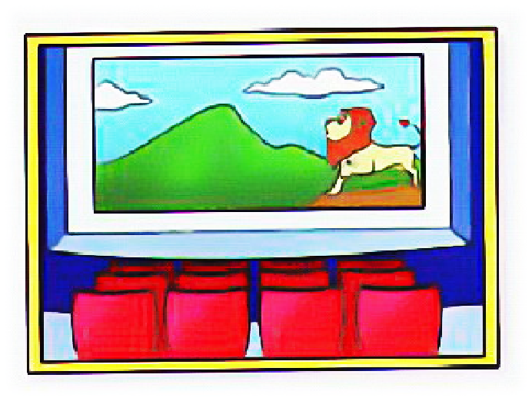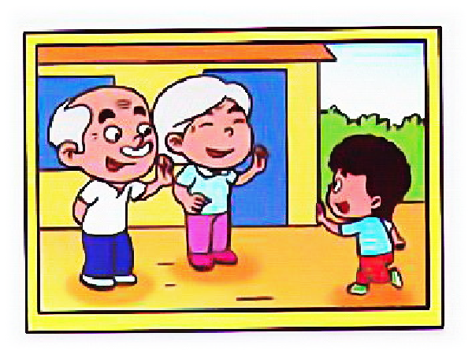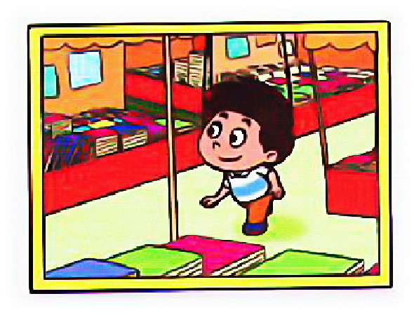

A. B.  C.

正确答案：C

1. 请认真阅读短文，回答问题。

What does Tom do in the afternoon?

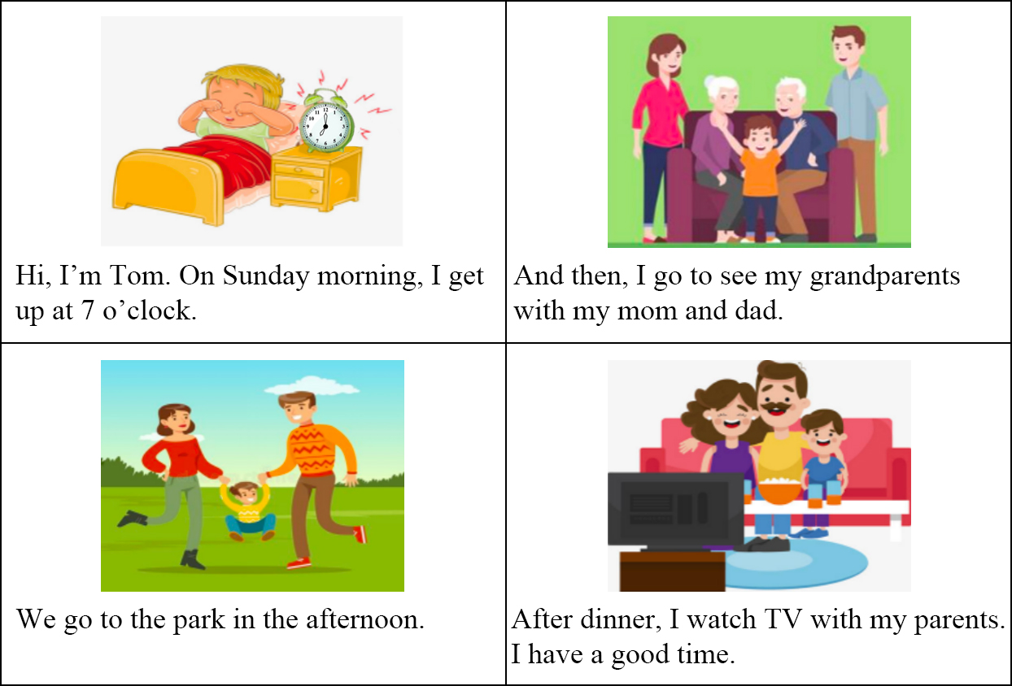A. He goes to see his grandparents.

B. He goes to the park.

C. He goes to the museum.

正确答案：B