1. 请选择正确的单词，将句子补充完整。

Sunday, Monday, Tuesday, ______ is the next day.

A. Thursday B. Friday C. Wednesday

正确答案：C

2. 请选择正确的单词，将句子补充完整。

________ is the last day of the week.

A. Monday B. Saturday C. Sunday

正确答案：B

1. 根据图片，选择正确的答语。

What do you do on Saturday?

A. I go to the zoo.

B. I read some books.

C. I draw pictures.

正确答案：C

1. 根据句子描述，选择正确的图片。

I go to the cinema on Sunday.

|  |  |  |
| --- | --- | --- |
|  |  |  |
| A | B | C |

正确答案：B

1. 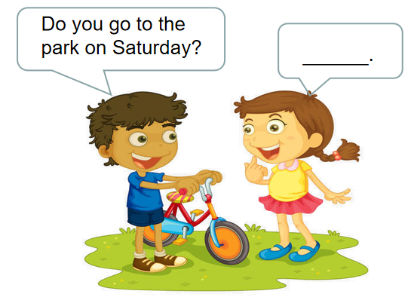Lucy如何回答Tom的问题呢？请你选择一个正确的答语。
2. I’m Lucy.
3. I read some books.
4. Yes, I do.

正确答案：C

1. 请你选择一个和图片相符的句子。
2. I go to see my grandparents.
3. I go to see my aunt.
4. I go to see my uncle.

正确答案： A

1. 读句子，根据句子的提示，选择正确的图片。

Mary likes animals. What does she do on Saturday?

|  |  |  |
| --- | --- | --- |
|  |  |  |
| A | B | C |

正确答案：B

1. 根据图片，选择正确的单词将句子补充完整。

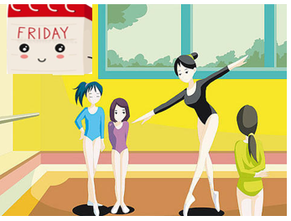I go ________ on __________.

A. swimming, Friday

B. dancing, Friday

C. dancing, Saturday

正确答案：B

1. 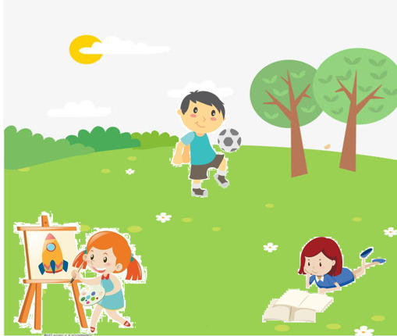下面哪句话的信息在图片上**没有**显现？

A. I play football on Sunday.

B. I draw pictures on Sunday.

C. I play basketball on Sunday.

正确答案：C

1. 阅读小短文，判断句子对错，对的打√，错的打×。



Hello, everyone. I am Lily. I go to school from Monday to Friday. On Saturday, I often go to see my grandparents. I love them. On Sunday, I often go to the park with my parents. We read books or fly my kite. We are very happy.

（ ）I often read books and draw pictures on Sunday.

A. × B. √

正确答案：A