**8年级英语第8课时**

**《复合句大家族—豪言“状”语九兄弟（二）》拓展资源**

**一、用心“阅”读，你会有更多收获哦！**

**(一) 目的状语从句**

**1. in order that与so that**

**两个连词都意为“以便……；为了……”，引导的状语从句中需用表可能性的情态动词，in order that比so that正式，引导的状语从句可置于主句之前或之后，而so that引导的从句一般置于主句之后。**

He drew a plan of the village so that she could find his house easily.

他画了一张这个村子的草图，以便她会容易找到他的房子。

In order that we might see the sunrise, we started for the peak early.

为了能看到日出，我们早早就出发去山顶了。

**2. for fear that与in case**

这些从属连词本身带有否定意义，意为“以免，以防”，相当于so that...not...或in order that...not...。

Take your umbrella with you in case it rains.

带上你的伞，以防下雨。

He took an umbrella with him for fear that it might rain.

他带了一把伞，以防下雨。

**(二) 结果状语从句**

**1.引导结果状语从句的从属连词有：so that, so ... that ..., such … that ...。在非正式语体中，由so ... that ..., such ... that ... 引导的句子中that可以省略，注意其结构形式：**

**so+形容词/副词+that从句**

**so+形容词+a/an+可数名词单数形式+that从句**

**so many/much/few/little+名词+that从句**

**such + a/an+形容词+可数名词单数形式+that从句**

**such+形容词+可数名词复数形式/不可数名词+that从句**

**such a lot of/lots of+名词+that从句**

It is such fine weather that we all want to go to the park.

天气如此好，我们都想去公园。

He earned so little money that he couldn’t support his family.

他挣得如此少，以至于不能养家。

It is not surprising that such little worms eat so little grain.

这么小的虫子吃这么少的谷物并不令人感到惊讶。

**2. 当so或such置于句首时，主句要用倒装语序。**

So clever was he a student that he was able to work out all the difficult problems.

他是如此聪明的学生，他能解出所有的难题。

**3. 除结果状语从句外，too ... to ... (太……而不能……) ，enough to ... (达到某种程度可以……) ，so ... as to ... (那么……以至于……) 等不定式结构同样可以表示结果。**

He didn’t get up early enough to catch the bus.

=He got up too late to catch the bus.

=He got up so late as to miss the bus.

他起得太晚了以至于没赶上车。

**(三) 条件状语从句**

**引导条件状语从句的从属连词有：if, unless (=if...not，除非) , so/as long as (只要) ,**

**in case (万一) , on condition that (条件是) , suppose/supposing (假设，如果) , provided that (如果) 等。**

You’ll fail the exam unless you study hard. (=if you don’t study hard)

除非你努力学习，否则你会考试不及格。

As long as you don’t lose heart, you will succeed.

只要你不灰心，你就会成功。

**二、用心“悦读”，和条件、目的、结果三兄弟去旅行吧！**

**First stop**

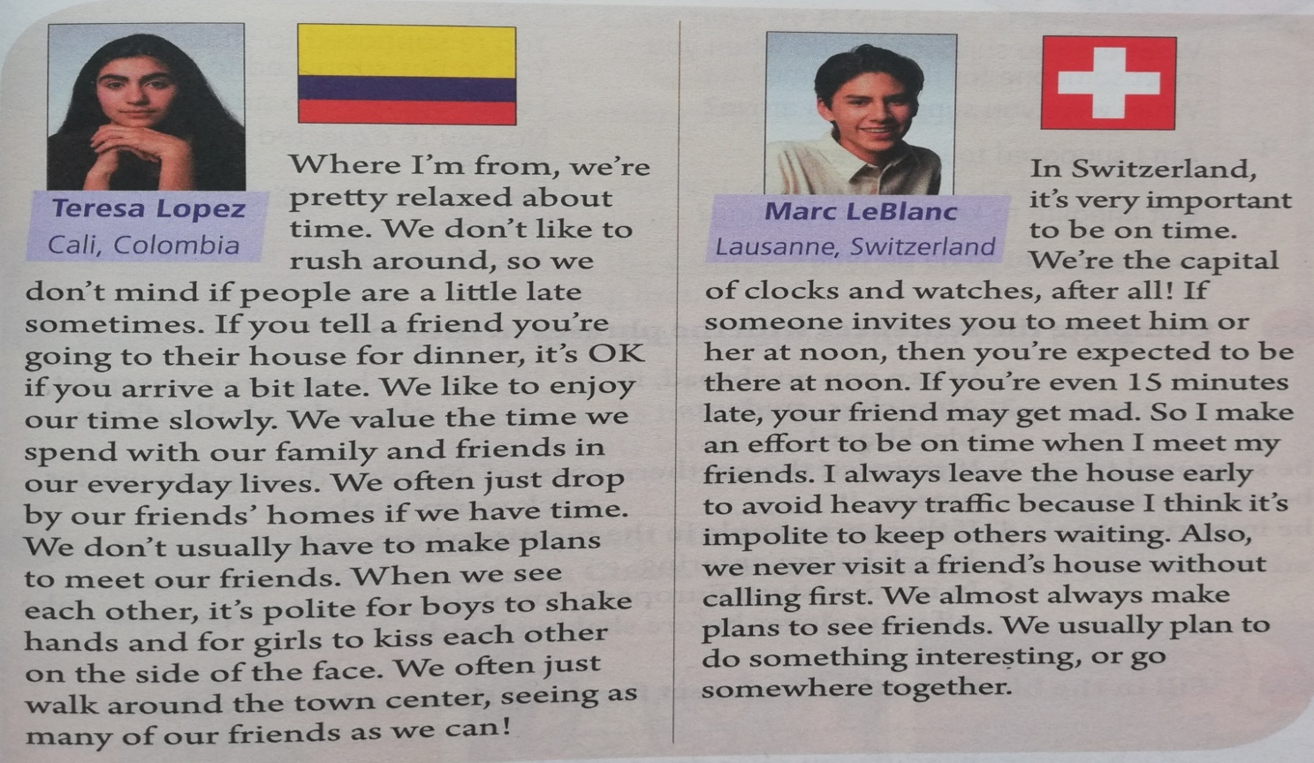

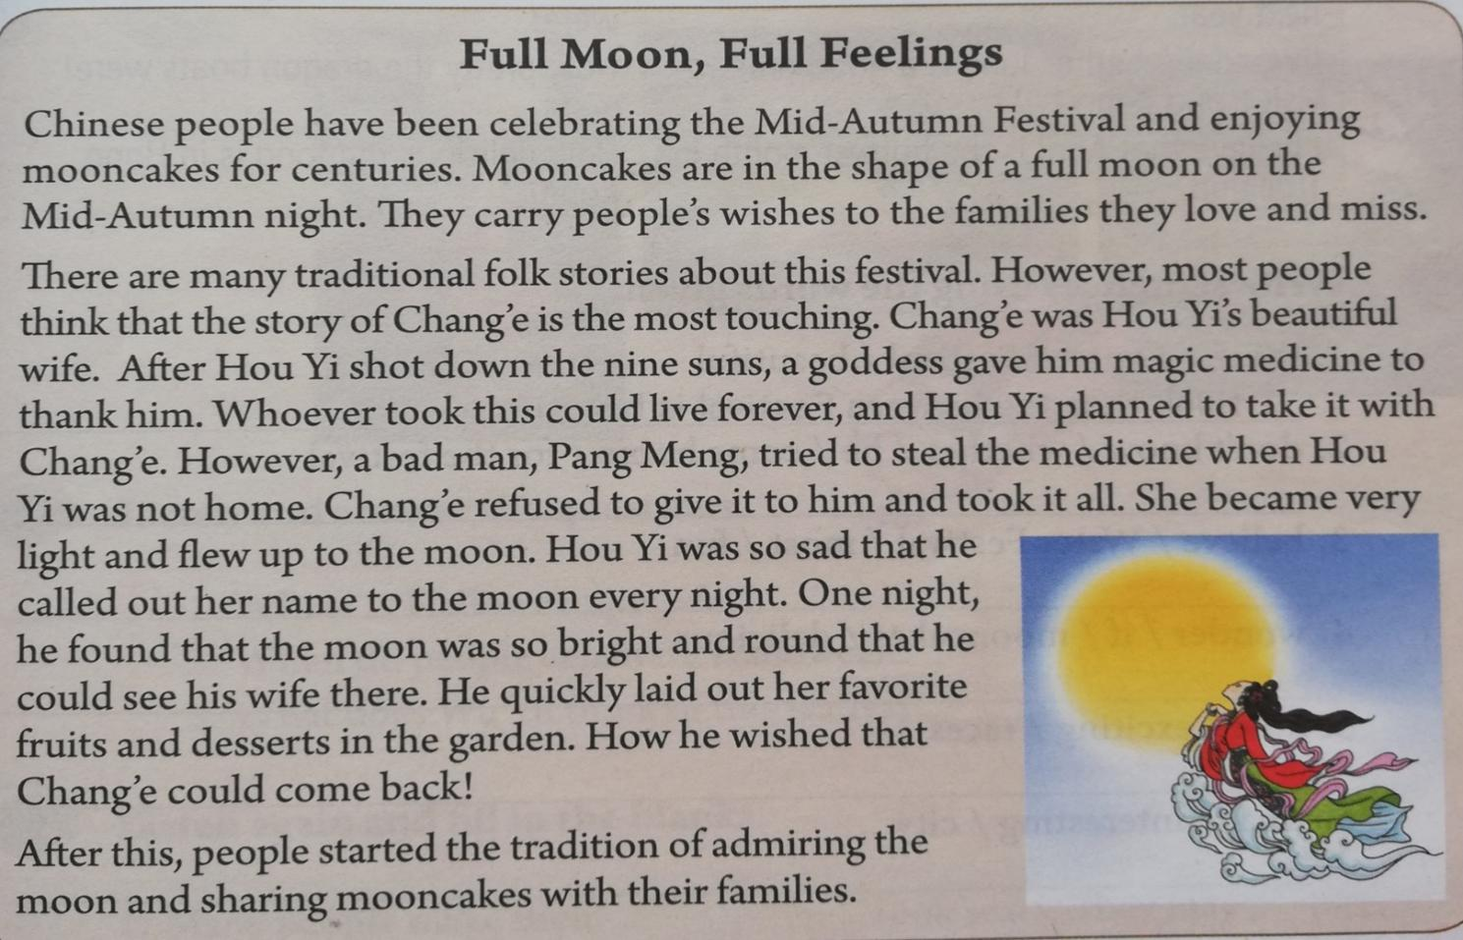

**Second**

**stop**

**Last**

**stop**

