**7年级英语第7课时**

**《用英语讲传统文化》拓展资源**

**春运的故事The Chinese New Year Travel Rush**

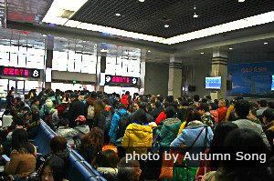**“春运”的由来：英语怎么说？可不是*Spring Travel!***

The Chinese New Year Travel Rush, known as 'Spring Movement' (春运 Chunyun), first appearedin *People’s Daily* in 1980. It usually begins 15 days ahead of Lunar New Year's Day and lasts for about 40 days (usually from mid-January to late February). And it causes the biggest and longest annual period of transport stress anywhere in the world.

***3 Reasons for the Travel Rush — Reunions, Vacations, Travel***

***Reunions* 团圆**

The Spring Festival is the most important annual festival for Chinese people. It has been a long tradition for Chinese people to return home from work or study and to enjoy a reunion dinner with their families on New Year's Eve, even if they have to travel a long distance.

***Vacations*假期**

The Spring Festival holiday period falls around the same time as Chinese students’ winter vacations.

Many people, including office workers and migrant laborers, work in big cities hundreds of miles from their hometowns, and the one/two-week-long vacation is always the main time in the year that they return home. Billions of people enjoy their vacations at the same time.

***Travel* 旅行**

In recent years, travel has become a popular way for many people to spend their Spring Festival holiday, which has added more stress to the transportation system.

For these reasons, transportation in the country, around the country, and in the major cities will be very crowded, so it is best to either avoid traveling during this time or get your tickets well in advance.



**请同学们扫描右侧二维码，跟视频了解更多春运的信息吧！**

***Word bank：***

appear v. 出现 annual adj. 每年的

transport stress n.交通压力 distance n.距离

migrant laborers 民工 major adj.主要的

either...or 要么...要么... avoid v.避免