**M2U4词汇与语法复习（2） 拓展练习**

练习一：阅读短文，从各题A、B、C、D四个选项中，选出最佳答案。

**Revolutionary TV Ears**

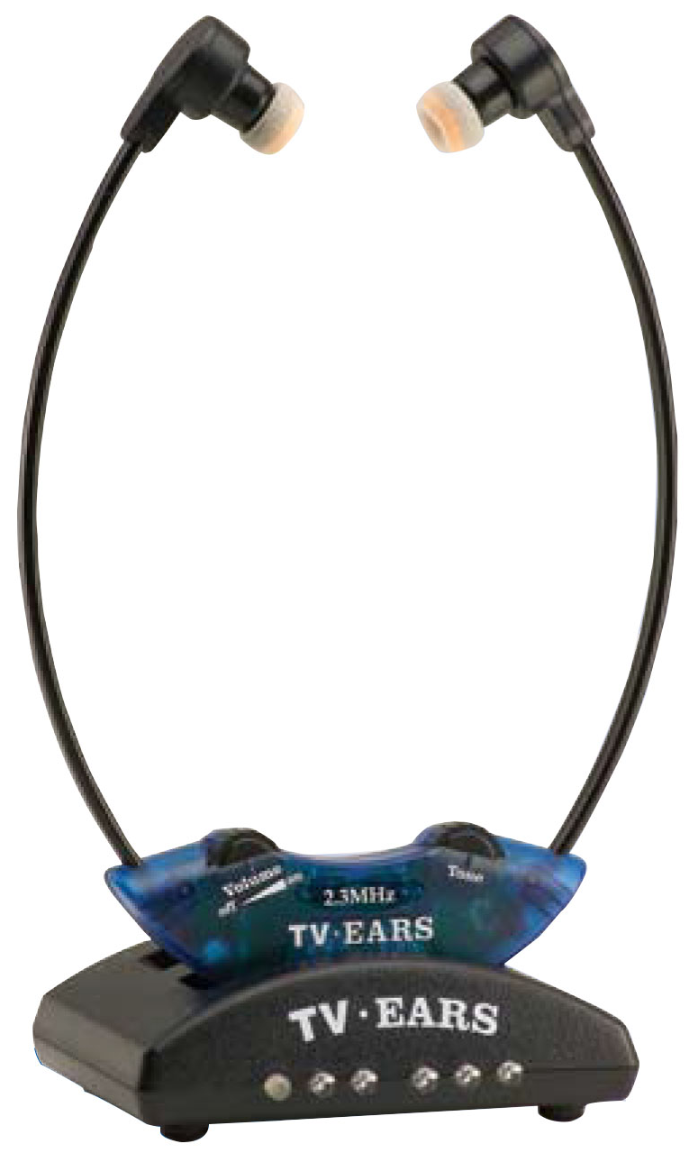

TV Ears has helped thousands of people with various degrees of hearing loss hear the television clearly without turning up the volume (音量) and now it’s better and more affordable than ever! With TV Ears wireless technology, you set your own headset volume, while other TV listeners hear the television at a volume level that’s comfortable for them. You can even listen through the headset only and put the TV on mute (静音) if the situation calls for a quiet environment—maybe the baby is sleeping. Or perhaps you are the only one who is interested in listening to the ballgame.

headset

TV Ears patented technology includes a revolutionary noise reduction ear tip, not used in any other commercially available headset. This tip reduces outside noise so that television dialogue is clear and understandable. Get the technology that has proven to help the most demanding customers. That’s why TV Ears has earned the trust and confidence of audiologists (听觉学家) nationwide as well as world-famous doctors.

**Doctor Recommended TV Ears!**

“My wife and I have used TV Ears almost daily for the past two years and find them a great help in our enjoyment of television. As a retired ear doctor, I heartily recommend TV Ears to people with normal hearing as well as those with hearing loss. ”

**— Robert Forbes, M.D., CA**

**Customer Recommended TV Ears!**

“Now my husband can have the volume as loud as he needs and I can have the TV at my hearing level. TV Ears is so comfortable that Jack forgets he has them on! He can once again hear and understand the dialogue.”

**— Darlene** & **Jack B., CA**

**Risk Free Trial!** TV Ears comes with a **30-day** risk free trial.

Special Offer—Now **$59.95**.

If you’re not satisfied, return it.

Money-back guarantee!

Call now! **800-123-7832**

1．TV Ears helps you _____.

A．improve your sleeping quality

B．listen to TV without disturbing others

C．change TV channels without difficulty

D．become interested in ballgame programs

2．What makes TV Ears different from other headsets?

A．It can easily set TV on mute.

B．Its headset volume is adjustable.

C．It has a new noise reduction ear tip.

D．It applies special wireless technology.

3．This advertisement is made more believable by _____.

A．using recommendations B．offering reasons for this invention

C．providing statistics D．showing the results of experiments

练习二：根据题目所提出的要求，在答题卡上写出一篇连贯完整的短文。词数不少于60。

假如你是李华，你们学校为了传承和发扬中国优秀传统文化，上个月举办了“京剧进校园”系列活动。请根据下面提供的信息，给校刊英文板块投稿，介绍活动情况，并谈谈自己的收获和感受。

短文的题目和开头已为你写好，不计入总词数。

Activities:

* attend a lecture on Peking Opera
* learn to draw Peking Opera masks
* watch Peking Operas
* …

Peking Opera Enters Middle Schools

*Last month, our school organized a series of activities focusing on “Peking Opera Enters Middle Schools” to help us students approach Peking Opera and understand Chinese culture better.*