**M1U3词汇与语法复习（2） 课拓展练习**

练习一：阅读短文，从各题A、B、C、D四个选项中，选出最佳答案。

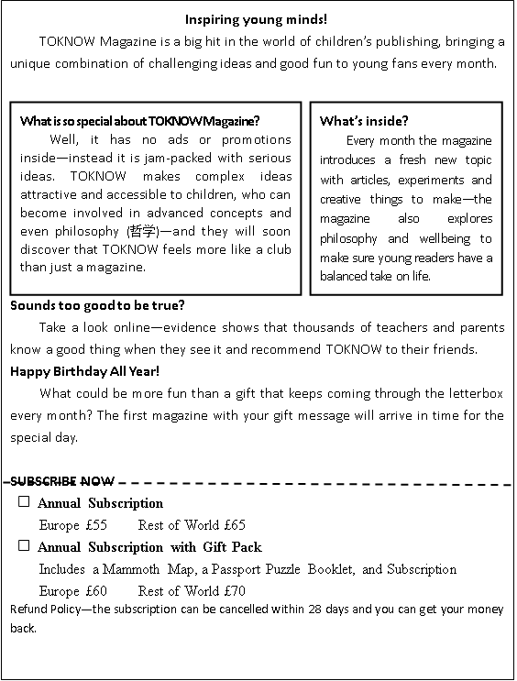

1．Why is TOKNOW a special magazine?

A．It entertains young parents.

B．It provides serious advertisements.

C．It publishes popular science fictions.

D．It combines fun with complex concepts.

2．What does TOKNOW offer its readers?

A．Online courses.

B．Articles on new topics.

C．Lectures on a balanced life.

D．Reports on scientific discoveries.

3．How much should you pay if you make a 12-month subscription to TOKNOW with gift pack from China?

A．£55. B．£60. C．£65. D．£70.

4．Subscribers of TOKNOW would get _____.

A．free birthday presents

B．full refund within 28 days

C．membership of the TOKNOW club

D．chances to meet the experts in person

练习二：根据题目所提出的要求，在答题卡上写出一篇连贯完整的短文。词数不少于60。

假如你是李华，你们学校上个月举办了“校园读书节”系列活动。请根据下面提供的信息，给校刊英文版块投稿，介绍活动情况，并谈谈自己的收获和感受。

短文的题目和开头已为你写好，不计入总词数。

Activities:

* exchange books
* attend lectures on western literature
* take part in Chinese poetry reading competition
* …

Campus Reading Festival

*In May, our school held Campus Reading Festival to encourage students to read.*