小学英语三年级上第一单元（第二课时）
小试牛刀
1. 下列两个单词划线的部分 skirt first
A 发音相同 | B发音不相同
正确答案：A
2. 与单词 girl 划线部分发音相同的是
A boy B bird
正确答案：B
3. 与单词 word 划线部分发音相同的是
A far | B skirt

正确答案：B
4. 与Maths 属于同类单词的是
A PE B sixth C English D Chinese
正确答案：A.C.D
5. 与eraser 属于同类单词的是
A pencil B Chinese C ruler D book
正确答案:A.C.D
6. 与third属于同类单词的是
A sixth B seventh C Maths D. fifth
正确答案:A.B.D
7. What does the bag look like in the passage ?(短文一中提到的书包是什么样子的?)
短文一My Little Bag
I have a little bag. It is black and white. It looks like a panda. There is one pencil case in it. The pencil case is green and white. It looks like a toy car. In the pencil-case there are three green pencils, a blue sharpener and a long ruler. There is also a white eraser. It looks like a fish. There are some books in the bag, too. Look! A Chinese book, an English book, a math book and three picture books .I like my little bag. It is my good friend. I go to school with it every day.
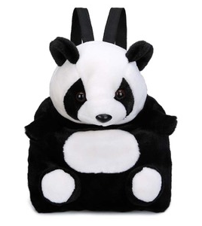  A It looks like a panda. | 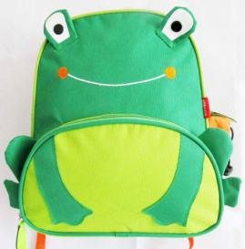  B It looks like a frog. | 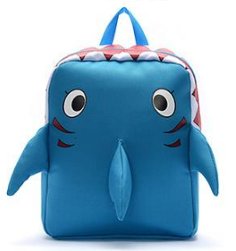  C It looks like a shark.
正确答案:A
8. Which one is mentioned in the passage?(短文一中提到了下列哪种文具？)
  A | 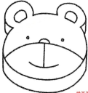  B | 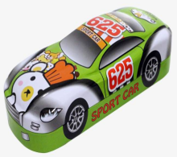  C
正确答案:C
9. Which kind of book is not mentioned in the passage? (短文一中没提到下列哪种书？)
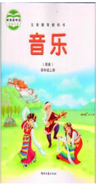  A a music book | 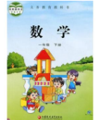  B a math book | 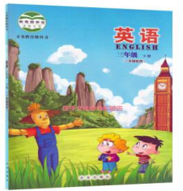  C an English book
正确答案:A
10.听课文录音Lesson1-Lesson3，有感情地朗读课文、词汇和短句，注意发音和语调。
正确答案：略

