**拓展提升任务**

1. **总结下列应用文类型的常见话题及常用表达。**

|  |  |  |
| --- | --- | --- |
| 应用文类型 | 常见话题 | 常用表达 |
| 书信类（电子邮件） |  |  |
| 社交类（邀请函） |  |  |
| 便条类（留言条） |  |  |
| 海报类（如环保主题海报） |  |  |
| 启事类（寻物启事） |  |  |
| 申请类（申请加入某组织） |  |  |

**二、完成下面一篇书面表达。**

假如你是李华，你想邀请交换生Peter在大年初一看电影请春节。下面是电影院的观影信息，请你从中选择一部影片和他一起观看。请你写一封信，告诉他你的选择，以及你选择这部电影的原因，并规定见面的时间及地点。

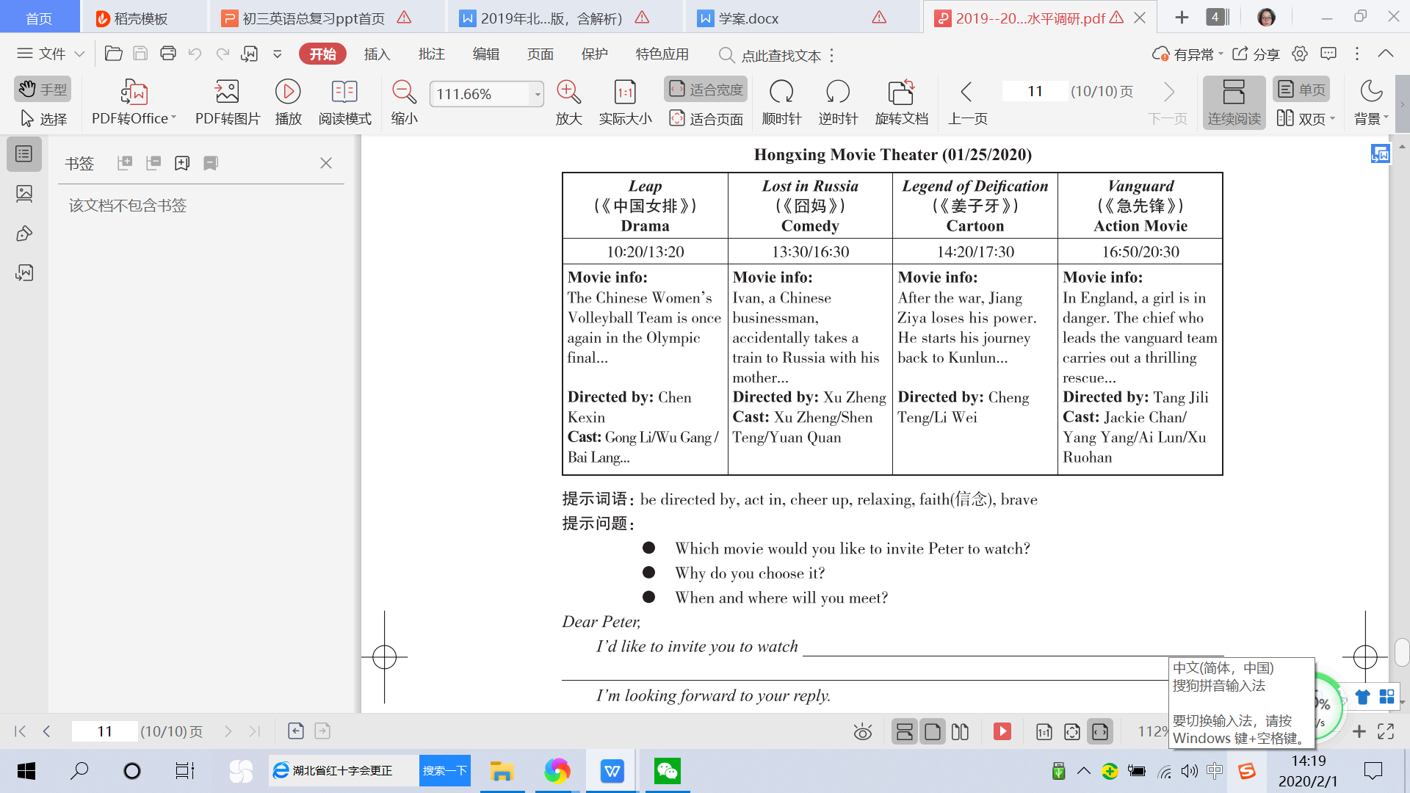

提示词语：be directed by, act in, cheer up, relaxing, faith(信念)，brave

提示问题：● Which movie would you like to invite Peter to watch?

● Why do you choose it?

● When and where will you meet?

Dear Peter,

I’d like to invite you to watch __________________________________________________

_______________________________________________________________________________________________________________________________________________________________________________________________________________________________________________________________________________________________________________________________________________________________________________________________________________________________________________________________________________________________________________________________________________________________________________________________________________________________________________________________________________________________________________________________________

I’m looking forward to your reply.

Yours,

Li Hua