- 下面易混淆的三个单词中，星期二的英文单词是哪个?
- Tuesday B. Thursday C. Thirteen
正确答案：A

- W __ dnesday 单词中所缺的字母是什么?
- u B. i C. e
正确答案：C

- 猜一猜这是星期几?
This day is the last day of the week.
- Friday B. Saturday C. Sunday
正确答案：B

- 读句子,选择正确的答语。
What day is today?
A. Tomorrow is Thursday.
B. Today is Tuesday.
C. I play basketball on Wednesday.
正确答案：B

- 根据句子描述，选择正确的图片。
I play football on Sunday.
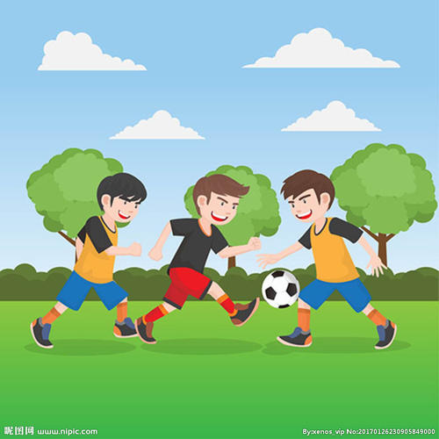 | 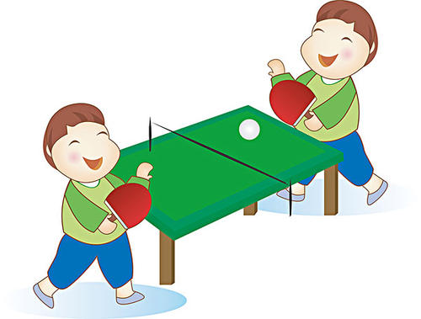 | 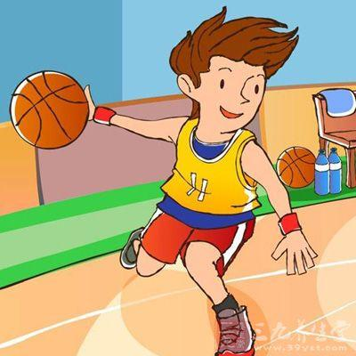
A | B | C
正确答案：A

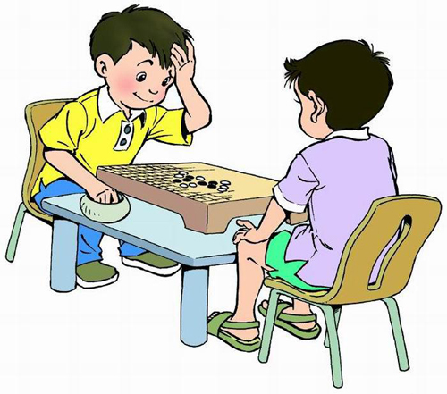
- 根据图片,选择正确的句子。
- I draw a picture on Saturday.
- I play chess on Saturday.
- I go dancing on Saturday.
正确答案：B

- 请选择句子中所缺的单词。
I go swimming ____ Saturday.
- in B. at C. on
正确答案：C
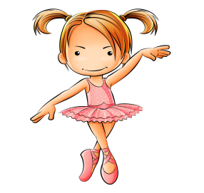
- 请根据图片信息，猜猜这个小姑娘在周一做什么?
- I go boating on Monday.
- I go dancing on Monday.
- I go swimming on Monday.
正确答案：B

- 爸爸问了什么问题,小明要这样回答?
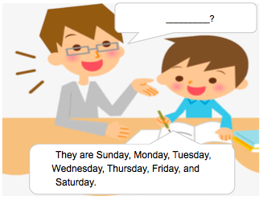
- What day is today?
- How many days in a week?
- What are the seven days in a week?
正确答案：C

10.阅读短文回答问题。
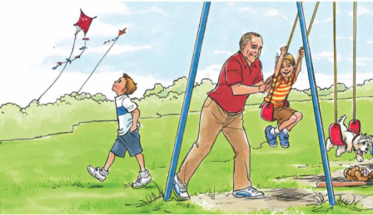 | On Friday afternoon. Mike and Sam go to the park with their grandpa. Mike likes to fly his kite. But Sam likes to swing.
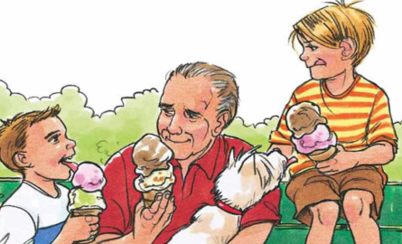 | Mike and Sam both like ice-cream. Grandpa likes ice-cream, too!
Mike，Sam和爷爷都喜欢什么?
- They like to fly kites.
- They like to swing.
- They like ice-cream.
正确答案：C

