**第1课时 挑战思维——动词原形、三单与时间的互动解码 练习**

一、单项填空

从下面各题所给的A、B、C、D四个选项中，选择可以填入空白处的最佳选项。

( )1．— What do you often do at weekends?

— I often______ my grandparents.

A．visited B．have visited C．visit D．will visit

( ) 2. My sister ______ her bike to school every day. It’s good for her health.

A. ride B. will ride C. is riding D. rides

( ) 3. Every year, thousands of farmers______ to big cities to find jobs.

A. go B. went C. have gone D. will go

( ) 4. Paul is crazy about basketball, but he ______ football very often.

A. isn’t play B. doesn’t play C. didn’t play D. won’t play

二、阅读理解

阅读下列短文，根据短文内容，从短文后各题所给的A、B、C、D四个选项中，选择最佳选项。

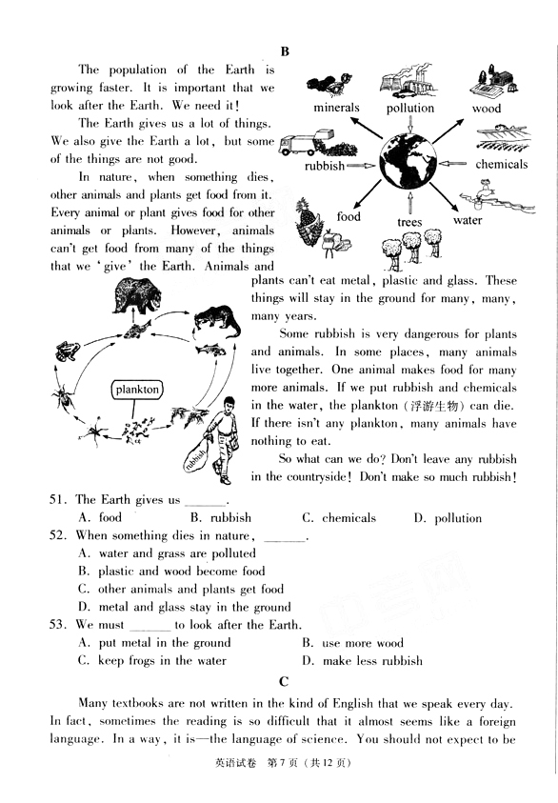 A篇

The population of the Earth is growing faster. It is important that we look after the Earth. We need it!

The Earth gives us a lot of things. We also give the Earth a lot, but some of the things are not good.

In nature, when something dies, other animals and plants get food from it. Every animal or plant gives food for other animals or plants. However, animals can’t get food from many of the things that we ‘give’ the Earth. Animals and plants can’t eat metal, plastic and glass. These things will stay in the ground for many, many, many years.

 Some rubbish is very dangerous for plants and animals. In some places, many animals live together. One animal makes food for many more animals. If we put rubbish and chemicals in the water, the plankton(浮游生物) can die. If there isn’t any plankton, many animals have nothing to eat.

So what can we do? Don’t leave any rubbish in the countryside! Don’t make so much rubbish!

( ) 5. The Earth gives us _______.

A. food B. rubbish C. chemicals D. pollution

( ) 6. When something dies in nature, _______.

A. water and grass are polluted

B. plastic and wood become food

C. other animals and plants get food

D. metal and glass stay in the ground

( ) 7. We must _______ to look after the Earth.

A. put metal in the ground B. use more wood

C. keep frogs in the water D. make less rubbish

B篇

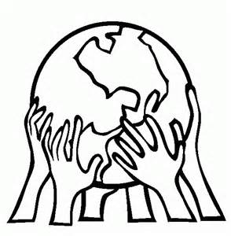Going Green

Green is no longer just a color. It is a new way of thinking about the world and a way of living your life. It’s catching on all over the world. More and more people decide to “go green” because they know that we only have one planet to live on. We won’t be able to live on it much longer if we keep wasting energy, and destroying(破坏) our home with air, land, and water pollution.

“Green Living” means:

Understanding that your choices affect(影响) not just you, but everybody everywhere.

Understanding that your choices affect not just today, but the future.

Understanding that when we talk about “saving the planet” or “saving the environment,” we are actually talking about saving ourselves!

You may be thinking: “Hey, I’m just one person, on a planet with billions. I can’t really make a difference.” Well, have you ever seen a group of people do “the wave(波浪)”? It always starts off with one or two people, jumping up and down like crazy. Soon thousands of people are joining in. “Going green” is just like that. It starts with small, simple actions. It can soon build into a wave that will change the whole planet and lead us all to healthier, happier lives.

Many students have already shared with us their efforts to help the environment:

Gabrielle, 12, writes, “I have helped my community plant a garden and I ride my bike or skateboard to school.”

Kaitlyn, 10, says, “Lots of paper towels are thrown away, so I use a reusable cloth towel to dry my hands instead.”

“I always recycle(重复利用)” says Natalie, 13. “You can call me a recycler! I always look at the bottom of things. I want to see whether they have the little sign that tells you it can be recycled. So I almost recycle everything!”

Now it’s your turn to think about how you can “go green”. Make important choices and take actions to improve the environment right around you and the health of the whole world.

( ) 8．What does the expression “catch on” in Paragraph 1 probably mean?

A．Go worse. B．Come to an end. C．Get help. D．Become popular.

( ) 9．From the passage we can learn that ______.

A．our choices can’t affect the future B．one person can’t make a difference

C．our planet is destroyed by pollution D．going green starts with small actions

( ) 10．The writer may agree that ______.

A．going green is hard for students B．going green means changing others

C．going green is actually a choice D．going green remains far away from us