**小学英语三年级上第一单元 （第一课时）**

**小试牛刀**

1. 第四正确的表达方法是

A first B fourth C third

正确答案：B

2. 九月正确的表达方法是

A September B October C January

正确答案：A

3. the first day 正确的理解是

A 第一天 B 第一周 C 第二天

正确答案：.A

4. Which fruit is the second one？

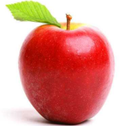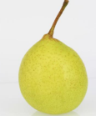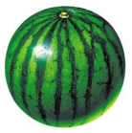

1. Pear B. watermelon C. apple

正确答案：A

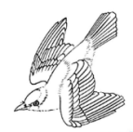5.Which bird is flying？

|  |
| --- |
| C:\Users\air\AppData\Local\Temp\1580397681(1).png |

1. The first one B. The second.

正确答案：A

6. Which kind of clothes is the first one？

|  |  |  |  |
| --- | --- | --- | --- |
| C:\Users\air\AppData\Local\Temp\1580397795(1).png | .C:\Users\air\AppData\Local\Temp\1580397889(1).png | C:\Users\air\AppData\Local\Temp\1580397938(1).png |  |

A coat B jacket C sweater

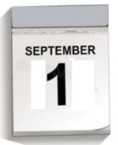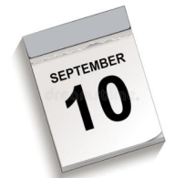正确答案： C

7. When is Teachers’ Day?

It’s September the tenth. A. B.

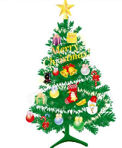正确答案：A

8. Let’s make a gift for our teacher.

正确答案：B. A. B.

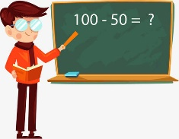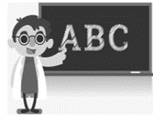9. Is the third class English?

Yes, it is.

正确答案：A A B

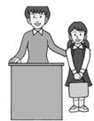

10. We have a new pupil.

正确答案B A B