**一、请你观察图片，找到相应的单词。**

**1.**



|  |  |  |
| --- | --- | --- |
| http://img.jf258.com/i/1a3118570184x1399702473b27.jpg | **A**  wood | **B**  a foot |

**正确答案：A**

**2.**



|  |  |  |
| --- | --- | --- |
| C:\Users\ALIENW~1\AppData\Local\Temp\WeChat Files\bd3841f6448cce5db8bfb542226d836.jpg | **A**  Kate | http://ku.90sjimg.com/element_origin_min_pic/18/07/01/215ea96ceb4f5022f4e3c5816df502c7.jpg  **B**  a cake |

**正确答案：A**

**3.**



|  |  |  |
| --- | --- | --- |
| http://pic.51yuansu.com/pic3/cover/00/77/42/58c6cf467a3c4_610.jpg | **A**  moon | **B**  good |

**正确答案：B**

**二、请你仔细阅读卡片中的单词，找到相应的图片。**

**4.**

|  |  |  |
| --- | --- | --- |
| http://www.zhideedu.com/UploadFiles/img_2_271893579_3600507833_200.jpg  **a gate** | **B**  **A**  http://pic.51yuansu.com/pic3/cover/03/06/46/5b31c4d4eb1d3_610.jpg | http://pic39.nipic.com/20140322/2600740_145028093360_2.jpg |

**正确答案：B**

**5.**

|  |  |  |
| --- | --- | --- |
| http://www.zhideedu.com/UploadFiles/img_2_271893579_3600507833_200.jpg  **a foot** | **B**  **A**  http://static2.bigstockphoto.com/4/9/2/large2/29413457.jpg | http://static2.bigstockphoto.com/4/9/2/large2/29413457.jpg |

**正确答案：B**

**三、请你仔细观察灯笼上的人物，找出他们要说的话。**

**6.**

|  |  |
| --- | --- |
| http://ku.90sjimg.com/element_origin_min_pic/17/12/20/c8ebda2af73006643272037cf3ad2eba.jpg  **A. Hi, I’m Maomao.**  **B. Hello, my name is Lily.** |  |
|  |

**正确答案：A**

**7.**

|  |  |
| --- | --- |
| http://ku.90sjimg.com/element_origin_min_pic/17/12/20/c8ebda2af73006643272037cf3ad2eba.jpg  **A. Kate is looking at the cake.**  **B. Kate is looking at the gate.** |  |
|  |

**正确答案：A**

1. **想一想，读句子，选择相应的答语。**

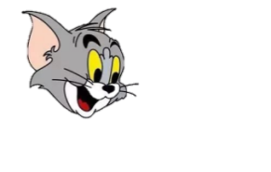

**8. What’ your name?**

**A. I’m a mouse.**

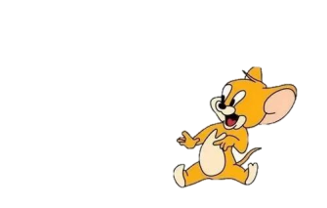

**B. I’m Jerry.**



**正确答案：B**

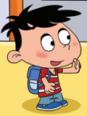

**9. Hello, Baobao!**

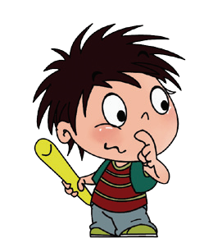

**A. Hello, Maomao!**



**B. My name is Maomao.**

**正确答案：A**

**五、读韵文，选择与韵文内容相符的图片。**

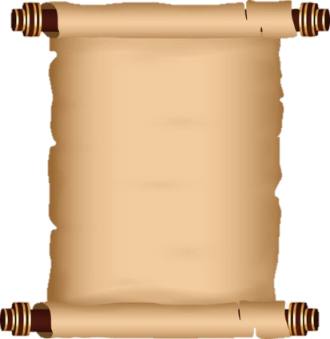**10.**

|  |  |  |
| --- | --- | --- |
| **A foot, a foot,**  **A foot is on the wood.**  **The wood, the wood,**  **The wood is under the foot.** | **A** | **B** |

**正确答案：B**