1. 选择合适的单词。

How many days are there in a week?

There are ______ days in a week.

A. six B. seven C. eight

正确答案：B

1. 毛毛虫里不完整单词中空缺的字母是什么?

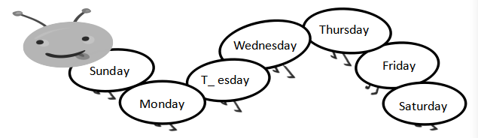

A. e B. un C. u

正确答案：C

1. 选择单词完成句子。Sunday, Monday, Tuesday, ______ is the next day.

A. Thursday B. Friday C. Wednesday

正确答案：C

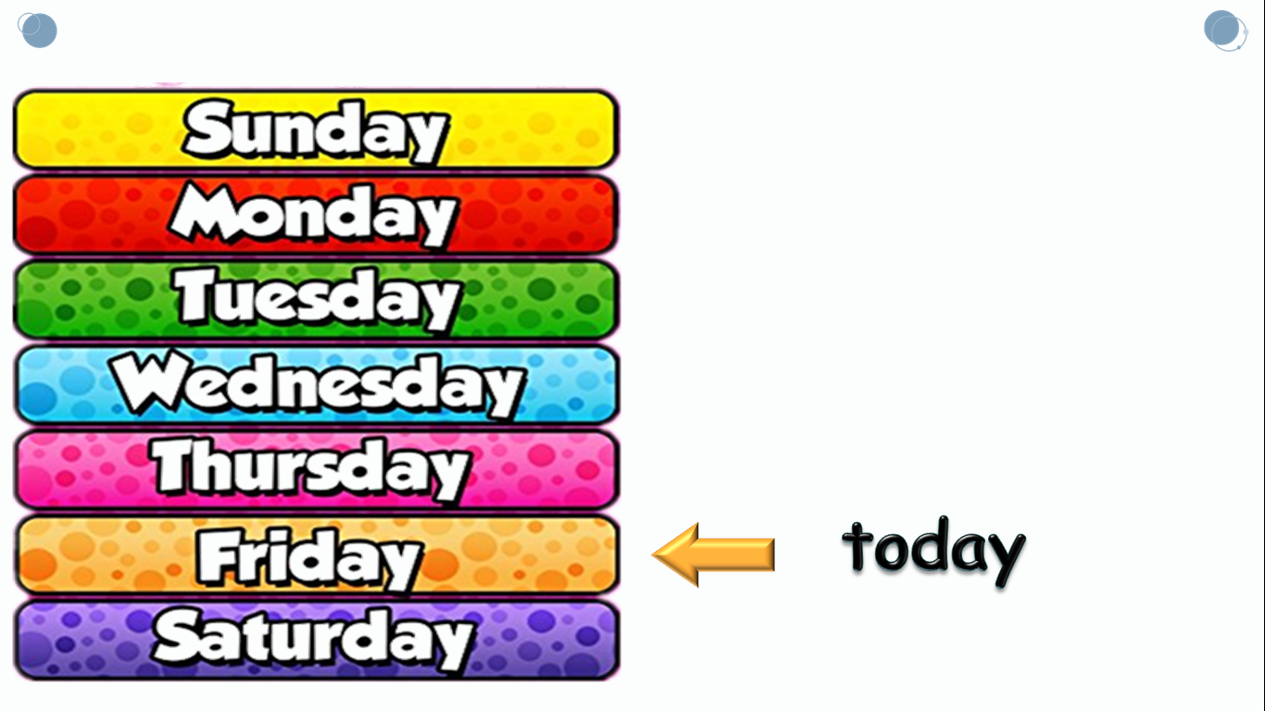

1. It’s Friday today. What day is tomorrow?
2. Tuesday B. Thursday C. Saturday

正确答案：C

1. 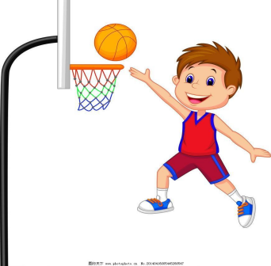What do you do on Monday?

A. I play ping-pong.

B. I play basketball.

C. I play football.

正确答案：B

1. Tomorrow is Saturday. Let’s __________.

A. go boating

B. go dancing

C. go swimming

正确答案：A

1. 根据句子描述，选择正确的图片。

It’s Thursday. I go swimming on Thursday.

|  |  |  |
| --- | --- | --- |
|  |  |  |
| A | B | C |

正确答案：C

1. 图片中**没有**的信息是哪句话?

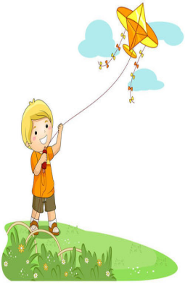

A. I go boating on Sunday.

B. I fly my kite on Sunday.

C. I go dancing on Sunday.

正确答案：C

1. 猜猜看,妈妈想和宝宝说什么?

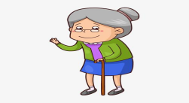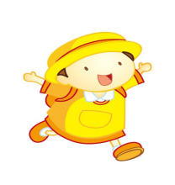

A. Let’s go to see your grandpa.

B. Let’s go to see your grandma.

C. Let’s go to see your uncle.

正确答案：B

10.请你认真阅读故事，回答问题。What does the boy do on Sunday?

|  |  |  |
| --- | --- | --- |
| On Friday, I have an idea（想法）. | **2020-02-02 (12)**  On Saturday, I make a house. | 2020-02-02 (13)  On Sunday, I play with my friends. |

A. He makes a house. B. He plays with his friends. C. He plays chess.

正确答案：B