**四年级第一单元（第三课时）**

**小试牛刀**

1. 看图片，选出正确单词。



1. upset B. happy

正确答案：A

1. 看图片，选出正确单词。



A. worried B. surprised

正确答案：B

3. 看图片，选出正确单词。



A. angry B. glad

正确答案：A

1. 根据情景，选择适当的选项。

I’m very _________.

1. tired B. tried

正确答案：A

1. 根据情景，选择适当的选项。

The football match is so ________.

A. excited B. exciting

正确答案：B

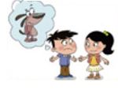6. Why do you look so sad?

Because my dog is _________ (A. missing / B. back)

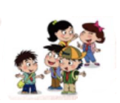正确答案：A

7. The pupils are very happy to be back at school.

They are glad to see ______________(A. Kate / B. each other)

正确答案：B

8. The gold is missing.

Captain Jack is very ________.(A. surprised / B. happy)

正确答案：A

9. They are _______(A. angry B. excited),

because they will go to the zoo.

正确答案：B

1. 阅读回答问题。

Tom is crying, because his watch is missing. Lingling tells him not to be sad. They are looking for the watch together.

Q: Who is sad? A. Tom B. Lingling

正确答案：A