**小学英语五年级上第一单元（第三课时）**

**小试牛刀**

1. skipping rope的正确理解是

正确答案：B

2. growing flowers的正确理解是

B. 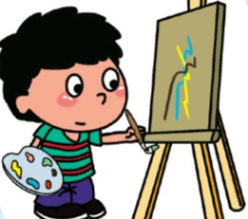

正确答案：A

3. swimming的正确理解是

C. 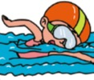

正确答案：C

4. Reading is my hobby.

A. 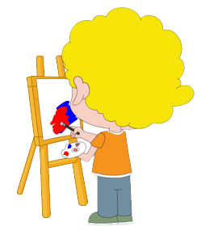 B.  C. 

正确答案：B

5. Which do you like better?

A. I like playing football best.

B. I like playing basketball, but I like playing football better.

C. I like playing football, but I like playing basketball better.

正确答案：B

6. Which do you like best?

A. I like playing chess best.

B. I like singing better.

C. I like swimming.

正确答案：A

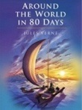7. What are you reading?

A. I’m reading *Around the World in Eighty Days*.

B. I like reading, but I like drawing better.

C. I like reading best.

正确答案：A

8. Is it a fairy tale?

A. Yes, it is.

B. Yes, you are right.

C. No, it’s science fiction.

正确答案：C

9. Yangyang likes English and he does best in English. Sara likes maths because it is useful. Chinese is Lingling’s favourite subject and she __________ Chinese.

A. doesn’t like

B. isn’t good at

C. does best in

正确答案：C

10. Children love to read stories and fairy tales. Sara loves science fiction better than the other two kinds. __________ He draws different animals.

A. Mike likes reading best.

B. Mike likes drawing, too, but he loves reading better.

C. Mike likes reading, too, but he loves drawing better.

正确答案：C