**小学英语五年级上第一单元（第二课时）**

**小试牛刀**

1. maths的正确理解是

A. 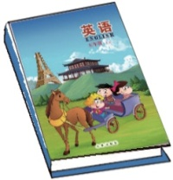 C. 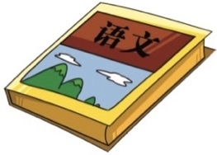

正确答案：B

2. art的正确理解是

B. 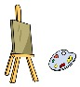 C. 

正确答案：B

3. science的正确理解是

A.  B. 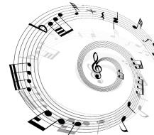 C. 

正确答案：A

4. like best的正确理解是

A. 最喜欢 B. 更喜欢 C. 喜欢

正确答案：A

5. 你想要知道你的朋友在两种食物间更喜欢哪一种，你会问：

A. Donuts or cupcakes, which do you like better?

B. Which food do you like best?

C. What’s your favourite food?

正确答案：A

6. 你想要知道你的朋友最喜欢哪门课程，你会问：

A. Calligraphy or PE, which do you like better?

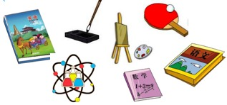B. Which subject do you like best?

C. What’s your favourite drink?

正确答案：B

7. 你想要表达语文这门课程很难但是很有趣，你会说：

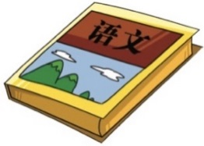A. I do best in Chinese.

B. Chinese is very useful.

C. Chinese is difficult but interesting.

正确答案：C

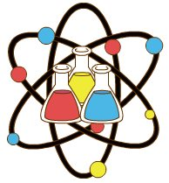8. Science or art, which subject do you like better?

A. I like art best.

B. Art is my favourite.

C. I like science better.

正确答案：C

9. What’s your favourite drink?

A. Meat is my favourite.

B. My favourite drink is milk shake.

C. I like water better.

正确答案：B

10. Here is a bottle of orange juice for you.

A. I don’t like it.

B. No, I don’t.

C. No, thank you. I like water better.

正确答案：C