**小学英语六年级上第一单元 （第三课时）**

**小试牛刀**

1. 听第3课课文录音，选择正确答案。

What did Mike do this summer?

A. He went to see his friends in Canada.

B. He went to see his grandparents in Canada.

C. He went to Canada for travelling.

正确答案：B

2. 听第3课课文录音，选择正确答案。

Mike’s grandparents are coming to visit them _______________

A. this summer B. next winter C. next summer

正确答案：C

3. 看图片，选出正确选项。

|  |  |  |
| --- | --- | --- |
|  | A. a pair of sneakers | B. a pair of Chinese shoes |

正确答案：B

4. 看图片，选出正确选项。

|  |  |  |
| --- | --- | --- |
|  | A. returned the books | B. borrowed some books |

正确答案：A

5. 看图片，选出正确选项。

|  |  |  |
| --- | --- | --- |
|  | A. went to the airport | B. went to the train station |

正确答案：A

6. 开学后当你与同学见面，想询问对方寒假都去哪里了？你该如何表达：

A. Where are you going this winter vacation?

B. Where did you go this winter vacation?

C. What do you often do this winter vacation?

正确答案：B

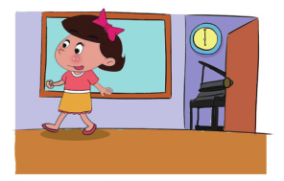7. What did you do last week, Cindy?

A. I finished my English lessons.

B. I finished the piano lessons.

C. I finished my homework.

正确答案：B

8. 当你拥有一个愉快的暑假时，你该如何去表达：

A. I did a lot of things this summer holiday.

B. I went to see lots of interesting places this summer.

C. I had a fantastic summer holiday.

正确答案：C

9. 当你想要了解更多的北京饮食文化，你如何有礼貌地去表达：

A. I want to know more about the food in Beijing.

B. Can you tell me more about Beijing?

C. Would you please tell me more about the food in Beijing?

正确答案：C

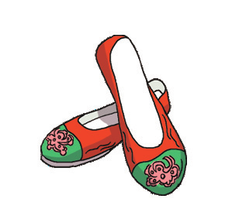10. What gift did you have for your grandma?

A. I bought a pair of Chinese shoes for her.

B. I bought a silk scarf for her.

C. I bought a pair of glasses for her.

正确答案：A