**高三年级英语第1课时《语法填空》学习指南**

**【学习目标】**

1.通过试题了解语法填空的命题热点；

2.掌握语法填空重要考点的解题策略，突破难点；

3.在语篇中理解和使用所学语法知识及解题策略正确答题。

**【学法指导】**

1.意识到语言使用中的语法知识是“形式一意义一使用”的统一体，学习语法的最终目的是在语境中有效地运用语法知识来理解；

2.在语篇中理解和使用高考三大核心考察点：时态语态、非谓语动词、复合句。

**【学习任务】**

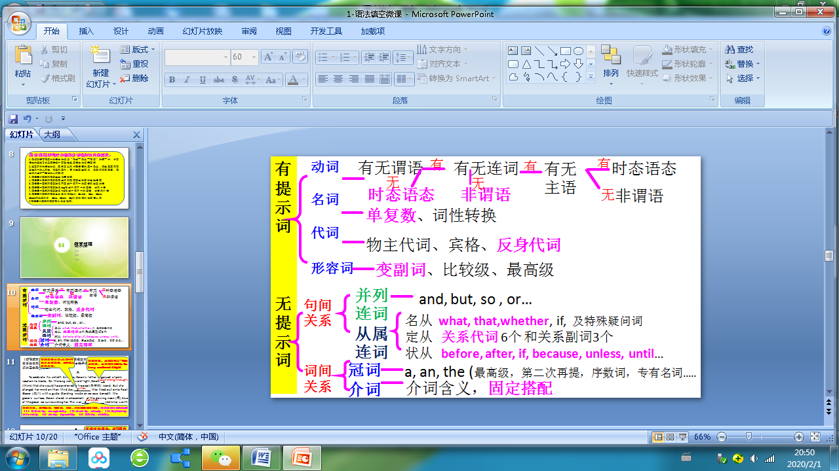

（朝阳期末） 阅读下列短文，根据短文内容填空。在未给提示词的空白处仅填写1 个适当的单词，在给出提示词的空白处用括号内所给词的正确形式填空。

**A**

To celebrate his sixtieth birthday, Devon’s father organized a family vacation to Alaska. On the long northward flight, Devon 1 (think) that she would have preferred a tropical (热带的) island. But she changed her mind on their third day, 2 they hiked out onto Root Glacier (冰川) with a guide. Standing inside an ice cave beneath the glacier’s surface, Devon stared in amazement at the glowing neon (氖) blue of the glacial ice surrounding her. This was 3 (definite) worth the trip!

**B**

While bottled water is convenient, it is also really bad for the environment. Not only does it create rubbish, but it also uses more resources because it 4 (ship) to the store. To be more eco-friendly, make it a habit 5 (carry) a reusable water bottle with you everywhere so that you can drink water on the go. Plastic bottles are usually the 6 (light) and most convenient. You can also find glass water bottles that are a great choice if you don’t like using plastic.

**C**

The debate 7 junk food in schools has gone on for many years, and people on both sides feel very strongly. Some people believe junk food, such as candy, cookies, potato chips, and soda, 8 (taste) good, but it’s not good for the human body. This is 9 they have made an effort to ban it from schools. They think taking junk food out of schools will make kids healthier. Others, however, believe this kind of ban doesn’t make much of a difference. Instead of banning junk food, they suggest students should be given choices between healthy and unhealthy ones. 10 (learn) to make healthier choices on their own is an important part of growing up.

（海淀区）

**A**

The first time I saw May, she 21 (sit) in my front yard, hugging my dog Harley. She had just moved into a small house down the road from us. From the second I talked to her, I knew May would be a cherished friend. Her smile and good cheer made me feel better when I was around her.

It didn’t take long 22 May was beloved by everyone in our neighborhood. Children and adults visited her home often. When we visited her, she would kindly listen to all of our 23 (trouble) and then say something so wise that we would leave her home with our hearts 24 (sing).

**B**

We are drowning in a sea of free information. The Internet is in our businesses, homes and our bedrooms. An army of designers and data engineers spend their working life figuring out ways 25 (make) us stay plugged in longer. Our desires are repackaged by giant tech companies and then 26 (sell) back to us under the cover of free content, but it isn’t free. We are paying for it with invisible currencies, such as our time and privacy, 27 people are only now beginning to understand.

**C**

Finding the opportunity to read can be a challenge, so it comes 28 (nature) that audiobooks (有声书) have become a preferred choice. 29 the help of audiobooks, people can enjoy their favorite books while exercising or commuting to school. Audiobooks 30 (grow) in popularity up till now, for they are undoubtedly a useful way to escape the stresses of modern life and a good way to keep busy.

（东城区）

**A**

Christmas was near. I walked away from my school and followed the worn path through the trees onto the street 1 Cole’s grocery store stood. In my pocket was a collection of coins and bills I 2 (earn) the summer before. Cars ran down the street as I opened the door to the store. The noise of the cars disappeared when the door closed 3 me. I was a kid who felt out of place and on a mission. For the first time, I was going to buy a Christmas gift for my mum and dad.

**B**

According to a recent study, dolphins have displayed certain characteristics of human conversation in their communication. Two dolphins, Yana and Yasha, 4 (study) as they communicated with each other. Researchers found that they would stop talking in order to listen to 5 the other had to “say”, just like a conversation between two humans. Dolphins have been known to be one of the most intelligent 6 (animal). We have studied dolphins for decades, but this new evidence on their communication patterns is one of the most exciting.

**C**

The Dunhuang Mogao Grottoes is a world heritage（遗产） site 7 (locate) in Gansu Province, Northwest China. In 2016, the first phase of the Digital Dunhuang resource database went online. Now people from all over the world can enjoy high-definition images and panoramic（全景的） tours of 30 caves on the Digital Dunhuang website. Digital Dunhuang 8 (integrate) all kinds of data, including videos, 3D data, pictures and others, into digital images that can be shared globally over the Internet. Although the Digital Dunhuang project has a long way 9 (go), it has significant meaning to 10 (culture) heritage protection.

（西城区）

A

Most of us claim we don’t have time for exercise. However, many experts say that exercise plays an important role in making our body healthy. Being 1_______(physical) active offers many advantages. As a physical reward, exercise can reduce weight and the risk of heart disease. Exercise also 2______(bring) good effects mentally. It can make us feel refreshed and happy, helping us increase our life quality. Actually, exercise can be done in simple 3______(way). For example, we can take the stairs rather than the life. Overall, it’s hard to find time to exercise in our busy lives, but every little bit helps.

B

It’s a popular belief that fish can’t remember anything 4________ longer than seven seconds. It may seem sad to think that they don’t remember what they’ve eaten or where they’ve been. But a recent study 5__________(find) that a kind of fish called African cichlids can remember events from as long as 12 days ago. Researchers trained the fish to go to a certain area of their tank 6_____ (get) food. They then waited for 12 days before 7_____ (put) then back in the tank again. With the help of computer software, they found the fish still went to the same place where they first got food.

C

In April 2017, two giant pandas from China arrived at a zoo in the Netherlands. There, they 8________(welcome) to the Chinese-style compound where they were to live. On May 30, after the preparations were complete, the day finally came 9______ the pandas met their fans for the first time. People were excited because 10_____ zoo is the only place in the country where it is possible to see pandas. In face, the last time there were pandas in the Netherlands was in 1987.

（石景山区）

**A**

Yesterday, I was walking down the street 1 I saw four separate dimes (角) on the ground shining in the sunlight. I bent down, picked them up and entered the post office. Inside a lady 2 (dig) through her purse at the counter anxiously looking for change to mail a package. Believe it or not, she was exactly forty cents short. How amazing it was! I placed my dimes on the counter. The smile I got in return was worth a thousand 3 (dollar).

**B**

The earth, the planet on 4 we are living, is the third planet from the sun. It came from the shrinking (收缩) of a vast cloud of dust and gas in outer space. Many scientists believe that the earth, as well as the sun and the other planets in our solar system, 5 (form) at least five billion years ago. The earth is slightly flattened at the North and South Poles, 6 it would look like a perfect ball if you were far out in space.

**C**

China is well known as the Kingdom of Bamboo. Bamboo culture has already been rooted 7 Chinese minds through the long history. To the Chinese people, bamboo is the symbol of virtue, 8 (reflect) people’s soul and emotion. Bamboo has the title of “the gentleman of plants”. 9 (it) deep root symbolizes determination and its straight and hollow pole represents straightness and modesty. Bamboo culture always 10 (play) a positive role in encouraging Chinese people to hold on when facing tough situations.

（丰台区）

A

I never believed in lucky coins. But one day as I was mowing the lawn (修剪草坪), I noticed a shiny object some five yards away. I stopped the machine to go and see 1 had caught my eye. Just as I bent over to pick up the object, the machine exploded behind me. I 2 (stand) there, frightened but unhurt. I 3 (save) by the shiny object—a coin. I now believe in lucky coins and stop to pick them up whenever I see them.

B

Reading as a teen leads to success. When teens read more than just their classroom assignments, research clearly shows that they generally do 4 (good) in school. First of all, the extra reading 5 (enlarge) their vocabularies. And teens 6 read more serious literary works gain skills in handling complex ideas. Besides, teens can educate

7 (they) in any area of life they are interested in if they are good at reading. Plus, reading also helps them expand their horizons as they learn more about people and the world.

C

A cheerful panda 8 (call) Bing Dwen Dwen has been chosen as the Olympic mascot for Beijing 2022 Olympic Winter Games. The new Olympic mascot will serve as an ambassador (大使) for winter sports, 9 (bring) joy to those who participate in and watch the Olympic Winter Games. “Bing” means ice and symbolizes purity and strength. “Dwen Dwen” relates to children and means 10 (honest), health, liveliness and loveliness. The mascot represents the strength and willpower of athletes and will help to promote the Olympic spirit.

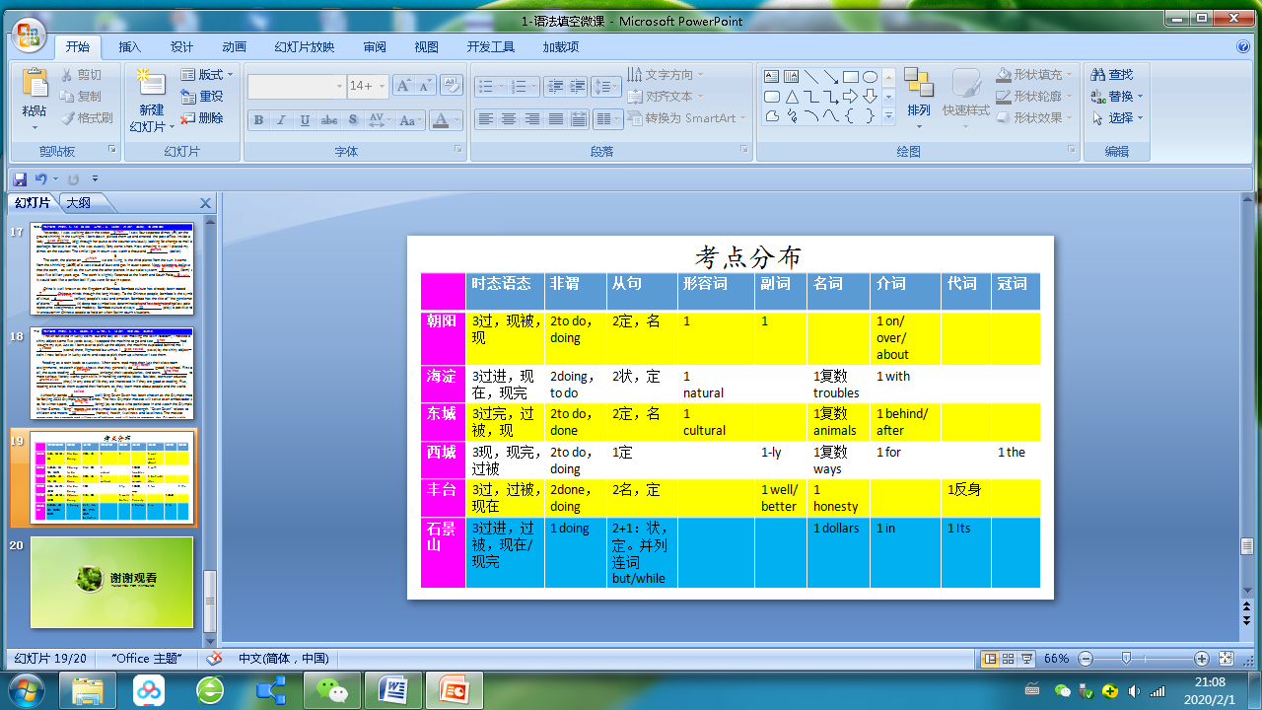

答案与解析：

朝阳期末：

第一节 语法填空（共10小题；每小题1.5分，共15分）

1．was thinking/thought 考查时态。文章用的是一般过去时态，此句时间状语On the long northward flight。

2．when 考查定语从句。从句中不缺少主宾表语，先行词是时间名词。

3．definitely 考查副词。修饰动词、形容词、副词、介词短语等用副词。形容词变副词的构成有（1）直接加-ly，如completely；（2）去e加-ly，如truly；（3）变y为i加-ly，如luckily；（4）去e加y，如possibly；（4）直接加y，如fully。

4．is shipped 考查语态。文章用的是现在时。表示被动用被动语态。

5．to carry 考查非谓语动词。考查非谓语动词:to do。（1）表示目的（可置于主句前面或者后面）；（2）在名词way/ability/chance等后作定语；（3）be glad to do；（4）the first to do；（5）find it hard to do；（6）allow sb to do；（7）want to do等

6．lightest 考查形容词。 由后面most convenient可知，用形容词最高级形式。

7．over/about/on 考查介词。debate后面的介词用on/about/over。又如research on/about sth; lecture on/about history。

8．tastes 考查时态。系动词没有被动语态，此句主语是不可数名词food。

9．why考查名词性从句。此处根据句子意义选用why。常用词还有：what/ that/ whether/when/ where/ because等。

10．Learning/To learn考查非谓语动词。用作主语时，可以用doing也可以用to do。

海淀期末：

21. was sitting 考查时态。篇章以过去时为主。在长动作的过程中发生了短动作，长动作用进行时。

22. before 考察状语从句。在句子中before翻译为“就”。

23. troubles 考察名词复数。

24. singing 考察非谓语动词在with后用法：with sb/sth to do/doing/done ， to do 表将要；doing表正在；done表示被动和已完成。

25. to make 考查非谓语动词:to do。（1）表示目的（可置于主句前面或者后面）；（2）在名词way/ability/chance等后作定语；（3）be glad to do；（4）the first to do；（5）find it hard to do；（6）allow sb to do；（7）want to do等

26. sold/are sold 考查并列连词and 用法：前后一致。...are repackaged ... and (are) told, 相同的部分为了避免重复，可以省略。

27. which 考查定语从句。which 指代前面这件事，作understand的宾语

28. natural 考查形容词。系动词后面与形容词连用。come是系动词，表示变得。比如：come true.

29. With 考查介词。with the help of 是固定搭配。

30. have grown/have been growing 考查时态。时间状语until now 是现在完成时标志。

东城期末：

1. where此题考查定语从句。where引导定语从句，修饰限定street，在定语从句中做状语。
2. had earned 此题考查时态中。之所以用过去完成时是因为主句的谓语动词是一般过去时was, coins and bills 是在the summer before 挣来的，所以是在动词was 之前发生的。
3. behind/after 此题考查介词的用法。根据句意需要填behind 或after。
4. were studied 此题考查被动语态。之所以用一般过去时的被动语态是因为主语是Two dolphins, 他们是被研究；又因为从句中的谓语动词是过去时communicated。
5. what 此题考查宾语从句. what引导的宾语从句在介词to后面作宾语，而且在宾语从中又做say的宾语。
6. animals 此题考查名词复数的用法。animal是可数名词，前面又有 one of the,所以填animals.
7. located 此题考查非谓语用法。过去分词located 做定语修饰site，表示坐落在甘肃省。
8. integrates 此题考查时态的用法。根据全文正体时态和语义应该用一般现在时，又因为主语是 Digital Dunhuang 是单数，所以动词用第三人称单数形式。
9. to go 此题考查非谓语用法。用不定式to go 是因为句意决定有很长的路要去走，表示将要发生。 have a long way to go.
10. cultural 此题考查词性转化。根据句意 这里需要形容词cultural修饰横线后面的名词。

西城期末：

1. physically 考查副词。修饰形容词active应用副词physically。
2. Brings 考察时态，上文：exercise can reduce weight，此处Exercise also，故应填brings,时态一致。
3. ways 考查名词。此处应填复数形式，in simple ways表示简单的方式做运动。
4. for 考查介词。表示持续一段时间应用介词for加时间段。
5. has found\finds\found 考查时态。此处既可以用现在完成时has found表示过去的研究得出的结论，也可以用一般现在时finds表示客观事实，还可以用一般过去时found表示这是过去的发现。
6. to get 考查非谓语动词。表示目的用不定式。
7. putting 考查非谓语动词。 介词before后＋doing。
8. were welcomed 考查时态语态。大熊猫2017年4月来到荷兰收到欢迎，故此处用一般过去时的被动语态were welcomed。
9. when 考查定语从句。修饰先行词the day用关系副词when，,句意：大熊猫和粉丝见面的这一天终于到了。
10. the 考查冠词。表示特指上文出现的荷兰的动物园，故此处用定冠词the。

石景山期末：

1. when 考查时间状语从句。when“当...时候”。

2．was digging 考查谓语动词的时态。一般过去进行时“was digging”表示“一位女士正在柜台前焦急地翻钱包找硬币来邮寄包裹。”

3．dollars 考查名词复数。 a thousand 加名词复数dollars。

4．which 考查定语从句。介词on+关系代词which修饰先行词earth。

5．was formed/formed 考查谓语动词的时态。时间状语five billion years ago ,表明谓语动词用一般过去时。主语为the earth, 所以 谓语用was formed/formed。

6．but/while 表示转折关系，“但是，然而”。

7．in 考查介词“in”。固定搭配“be rooted in ”翻译为“植根于...”

8．reflecting 考查非谓语。reflecting与其逻辑主语bamboo为主动关系，故用reflecting。

9．Its 考查物主代词。修饰名词root。

10. plays/has been playing 考查谓语动词的时态。主语为bamboo culture，“always”说明谓语动词用一般现在时或现在完成进行时。

丰台期末：

1. what 本题主要考查宾语从句。动词see后面的句子为宾语从句，宾语从句缺主语，故正确答案为 what。
2. stood本题主要考查时态。结合句意，就在我弯腰捡东西的时候，机器在我身后爆炸了。我站在那里，害怕但没有受伤。 该处应用一般过去时，故正确答案为 stood。
3. was saved本题主要考查被动语态。结合句意，我被闪亮的物体-一枚硬币救了。主语为I，谓语动词要用被动语态。故正确答案为 was saved。

4. well/better本题主要考查副词或副词的比较级。结合句意，当青少年阅读的不仅仅是他们的课堂作业时，研究清楚地表明，他们通常在学校会表现的好或更好。修饰动词 do 应用 good的副词形式或good的比较级形式。故正确答案为well或better。

5. enlarges本题主要考查时态。根据前面的时间状语First of all 并结合句意，首先，额外的阅读扩大他们的词汇量，可知。应用一般现在时。故正确答案为 enlarges。

6. who/that本题主要考查定语从句。先行词为 teens，表示人；且关系词在从句中作主语，故关系词可用 who/that。故正确答案为who/that。

7. 本themselves 题主要反身代词。后文中提到they are interested in， they are good at reading， 文章的主语是they，此时需要通过反身代词指代主语， 故正确答案为 themselves。

8. called本题主要考查非谓语动词。结合句意，一只叫冰墩墩的欢快的熊猫被选为北京2022年冬季奥运会的吉祥物。这里panda与call是动宾关系，应用called做panda的后置定语。 故正确答案为 called。

9. bringing本题主要考查非谓语动词。结合句意，新的奥运吉祥物将担任冬奥会的大使，为那些参加和观看冬奥会的人带来欢乐。这里The new Olympic mascot和bring是主谓关系，应用bringing做状语。 故正确答案为bringing。

10. honesty本题主要考查名词。结合句意，冰墩墩指诚实、健康、活泼和可爱，考查几个并列的名词，故正确答案为 honesty。