**Module 4 Unit 3 A Taste of English Humor Word study[学习目标]** 本节课重点复习10个词/词组在不同语境中的意思，关注其用法，并在新语境中熟练运用。

**[学法指导]** 学生阅读句子，理解不同语境下的词义和形式，整理词汇的用法，并完成填空和翻译练习。

**Task 1**

**Text Summary**

Chaplin was an extraordinary performer who _____________________(*be one of the main characters and director of* ) many outstanding comedies. Few were bored watching his moustache, his gestures or his _____________(*interesting; amusing*) __________(*response*) when chased by detectives. Being drunk, sliding on a banana skin or ____________(*to speak or say something very quietly*) his own failures to nobody, he made us feel more __________ (*satisfied; pleased; happy*) with our life without any verbal explanation. In a film, he played person who is homeless and __________ (*poor*). Though he_________(*come over*)many difficulties, he wasn’t fortunate enough. With all the porridge eaten up, he boiled his shoe, ___________(*select; choose*) the shoe lace, _________the leather bottom and chewed it like a pancake. His acting was so____________(*making you believe that sth. is true*)and amusing that everybody couldn’t help bursting into laughter. His sense of humor has astonished everybody throughout the world __________(*so far; till now*).

**Task 2**

**Match and Read**

star in and direct

entertaining reactions

be/feel content with

pick out

cut off

up to now

badly off

convincing adj.

overcome v.

whisper v.

**耳语**

**到目前为止**

**对…满意**

**切断**

**克服**

**挑出**

**令人信服的**

**有趣的反应**

**穷的**

**主演并导演**

**Task 3**

**Practise and explore 1**

* **star in and direct; entertaining reactions**

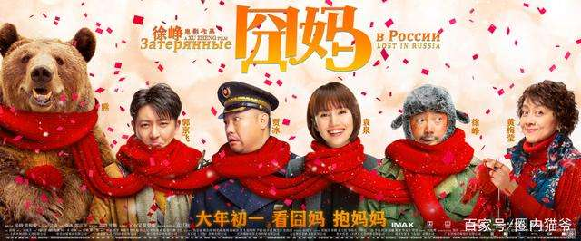 Yesterday, I watched a film which Xu Zheng, the famous _______________ (direct)and ___________(star)**,** **directed** and **starred in**, and was greatly impressed by his **entertaining reactions ____** his mother in the film.

His performance never fails _______________ (entertain) the audience and they_______(reaction) violently **to** his outstanding talent. No wonder he is so successful in the ___________ (entertain) industry.

**Practise and explore 2**

* 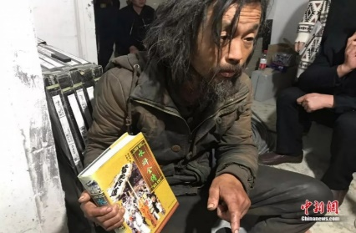**be/feel content with ; badly off; overcome; up to now**

Though the tramp is pretty _________than ever, so far, he ______________ fear and others’ judgements and leads his life in his own way by reading books and picking rubbish. **Up to now**, he _________ (read) hundreds of books and ________________ with his peaceful life.

**Practise and explore 3**

* **whisper v. n. convincing adj.**

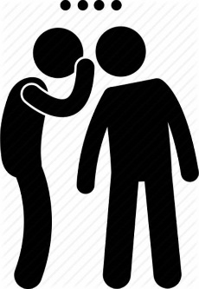 When Copernicus first found that the earth is not the center of the universe, he only **__________** (whisper)it to some of his friends. Later with enough evidence he __________(convince) people_____ his theory. His evidence was so ___________ (convince) that everyone ______________(convince) to believe in him and stopped talking about him _____________(低语).

**Practise and explore 4**

* **With all the porridge eaten up, he boiled his shoe, picked out the shoe lace, cut off the leather bottom and chewed it like a pancake.**

**pick out**

A. His story was picked out as the best by the judges.

B. I picked out Valerie's voice from among the general conversation.

C. I could just pick out some letters carved into the stone.

D. I bet you he can pick him out of a crowd of people.

1. **choose\select**
2. **recognize\spot\make out**

**cut off**

A. One of his fingers was cut off in the accident.

B. The US has threatened to cut off economic and military aid.

C. In winter, the town is often cut off by snow.

1. **separate**
2. **stop the supply of**

**pick out; cut off**

The talented little boy is good at ___________ a particular voice from a noisy background.

We forgot to pay the bill. As a result, our electricity _____________.

As usual, the director ___________ some entertaining scenes to make sure the amusing effect of the film.

Due to the severe cancer, part of his lung had to ___________.

**Task 4**

**Language in use**

在童年时期，憨豆先生就梦想着**主演并导演**一些喜剧。然而他们没有**搞笑的**外貌并且口吃（suffer from stutter）。他甚至可以听到人们**低声**谈论他。即便如此，他**克服**了自己的尴尬并且没有让别人的品头论足（judgements）**切断**了他实现梦想的道路。在牛津大学（Oxford University）学习时，他因**滑稽的**表演被一名导演**选中**。在20世纪90年代，**贫困潦倒**并总是发现自己处于诸如**切断**手指等尴尬境地的憨豆先生在**娱乐圈**广受欢迎。**至今为止，**他从没有失败过**说服**观众自己相信非凡的表演才华，并且一直**对**自己坚持梦想的决定**感到很满意**。

**Task5**

**Homework**

* Make up a story with the expressions we reviewed today.