**第 5课时 挑战思维 –动词过去分词与时间的互动解码**

**————————————拓展资源————————————**

**Over 500 million animals have died in Australian bushfires**

**看新闻 学英语**

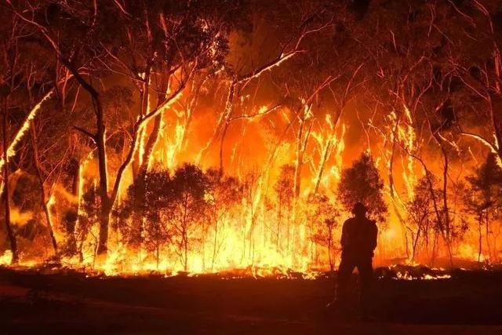新闻导读: 澳大利亚山火已经熊熊燃烧了四个月，山火导致近600万公顷土地被毁，近5亿动物葬身火海，野生动植物和整个生态系统遭到巨大破坏。这次灾难不仅是澳洲的，还是全世界的一次重创，严重破坏的生态环境，可能还会对全球的气候产生极大的影响，这次大火造成的恶劣影响将会持续存在很长时间。

Around 480 million animals are feared to have died in the [bushfires sweeping Australia](https://www.standard.co.uk/topic/australian-bushfires), including nearly a third of the koalas in [New South Wales](https://www.standard.co.uk/topic/new-south-wales)'s main habitat.

Ecologists at the University of Sydney estimate around 480 million mammals, birds and reptiles have been killed, directly or indirectly, by the devastating blazes since they began in September.

This includes almost 8,000 koalas, which are believed to have burnt to death on the state’s mid-north coast.

The region, which lies around 240 miles north of Sydney, is home to the largest number of Australia’s koalas, with a population of up to 28,000.

Federal environment minister Sussan Ley told [ABC](https://www.abc.net.au/radio/adelaide/programs/am/govt-is-working-to-address-threats-to-native-species:-ley/11828480) "up to 30 per cent of the population in that region" may have been killed, because around 30 per cent of their habitat has been destroyed. “We’ll know more when the fires have calmed down and a proper assessment can be made,” she added.

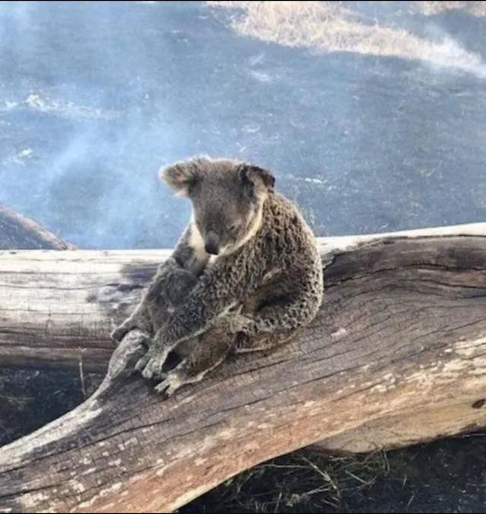More than 100 fires continue to rage across the country, having so far consumed more than five million hectares of land. Nine people have died and hundreds of homes have been razed to the ground during the unprecedented bushfire season. About four million hectares have been burnt in New South Wales alone.

As well as being one of Australia's most populous koala habitats, the mid-north coast region also houses one of the country's main [koala](https://www.standard.co.uk/topic/koala) hospitals.

Dedicated workers at the The Port Macquarie Koala Hospital reportedly treated 72 badly burnt animals on Christmas Day.

They were brought in after bushfires destroyed up to three quarters of their habitat, according to the clinical director Cheyne Flanagan.

“We have teams on roster for capture if any are in trouble and they are available 24 hours a day,” she told Reuters.

**Word Bank**

habitat n. (动植物的) 生活环境;栖息地

assessment n. 看法; 评估; 评定

populous adj. 人口众多的;人口密集的

新闻链接

https://www.standard.co.uk/news/world/australian-bushfires-new-south-wales-koalas-sydney-a4322071.html